f071025

A Partnership with Africa

Partners in development with the people of Africa




Updated: October 07, 2025
Address: Kimmage Manor, Whitehall Rd, Dublin D12 P5YP, Ireland
Email: info@apa.ie
Tel: (353.01) 406 4316
Website: www.apa.ie
Company No.: 372427
Charity No.: CHY 15814
CRA No: 20055547

Policy Manuals

Purpose

The purpose of this policy manual is to present a cumulative manual of all relevant policies, handbooks and manuals for A Partnership with Africa (APA). Each of the manuals found in this document can stand independently as references for relevant personnel. As a result, some information may be repeated across documents. Cumulatively, this document presents the internal controls of APA.

Table of Contents

* Please note that this Table of Contents refers to the pages of the various manuals housed within this document. For a more detailed table of contents, please see the start of each separate manual. *

Part 1: Board manual 4
Chapter 1: About APA 6
Chapter 2: Board Members 16
Relevant Appendices 28

Part 2: Staff Policy Manual 64
Chapter 1: Staff Procedures 68
Chapter 2: Staff Policies 80
Chapter 3: Financial Policies 120
Relevant Appendices: 138

Part 3: Financial manual 159
Chapter 1: Financial Procedures 161

Part 4: Guidelines for APA Charity Shops 177
Chapter 1: General Information about APA 179
Chapter 2: Management of the Shop 183
Chapter 3: Financial Procedures and Internal Controls 188
Relevant Appendices: 190

A Partnership with Africa

Partners in development with the people of Africa

Board Manual

Updated: October 07, 2025
Address: Kimmage Manor, Whitehall Rd, Dublin D12 P5YP, Ireland
Email: info@apa.ie
Tel: (353.01) 406 4316
Website: www.apa.ie
Company No.: 372427
Charity No.: CHY 15814
CRA No: 20055547

Board Manual Table of Contents

CHAPTER 1: ABOUT APA 6
Vision, Missions, Values 7
History 9
General Information 10
Partnership with CVM 11
Staff Organisation and Positions 13

CHAPTER 2: Board of Directors 15
Board of Directors Information 16
Board Member Positions and Responsibilities 19
Board Membership Documents 21

Appendices 28
Appendix A: Code of Conduct for Board Members 28
Appendix B: Declaration of Interests 30
Appendix C: Board Self-Assessment Tool 31
Appendix D: Conflict of Interest & Loyalty Policy 32
Appendix E: Constitution 33
Appendix F: Certificate of Incorporation 46
Appendix G: Charity Status 48
Appendix H: Consortium Agreement 50
Appendix I: APA/CVM Organisation Diagram (detailed) 62
Appendix J: Board Meeting Evaluation Sheet 63

Chapter 1
About APA

Vision, Mission and Values

Vision

APA’s vision is of a just world where all people are equally empowered to realise their full potential; where all will have universal access to basic services such as food, shelter, education and health.
Mission

APA’s mission is to work globally in a spirit of partnership with local communities and institutions to facilitate equal access to basic services and empower the most vulnerable citizens of the world to reach their full potential.

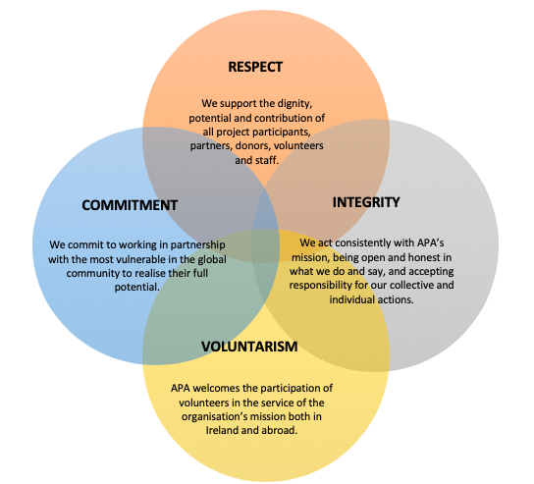
Values
Principles
APA upholds the following principles for the vision, mission and values of their work. All board members, volunteers, employees or other persons associated with the organisation should strive to uphold these principles not only in their professional activities but also in their personal attitudes and practices.

The Development of All People
APA’s goal is to build a fairer world for its inhabitants. Forms of global injustice and marginalization are widespread in all communities and continue to oppress entire populations around the globe. The development of each person and of all peoples remains the primary objective of the organisation. Historically, APA has supported marginalised and most at-risk groups and individuals by encouraging their own personal empowerment as well as the acceptance and advocacy from community members in positions of power and privilege. People living with HIV/AIDS, those living with unequal access to food, shelter and water and individuals and groups who have historically lacked fair access to education have been primary focuses for APA. The organisation follows the model of enabling the most at-risk and marginalised groups who have been trapped in cycles of poverty and oppression including bar workers, domestic workers, and others who seek recognition, respect and acceptance from the local, national and global community and their institutions.

Capacity Building
Widespread lack of awareness and disregard for of the rights of the most at-risk and marginalised groups of people should be considered a crime against humanity as it deprives such people of a fair and just chance to succeed either personally and socially. As a result, APA aims to combat these crimes against humanity in a way that builds the capacity of individuals around the world by unlocking their own potential. The increase of human dignity, hope and awareness offers an opportunity for people to freely define their own paths and projects for development, free from external economical oppression and within their own reasonable limits.

Partnership
Partnership is at the core of APA's vision and work, from facilitating communities to develop projects to collaborating with government, to enabling vulnerable groups like Domestic Workers or the Menja populations to access their rights through constitutional and legal avenues. APA also partners with other likeminded organisations in order to maximise the impact of its efforts with people who are poor. APA shares a unique relationship with Comunita Volontari per il Mondo (CVM), a non-profit organisation based in Porto San Giorgio, Italy. APA and CVM maintain a Consortium Agreement in which the two organisations have both aligned their missions and agreed to collaboratively implement their projects. Through its robust network of local and national partners in Ethiopia and Tanzania, CVM has established a strong basis of trust in the communities within which it works. APA and CVM have maintained a partnership for 17 years through which they have been able to maximise development efforts.

Education and Awareness
The organisation’s mission and policies should inform its projects, but at the same time, the projects should enter into a complete circular dialogue in order to inform the policies and mission. APA pledges to integrate its policies into its work so that the policies are not only reference points for board members, volunteers, staff and projects, but ultimately also support the mission and vision of all of the organisation’s work. APA pledges to approach their policies in a spirit of education and awareness, not only for those impacted by projects, but also for its board of directors, volunteers, staff, local authorities, and other community members with whom they engage.
History

​APA was incorporated on the 18th of June 2003 with Company Registered Number 372427, was granted charity status a year later with Registered Charity Number CHY 15814 and was more recently registered under the Charities Regulatory Authority with CRA Number 20055547 by Fr. Owen Lambert CSSp (Spiritan Priest) and friends as AIDS Partnership with Africa - APA.
​Fr. Lambert spent nearly thirty years in Africa (mainly in Ethiopia and Tanzania) working with the people through the great famine in Ethiopia and the tragedy of the HIVA pandemic. APA promoted a broad-spectrum response to HIVA control by integrated prevention and care as top priorities, working with regional government structures up to the national level, including ministries of health, education and political establishments, as well as with influential local and religious leaders. Adopting an integrated approach, APA promoted the networking of all social structures and community organisations, facilitating people to mobilise their resources and skills to cope with and stem the growing tsunami of death being wrought by the epidemic including the vast numbers of children orphaned due to the deaths of young parents under the care of grandparents who took up the huge challenge of caring for their grandchildren.
​
The impact of the HIVA pandemic on orphaned children and the many single-parent families, widows and domestic workers remained the focus of APA project activities. In 2014, as APA evolved and expanded into areas especially with women’s and children’s rights, the rights of ethnic minorities and development education in Ireland, the organisation underwent a name change to better represent the scope of its work. Thus, the name was legally changed from AIDS Partnership with Africa to A Partnership with Africa (APA). Operating under this title, APA continues to grow and adapt to the changing needs in Africa with current programmes in Ethiopia, Tanzania and Kenya.

General Information

Address:
A Partnership with Africa
Kimmage Manor, Whitehall Road, Dublin 12, P5YP
Ireland

Phone: +353 (0) 1 4064 316

Email: info@apa.ie

Website: www.apa.ie

Charity Number: CHY 15814

Company Number: 372427

Charities Regulatory Authority (CRA) Number: 20055547

Memberships: Charities Institute Ireland (CII), The Irish Association of Non-Governmental Development Organisations, Irish Development Education Association (IDEA). APA is compliant with Charities Regulator Authority and Dóchas Code of Conduct for Images and Messages, The Governance Code, General Data Protection Regulation (GDPR)

Partnership with CVM

1. Background

A Partnership with Africa shares a unique relationship with Comunità Volontari per il Mondo (CVM), a non-profit organisation based in Ancona, Italy. CVM serves not only as a key implementing partner in Ethiopia and Tanzania, but also maintains a Consortium Agreement with APA which can be found in Appendix I. The first consortium agreement was signed in 2004 and is subject to regular review and updating.

The vision, mission and values of APA and CVM are aligned. Both organisations have agreed to focus on interventions that will benefit the people who are most marginalised and at risk in the partner countries of Ethiopia and Tanzania. Together, they have committed to promoting a people-centred development philosophy as well as a multi-sectoral and multi-dimensional approach to the implementation and facilitation of partner projects.

Both APA and CVM have a history of collaborating on projects related to HIV/AIDS, but in recent years they have branched into different sectors including development education, minority advocacy, water sanitation, domestic workers, bar workers, and more. CVM provides progress reports on the projects at each board meeting. Additionally, regular meetings are held between the management of both organisations to monitor progress against targets and to assess risks and opportunities. The strategy of each organisation reflects the key role the partner organisation plays.

2. APA/CVM Consortium Organisation Diagram (see next page for the basic diagram, and see Appendix J for a more detailed version of the diagram)

APA Board of Directors
CVM Board of Directors
Programming in Ireland

Implementing Partners

Programming in Italy

Country Offices in Ethiopia/Tanzania

Implementing Partners in Ethiopia/Tanzania

Programming in Ethiopia/Tanzania

North Area
West Area
Dublin/East Area
South Area

Charity Shops

Fundraising

Implementing Partners in Italy

APA Management

CVM Management

MONITORING
Staff Organisation and Positions

1. Board and Staff Organisation Chart
Board of Directors

CEO
IAFRC (Internal Audit, Finance & Risk Committee) -Maintains Financial Control & Oversight of APA

Administration
Communications & Fundraising
Education
Accounts & Finance
Development Projects
Education

2. Staff Position Descriptions

Position Title | Position Details | Responsibilities
CEO  Owen Lambert CSSp (2003) | - Full-time position  - Located in head office  - Reports to Board of Directors  - Paid contracted position or voluntary | - Manage day-to-day affairs of the organisation  - Files relevant and necessary reports  - External networking  - Strategic planning and budgeting  - Donor relations
COO  Caleb Kyle (2025) | Full-time position  - Located in head office  - Reports to CEO  - Paid contracted position | Manage day-to-day affairs of the organisation  - Files relevant and necessary reports  - External networking  - Strategic planning and budgeting  - Donor relations
Deputy CEO  Shared with senior staff members | - Full-time position  - Located in head office  - Reports to Board of Directors  - Paid contracted position or voluntary | - Manage day-to-day affairs of the organisation  - Files relevant and necessary reports  - External networking  - Strategic planning and budgeting  - Donor relations
Projects Officer  Joe Jennings (2021) | Part time position  - Paid contracted position or voluntary | -Projects Development, Technical Supervision of Domestic Workers Project  -Monitoring, Learning, Evaluation & Reporting  -Assists with Regulatory Compliance  - External networking and Communications
Accounts & Finance Manager Shijo Paul (2020) | - Part-time position  - Located mainly in head office  - Works in collaboration with CEO/Deputy, Projects & Administration Officers.  reports to Internal Audit, Finance and Risk sub-Committee (IAFRC).  - Member of IAFRC  - Potential to be contracted, outsourced or in-house position or voluntary | - Manages day-to-day financials of the organisation  - Ensures the organisation is viable financially  - Preparation of books for audits  - Reports on any financial irregularities  - Compiles and manages budgets & Fundraising plans  - Files financial reports  - Manages reporting of finances with respective donors  - Cash counting and recording
Administration Officer  Adrienne Dunne (2224) | - Part-time positions/can be voluntary  - Located in head office  - Reports to CEO/Deputy and Financial Controller | - Day-to-day operation of office duties  - Manages office communications including Charity shops
Communications  Officer  Catherine Foley  (2022) | - Part-time positions/can be voluntary  - Located either in head office or remote based on organisation needs  - Reports to CEO/Deputy and project officer | - Presents the profile of APA  - Manages the website and relevant social media accounts  - Leads public relations  - Analyses marketing and communication trends for the organisation  Charity Shops Branding & Awareness
Development Education  Kathryn Moore  (2024) | - Part-time position  - Mainly Remote-based work  - Reports to CEO/Deputy  Position contingent upon project dates | - Planning & coordinating the activities related to Development Education programming in Ireland  EU-ED Project Coordinator in Ireland  - Completes progress reports  - Networks with schools and teachers

Chapter 2
Board of Directors

Board of Directors Information

1. Current Board Members and Roles

Name of Board Member | Profession/Resource | Role on Board
John Rice | Finance & Management Specialist | Chairperson of APA Jan 2014  Education Awareness Committee
Owen Lambert CSSp | Spiritan Priest, Development Coordination Specialist  Voluntary Director | IAFRC, Fundraising & Awareness
Conor Canavan | Accountant / Auditor | Board Secretary  North West Committee
Attilio Ascani | CVM Programme Coordinator | Communications
Aidan Clifford | Educational Specialist; Curriculum Development  and EU Global Education | Development Education  Networking  Internal Audit Finance & Risk
Vyara Panova | Accountant/Auditor | Internal Audit Finance & Risk  Fundraising
Mary Sheehan | Health Care Manager | Human Resources  Team building  Internal Audit Finance &Risk
Mari Buljo | Project Manager, Tech Advisory | Media Committee
Evan O Quigly | PR & Communications Associate Director | Media Committee

2. Committees

Internal Audit, Finance and Risk Committee (IAFRC)
Purpose: Manage and develop strategy for all matters related to finance, audits and financial risks to the organisation.
Members:
- Vyara Panova
- Owen Lambert
- Shijo Paul
- Mary Sheehan
- Aidan Clifford
- Adrienne Dunne

Education Committee
Purpose: Oversee the EU Education Projects and their progress in Ireland as they related to APA’s involvement.
Members:
- Joe Jennings
- Aidan Clifford
- Kathryn Moore
- Owen Lambert

Fundraising Committee
Purpose: Develop strategies, activities and events related the organisation’s fundraising efforts.
Members:
- Shijo Paul
- Owen Lambert
- John Rice
- Adrienne Dunne

North, East/Dublin, South, West Committees:
Purpose: Develop strategies and activities aimed at networking for the organisation in addition to seeking funding from these areas.
Members:
- Conor Canavan
- Owen Lambert

3 APA Resource Persons Details
Name | Contact | Profession | Year Joined | Role
Clarke Jeffors & Co | Dublin Street, Carlow | Solicitors | 2015 | Legal Advisors
Crowe & Co | 40 Mespil Road, Dublin  D04 C2N4, | Auditors | 2023 | Auditors

4. APA Patrons
Name | Title | Year Joined
Brian Kerr | Football Manager | 2009
Lorna Byrne | Lorna Byrne Children’s Foundation Founder | 2013
Ruth Negga | Actor | 2023

Board Member Positions and Responsibilities

** For more detailed information on the role of the Board of Directors please see the Organisation’s Constitution found in Appendix E, the guidelines provided by CSA, CII, and the Dochas Code of Conduct. **

1. Board Member Responsibilities

The following responsibilities are expected of all current board members:
- Regularly attend quarterly board meetings and other important and/or relevant meetings.
- Commit to participate actively in committee work.
- Volunteer for, willingly accept and complete assignments thoroughly and on time.
- Stay informed about board matters, prepare thoroughly for meetings, and review/comment on minutes and reports.
- Familiarise oneself with other board members to build collegial working relationships.
- Actively participate in the board’s annual evaluation and planning efforts.
- Remain informed on organisation’s finances and collaboratively appoint the Financial Controller.
- Maintain good relations with donors and in fundraising for the organisation.
- Promote fundraising and seek out new donors and sources of funding.
- Actively commit to the growth of the organisation.

2. Board Officers and Responsibilities

A. Chairperson (required)

Responsibilities:
- Must be a member of the board.
- Serves as Chairperson of the Board and of the whole body.
- Partners with the CEO to achieve the organisation’s mission.
- Provides leadership to the board.
- Chairs board meetings.
- Reviews issues of concern to the board with the CEO.
- Encourages the board’s role in strategic planning.
- Discusses issues confronting the organisation and sector with the CEO.
- Helps guide and mediate board actions with regard to organizational priorities and governance concerns.
- Monitors financial planning and financial reports.
- Plays a leading role in relations with donors and in fundraising activities.
- Promotes fundraising and seeks out new donors and sources of funding.
- Ensures that the board members uphold their roles in fundraising and donor relations.
- Informally evaluates the participation and effectiveness of board members by ensuring that all board members complete their Self-Evaluation Forms (see Appendix C).
- Signs off on the director’s reports and reviews financial statements in an effort to ensure that the organisation is achieving its mission.
- Represents the board and the organisation publicly.
- Is available to organisation management.
- Performs other responsibilities for organisation as they arise.

B. Vice Chairperson (not required)

Responsibilities:
- Must be a member of the board.
- Performs Chairperson responsibilities in the absence of the Chairperson (see responsibilities listed above).
- Maintains regular (monthly) communications with the Chairperson, CEO and/or Secretary regarding any updates, activities or opportunities within the organisation.

C. Company Secretary (required)

Responsibilities:
- Maintains records of board meetings and ensures effective management of records.
- Must have familiarity with legal documents (memorandum, articles, bylaws, Revenue Commissioners letters, etc.) to note applicability during meetings.
- Makes annual returns and files appropriate documentation with the Revenue Commissioners (CRO).
- Registers office on an annual basis.
- Ensures board meeting minutes are distributed to management and board members within two weeks to one month after each meeting.
- Maintains records of all AGM’s.

D. Financial Controller (required)
- Must be either a member of the board or an employee/volunteer for the organisation.
- Holds responsibility for oversight of the effective financial management of the organisation.
- Holds responsibility to the board for the discharge of its obligations under the Articles of Association.

Board Membership Documents

1. Relevant Documents

Director’s Report and Financial Statement: These must be approved and submitted annually and must include the Board Member details including the frequency of attendance to meetings. These documents should be signed by the Chairperson.

Code of Conduct: All board members are required to read the section below and then sign the abbreviated version found in Appendix A. Board members are expected to adhere to this code of conduct. If they fail to do so, they will be removed from the board.

Declaration of Interests: Members are also required to fill in the Declaration of Interests form, found in Appendix B, so that any interests related to service on APA’s Board of Directors are up-to-date with the organisation.

2. Code of Conduct for Board Members

2.1 General Information

The present document constitutes the Code of Business Conduct for the Directors of
A Partnership with Africa (APA). This Code has been prepared via a participative approach, has been approved by the Board and takes the implications of the Ethics in Public Office Act into account. All members of the Board of Directors are required to sign a copy of the Code of Conduct as found in Appendix A.

The document outlines the general principles that govern the operation of the Board of A Partnership with Africa (APA). In general, the following code sets out the basic objectives of the Board of Directors including the following:
- The establishment of an agreed set of ethical principles
- The promotion and maintenance of confidence and trust
- The prevention of development or acceptance of unethical practices

The document is not intended to be an exhaustive list of guidelines and will be subject to review on an annual basis. APA expects that is board will always operate with the highest standard of integrity and professionalism.

A Partnership with Africa (APA) will take all necessary measures to ensure that the Code of Conduct receives the widest possible publicity. A copy will be given to existing and new members of the Board and the document will also be made available on the A Partnership with Africa (APA) website. A Partnership with Africa (APA) will make this code available to interested parties as a recommended best practice document. Directors will be required to indicate in writing that they have received and understood the document, as included in Appendix A. Breaches of the code may result in termination of membership to the board.

2.2 General Principles

The principles, which underpin the general ethos of this code, are as follows:

A. Loyalty
The Directors shall acknowledge the responsibility to be loyal to APA’s aims and objectives and be committed to its activities, while also being mindful that the organisation itself must consider the interests of lead departments, beneficiaries and the public.

The Board has a duty to conform to the highest standards of business ethics.

B. Integrity
The Board has a commitment to acting ethically and honestly.

The Board will ensure that accounts and reports accurately reflect their business performance and are not intentionally or unintentionally misleading.

The Board will not use APA’s resources or time for personal gain, for the benefit of persons/organisations unconnected with the body or its activities or for the benefit of competitors.

The Board of Directors will disclose any outside employment/business interests in conflict or in potential conflict with the business of the body.

C. Declaration of Interests
In compliance with the Ethics in Public Office, each Director will, on an annual basis, complete the Declaration of Interests form found in Appendix B. The Secretary should collect and maintain these records.

This statement should include details relating to his/her employment and all other business interests (including shareholdings, professional relationships etc.), which could involve a conflict of interest or could materially influence the individual’s performance of his/her functions as a member of the Board. The board member should also disclose the interests of his/her family members’ or other personal acquaintances’ who have the potential to influence the member’s performance and functions. For this purpose, persons and bodies connected with a member should include:
- a spouse, parent, brother, sister, child or step-child;
- a body corporate with which the member is associated;
- a person acting as the trustee of any trust, the beneficiaries of which include the member or the persons at (a) above or the body corporate at (b) above; and
- a person acting as a partner of the member or of any person or body who, by virtue of (a) - (c) above, is connected with the member.

Each member should furnish to the Secretary details of business interests of which he/she becomes aware during the course of his/her directorship. Where it is relevant in any matter that arises, the member should be required to indicate to the Secretary the employment and any other business interests of all persons connected with him/her, as defined above.

If a member has a doubt as to whether this Code requires the disclosure of an interest of his/her own or of a connected person, that member should consult the Chairperson.

Details of the above interests should be kept by the Secretary in a confidential register and should be updated on an annual basis. Changes in the interim should be notified to the Secretary as soon as possible. Only the Chairperson, Secretary and Chief Executive of the body have access to the register.

Should a matter relating to the interests of the Chairperson arise, he/she should depute the Deputy Chairperson or another Director to chair the Board meeting and should abstain from discussion and/or voting when the Board is deliberating or deciding on a matter in which the Chairperson, or a person or body connected with the Chairperson, has an interest.

Board or Company documents on any case that relate to any dealings with the above interests should not be made available to the member concerned prior to a decision being taken. Such documents should be taken to include those relating to cases involving competitors to the above interests. Once decision have been made, they should be then shared with the relevant member.

As it is recognised that the interests of a Director and persons connected with him/her can change at short notice, a Director should, in cases where he/she receives documents relating to his/her interests or of those connected with him/her, return the documents to the Secretary at the earliest opportunity.

A Director should abstain from deliberation or decision making on matters in which that member (other than in his/her capacity as a member of the Board) or a person or body connected with the member has an interest. In such cases a separate record (to which the Director would not have access) should be maintained.

Where a question arises as to whether or not a case relates to the interests of a Director or a person or body connected with that Director the Chairperson should make a final ruling.

D. Information
The Board of Directors will conduct its activities in a confidential and objective manner.

The Directors will support the Management and employees of A Partnership with Africa (APA) for the provision of access to general information relating to the body’s activities in a way that is open and enhances its accountability to the general public.

Directors have a commitment not to acquire information or business secrets by improper means.

Members of the Board are not permitted to disclose any confidential information obtained while performing or as a result of performing any activities on behalf of A Partnership with Africa (APA). The above requirements do not apply to information already in the public domain or in the possession of the person prior to undertaking the activities.

The Directors will comply with relevant statutory provisions (e.g., GDPR, Freedom of Information Act).

Based on the latter, Directors will respect the confidentiality of sensitive information held by A Partnership with Africa (APA). This would constitute material such as:
- Commercially sensitive information (including but not limited to future plans or details of major organisational or other changes such as restructuring)
- Personal information
- Information received in confidence by A Partnership with Africa (APA)

Directors will observe appropriate prior consultation procedures with third parties where, exceptionally, it is proposed to release sensitive information in the public interest.

Former Directors should treat commercial information received while acting in that capacity as confidential.

E. Legal Obligations
Directors of State bodies incorporated under the Companies Acts have duties under these Acts, and it is the responsibility of each Director to act in conformity with the applicable provisions of those Acts.

The Board will fulfil all regulatory and statutory obligations imposed on A Partnership with Africa (APA).

The Board of A Partnership with Africa (APA) shall act according to law and apply the rules and procedures laid down in Irish and relevant European legislation.

The Board shall take due care that decisions which affect the rights or interests of individuals have a basis in law and that their content complies with the law.

Where individual Board members become aware of non-compliance with any legal obligation, they should immediately bring this to the attention of their fellow Board members with a view to having the matter rectified.

Directors shall comply with all relevant APA Policies including, though not limited to: Child Protection, Safeguarding Vulnerable Adults, Gender, Data Protection, Fraud, Conflict of Interest, Risk Management, Fundraising, etc. All relevant policies can be found in the Staff Policy Handbook.

Directors shall comply with A Partnership with Africa (APA) tendering and purchasing policies, as well as comply with prescribed levels of authority for sanctioning any relevant expenditure.

F. Board Operation
Directors should use their reasonable endeavours to attend every Board meeting. The Board should meet at least 4 times a year, retain full and effective control over the body and monitor the executive management and performance of A Partnership with Africa (APA).

A Director who absents himself/ herself from six consecutive Board meetings without special leave of absence from the Board of Directors shall cease to be a member of the company. This is on the understanding that the Director will be notified in advance of this taking effect.

A member who wishes to resign from the Company may do so by letter addressed to the Secretary, and with effect from the receipt of such letter by the company, such member shall cease to be a member of the Company.

At each Annual General Meeting, one quarter of the Directors of the company shall be required to retire with effect from the end of the meeting. The Directors to retire in every year shall be those who have been longest in office since their last appointment and as between persons who become directors on the same date, those to retire shall (unless they otherwise agree amongst themselves) be determined by lot. Retiring Directors shall be eligible for re-nomination and appointment.

The quorum necessary for the transaction of business of the directors may be fixed by the Directors, and unless so fixed shall be one less than 50% of the Directors of the company at the time of the meeting.

The Board should have a formal schedule of matters specifically reserved to it for decision to ensure that the direction and control of the body is firmly in its hands. This schedule includes the following:
- Significant acquisitions, disposals and assets of the body
- Major investments and capital projects, delegated authority levels, treasury policy and risk management policies
- Approval of terms of major contracts
- Approval of annual budgets and corporate plans
- Production of annual reports and accounts
- Appointment, remuneration and assessment of performance of Chief Executive
- Amendments to pension benefits of Chief Executive and staff

The collective responsibility and authority of the Board should be safeguarded. Excessive influence on Board decision-making by individual members should be avoided, while allowing Board members the opportunity to fully to contribute to Board deliberations.

In the event if an equality of votes, the Chairman of the Board of Directors shall have the casting vote.

G. Fairness
The Directors are committed to fairness in all business dealings and will value and treat all clients equally.

Directors must comply with employment equality and equal status legislation.

When taking decisions, the Board of A Partnership with Africa (APA) shall ensure that the principle of equality of treatment is respected. The Board shall in particular avoid any unjustified discrimination based on gender, marital status, family status, sexual orientation, religion, age, disability, race or membership of the travelling community.

A Partnership with Africa (APA) is an equal opportunities employer and requires that staff appointments are made based upon demonstrably objective criteria and that recruitment procedures are always adhered to.

H. Impartiality and Independence
The Board shall be impartial and independent. They shall abstain from any preferential treatment on any grounds whatsoever.

They shall not be guided by any inappropriate influences of whatever kind, including political influences, or by personal interests.

When taking decisions, Directors shall take into consideration the relevant factors and give each of them its proper weight in the decision, whilst excluding any irrelevant element
consideration.

I. Authority
Directors’ powers and authority shall be exercised solely for the purposes of the organisation.

Directors shall in particular avoid using those powers for purposes which have no basis in the law or which are not motivated by public interest.

J. Hospitality
Directors shall avoid the giving or receiving of corporate gifts, hospitality, preferential treatment or benefits which might affect or appear to affect the ability of the donor or the recipient to make independent judgment on business transactions.

A Partnership with Africa (APA) Board members may not approach any business with which they have contact through their official duties seeking sponsorship or support for any club, association, trade union or other organisation.

It is impossible to lay down hard and fast rules covering the acceptance of hospitality in all possible circumstances. The overriding concern is that the actions of A Partnership with Africa (APA) Board members be above suspicion and not give rise to any conflict of interest, and that their dealings with commercial and other interests should bear the closest possible scrutiny. It is accepted that Board members should not be put in a position where they cannot accept what are regarded as normal courtesies in business relationships. That being said, in their contacts with outside organisations or persons, every care must be taken by A Partnership with Africa (APA) Board members to ensure that their acceptance of hospitality does not influence them, and could not reasonably be seen to influence them, in discharging their official functions.

The following general guidelines provide a framework within which decisions in this area can be made:
- No objection would normally be taken to the acceptance of what is regarded as routine hospitality, the most obvious example being a business lunch. What may be regarded as “routine” for this purpose will depend on a number of factors such as the value of the hospitality offered, the frequency of offers, whether there is an element of reciprocity and the circumstances in which it is offered (for example whether it is offered by a company to all its customers or is directed at specific customers or potential customers). Certain types of hospitality (for example involving traveling abroad or holiday weekends) should not be regarded as routine.
- Board members should not accept offers of hospitality which go beyond the routine practices referred to above, except where acceptance of such an offer can be clearly shown to be in the interest of A Partnership with Africa (APA) and has been approved by other Board members.

K. Work/External Environment
The Board will place the highest priority on promoting and preserving the health and safety of A Partnership with Africa (APA) employees.

They will ensure that public concerns are taken into consideration and will endeavour to minimise any detrimental impact of the operations on the environment.

L. Responsibility
The Chairperson of the Board will ensure circulation of this Code of Conduct to all Directors for their retention and they must sign and return the abbreviated code in Appendix 1 for filing. This constitutes acknowledgement of receipt of this policy and understanding of same on the part of each Director.

M. Review
The Directors should review annually the effectiveness of the body’s system of internal controls, including financial, operational and compliance controls.

The Directors have a commitment to review the code of conduct on a periodic basis, as with all policy documents.

Appendix A: Code of Conduct for Board Members

Organisational Values
As a board member of A Partnership with Africa I promise to abide by the fundamental values that underpin all the activities of our organisation.

Accountability
Everything A Partnership with Africa does will be able to stand the test of scrutiny by members of the public, the media, beneficiaries, stakeholders and the regulatory authorities.

Integrity and Honesty
These will be the hallmarks of all conduct within A Partnership with Africa, particularly when dealing with colleagues (board and staff) and external individuals and agencies.

Transparency
A Partnership with Africa will strive to promote an atmosphere of openness throughout the organisation in order to promote confidence to members of the public, staff, beneficiaries and regulators.

Law, mission, policies
In my role as board member I will not break the law or go against any regulation in force. I will support the organisation’s mission and actively promote it.
I will abide by organisational policies and procedures.

Conflicts of Interest
I will always act in the best interests of the organisation and comply with the A Partnership with Africa’s Conflict of Interest policy.
I will declare any conflict of interest or any such circumstance as may be viewed by others as conflicting as soon as it arises.
I will submit to the judgement of the board and do as it requires regarding potential conflicts of interest.

Person to Person
I will not act in disregard of organisational policies in my relationships with fellow board members, staff, volunteers, beneficiaries or anyone I come into contact within my role as board member.

Guardian of the organisation’s reputation
I will not speak as a board member to the media or any public forum without the prior knowledge and approval of the Chair or CEO.
When I am asked to represent the organisation, any comments I make will reflect current policy even if I do not agree with them.
When speaking as a private citizen I will aim to uphold the reputation of the organisation and those who work and volunteer for it.
I will respect organisational, board and individual confidentiality.
I will take an active interest in the organisation’s public image.

Personal Gain
I will not personally gain from my role as a board member nor will I permit others to do so as a result of my actions or negligence.
I will document expenses and seek reimbursement according to agreed procedure.
I will not accept gifts or hospitality without the consent of the Chair.
I will use organisational resources responsibly, when authorised in accordance with procedure and comply with APA fraud policy.

At board level
I will embody the principles of good governance in all my actions and live up to the trust placed in me by A Partnership with Africa.
I will abide by the board governance procedures and practice.
I will strive to attend all board meetings.
I will strive to absorb agenda items sent to me in good time and be prepared to contribute my opinions during meetings.
I will honour the authority of the Chair.
I will maintain a respectful attitude to the opinions of others.
I will accept a majority vote.
I will maintain confidentiality unless authorised to speak on matters outside board meetings.

Enhancing governance
I will participate in appropriate induction, training and development board activities. I will support the CEO in his/her executive role and the Chair in their leadership role.

Leaving the board
I understand that any substantial breach of this code may result in my removal from the board.
Should I wish to resign I will inform the Chair in writing, stating my reasons for resigning from the board.
I will participate in an exit interview if necessary.

Signed: _______________________________

Board Member of A Partnership with Africa

Date: ______________________

Appendix B: Declaration of Interests

I .................................................................. as employee / director / trustee* (*delete as appropriate) of A Partnership with Africa – APA, have set out below my interests in accordance with the organisation’s conflicts of interest policy.

Category | Details of interest and whether it applies to yourself or, where appropriate, a member of your immediate family or some other close personal connection
Current employment and any previous employment in which you continue to have a financial interest.
Appointments (voluntary or otherwise) e.g. trusteeships, directorships, local authority membership, tribunals, etc.
Membership of any professional bodies, special interest groups or mutual support organisations.
Investments in unlisted companies, partnerships and other forms of business, major shareholdings and beneficial interests.
Gifts or hospitality offered by external bodies in the last twelve months.
Do you use, or care for a user of the organisation’s services?
Any contractual relationship with the charity or its subsidiary.
Any other conflicts that are not covered by the above.

To the best of my knowledge, the above information is complete and correct. I undertake to update as necessary the information provided, and to review the accuracy of the information on an annual basis.
I give my consent for it to be used for the purposes described in the conflicts of interest policy and for no other purpose.

Signed: …………………………………………….

Date: ………………………….

Appendix C: Board Self-Assessment Tool

This table is intended to be used as the basis of discussion by the board and lead on to board
developments.

East trustee, the chief executive (CE) and other staff selected to complete the form, are encouraged to complete column two about how the board fulfils each responsibility. Together they discuss how the board can improve. If there is no room for improvement that is fine, the board can move on, but at least the discussion would have taken place

Responsibility | My board supports this responsibility by: | My board could improve this area by:
Determine the organisation's mission and vision
Engage in strategic planning

Formulate needed policies

Approve and monitor the organisations programmes and services.
Ensure adequate financial resources

Provide effective fiscal oversight.

Select and support the CEO, review his or her performance and hold the CEO to account.
Understand and respect the relationship between board and staff
Act as a responsible employer

Enhance the organisations public image.

Carefully select and induct new board members
Carry out board business efficiently

Appendix D: Conflict of Interest and Loyalty Policy

1. Conflict of Interest
In the event that competition for a procurement involves an immediate relative or related party (father, mother, brother, sister, child, spouse, in-laws, business associate or friends) of an officer or official of the organization who would ordinarily be part of the procurement decision making process, that person must declare this relationship by written notice to the relevant APA senior staff or board meeting or chairperson in advance and absent him/herself from the process. In the Case of a Conflict of Interest for the Executive Director or a Board member, the written notice must be presented to the Chairperson or at the Board of Directors meeting.

In the case of conflict of interest for a Chairperson, the written notice should be presented to the Deputy Chairperson or at the Board of Directors Meeting. In the event that failure to comply with this policy results in the subsequent awarding of the procurement to the immediate relative/related party, APA reserves the right to undertake whatever action possible to recover disbursed funds for the goods or service from the official or officer who had thus entered into the conflict of interest. It also reserves the right to take appropriate disciplinary action up to and including dismissal against the officer involved.

This conflict of interest policy also applies to any hiring of related parties as staff members, or any other APA related transaction.

2. Loyalty to the Organisation
All persons associated with the organisation including staff, employees, volunteers and board members are expected to exhibit loyalty to the organisation. Such a person is expected to render loyal service to the employer and act in good faith at all times. While working with the organisation, the associated person must agree not to act in a way that supports his/her own personal gain, but instead supports the interests of the organisation. Persons associated with the organisation must agree to the following principles:
- Confidentiality: During his/her time with the organisation and following termination, the person agrees not to divulge or make use of confidential information, intellectual property, or other relevant information.
- Non-Compete: During his/her time with the organisation, the associated person agrees not to engage in the same or similar activities in other organisations that are competition without first informing the employer.
- Non-Solicitation: Should the associated person leave the organisation, from that time up to a period of two years after leaving, s/he agrees not to solicit customers, clients or employees of the organisation.

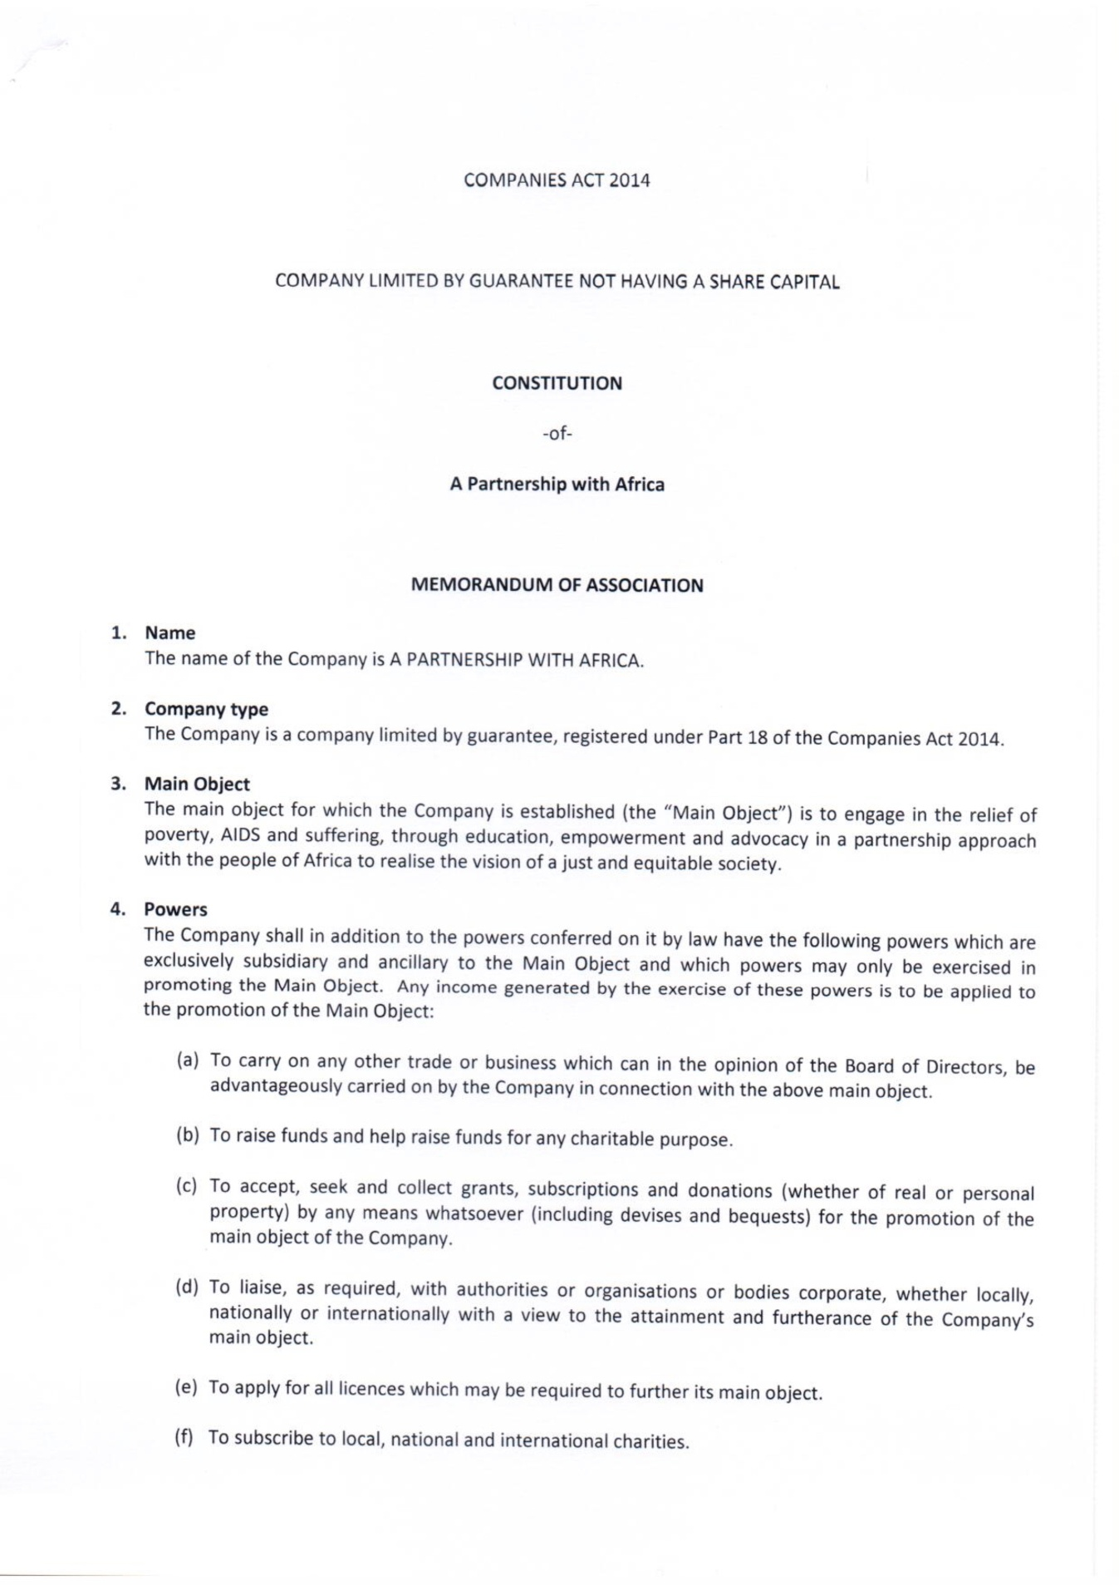
Appendix E: Constitution
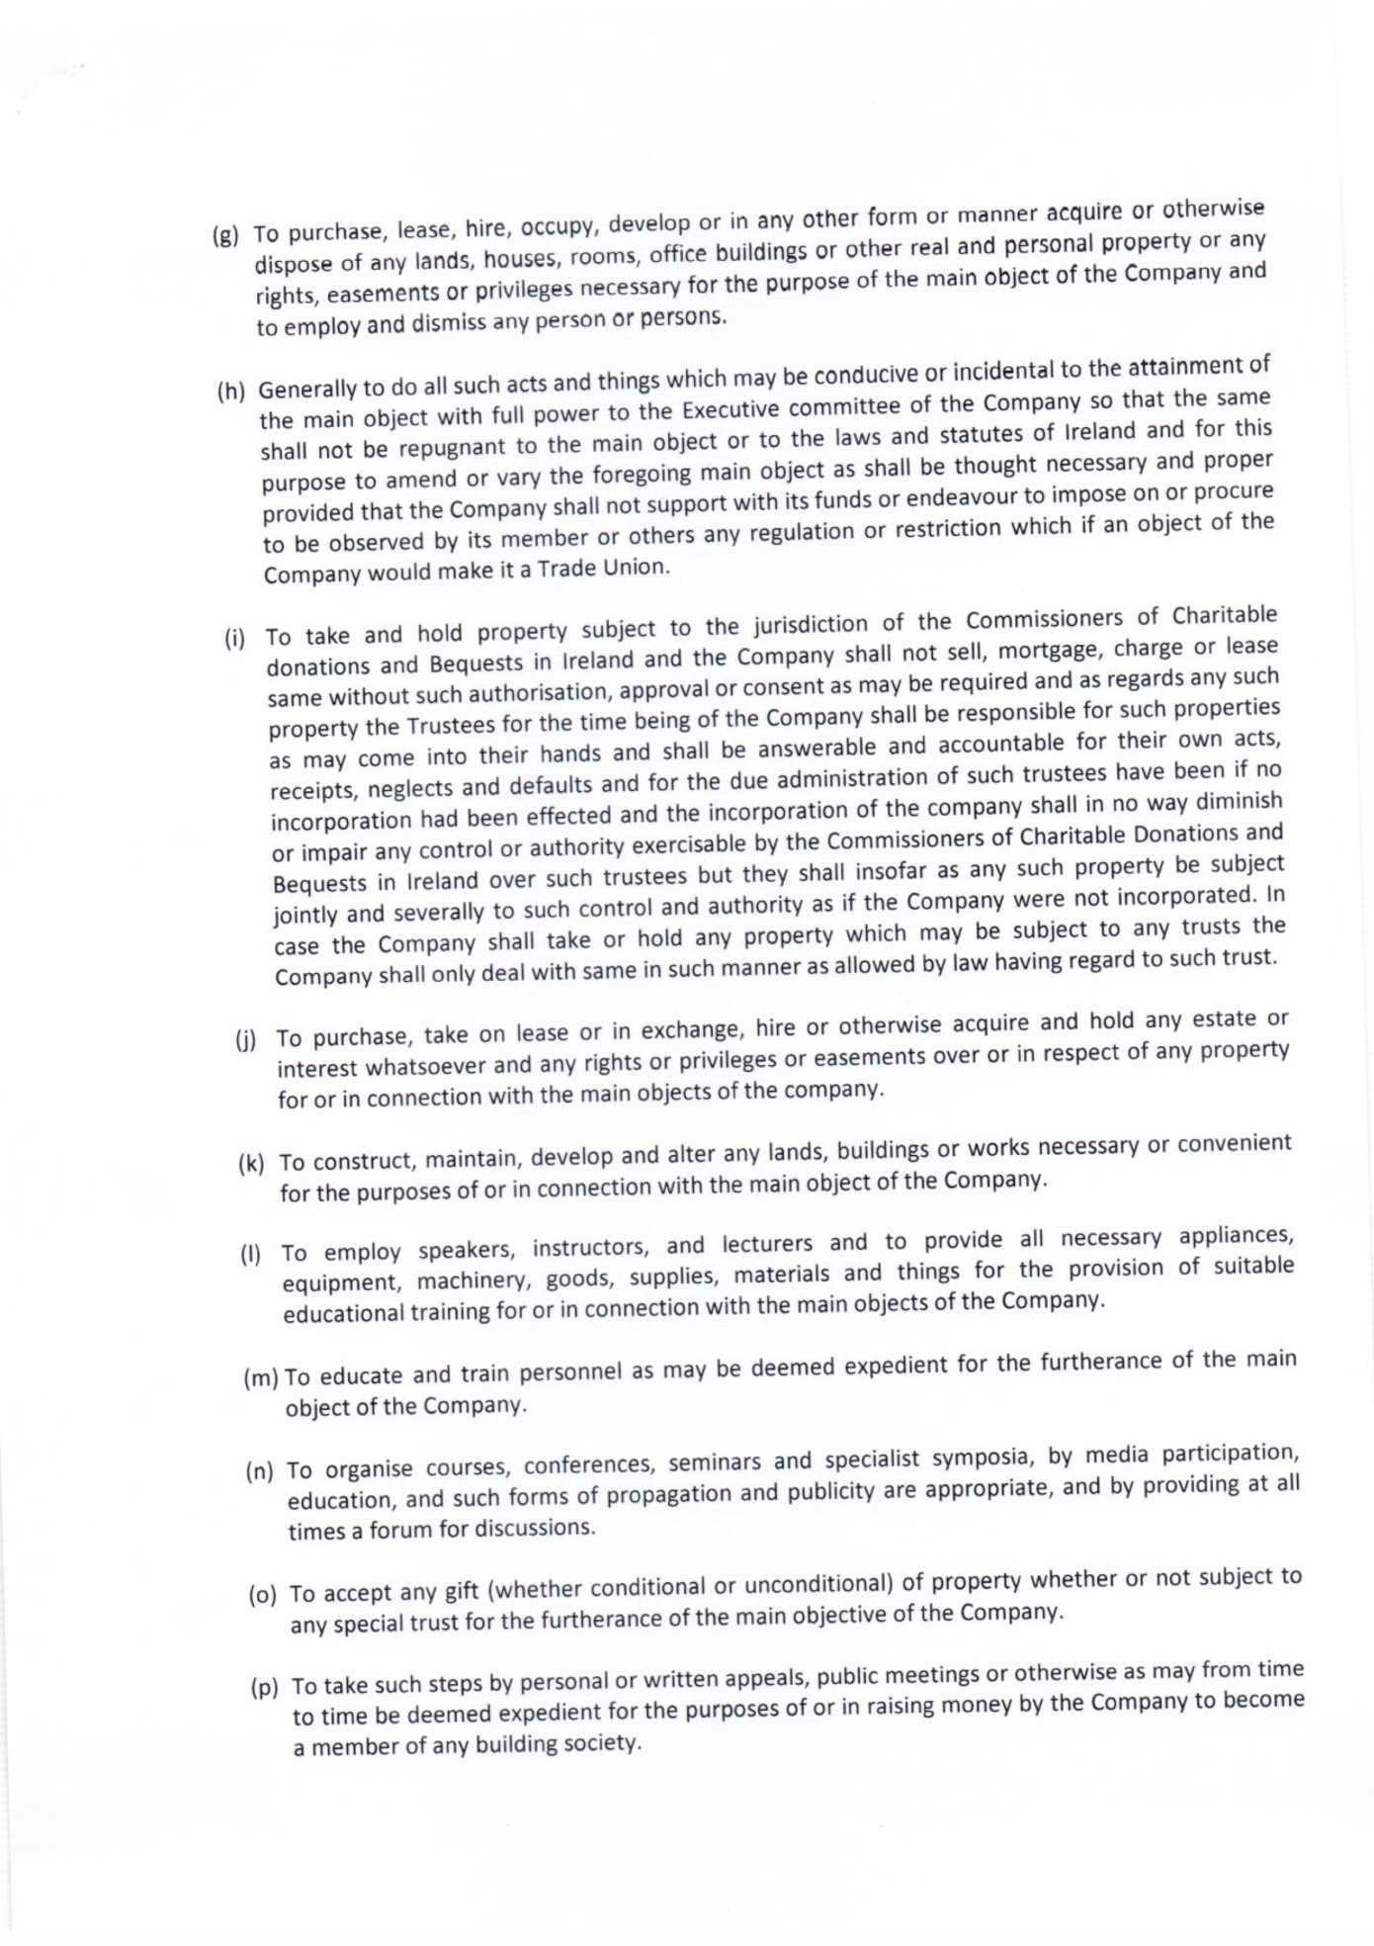
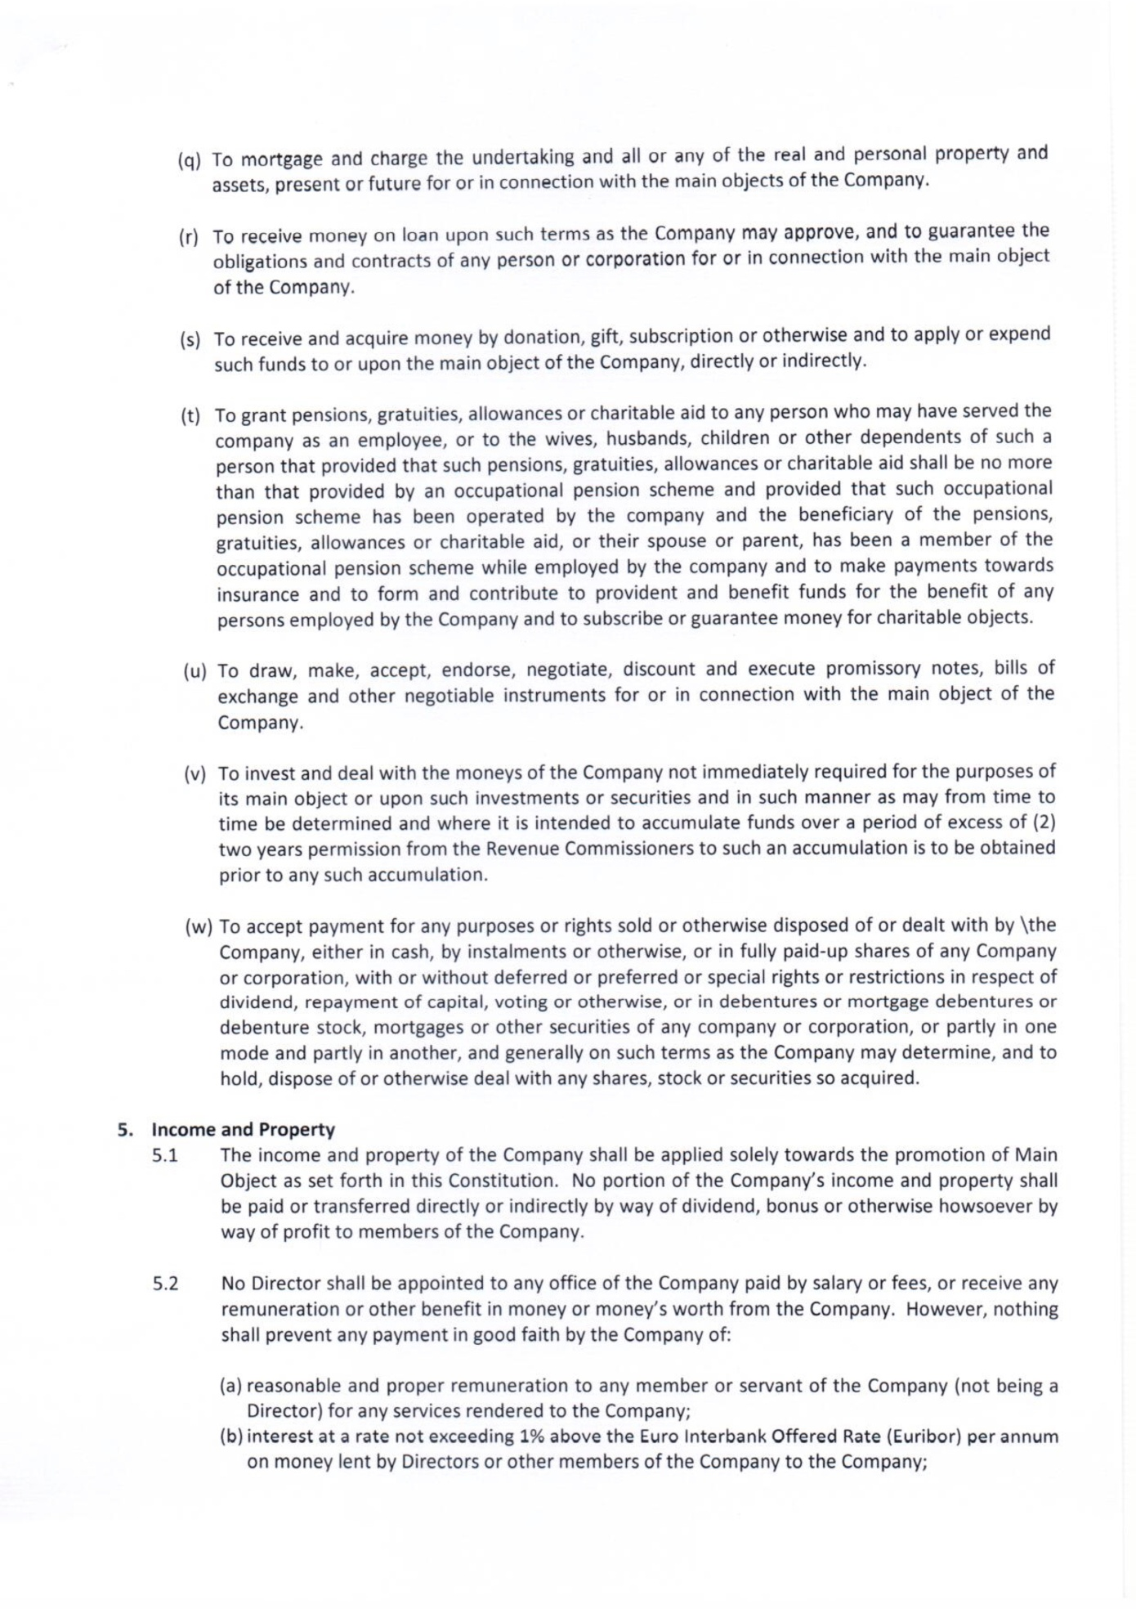
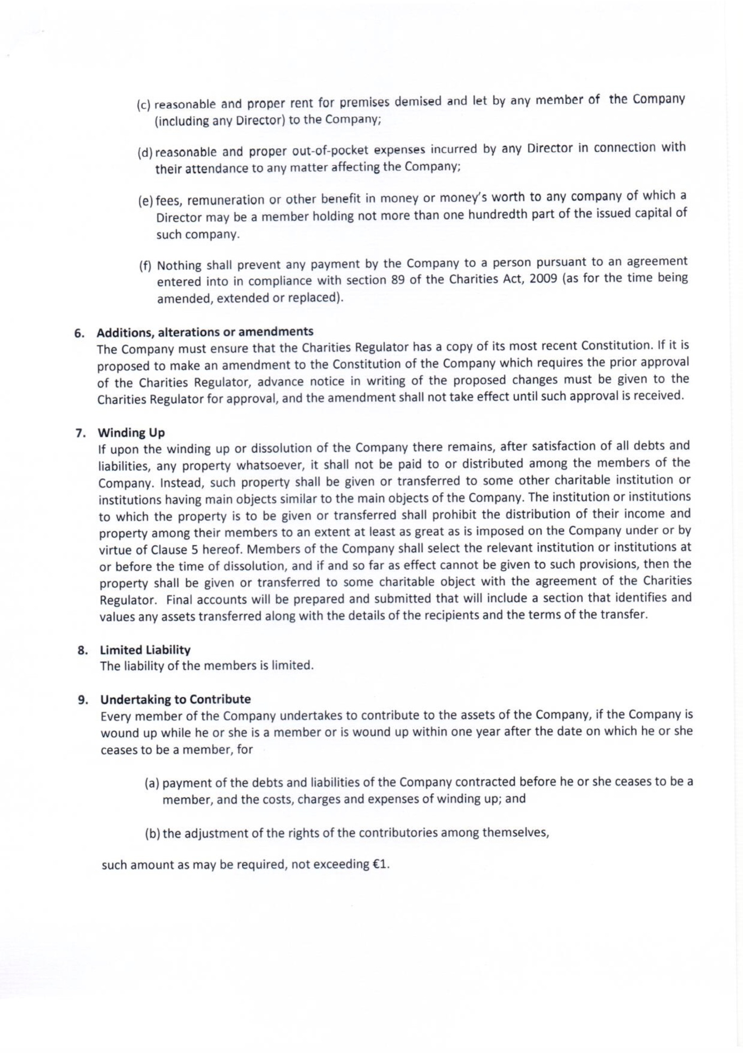
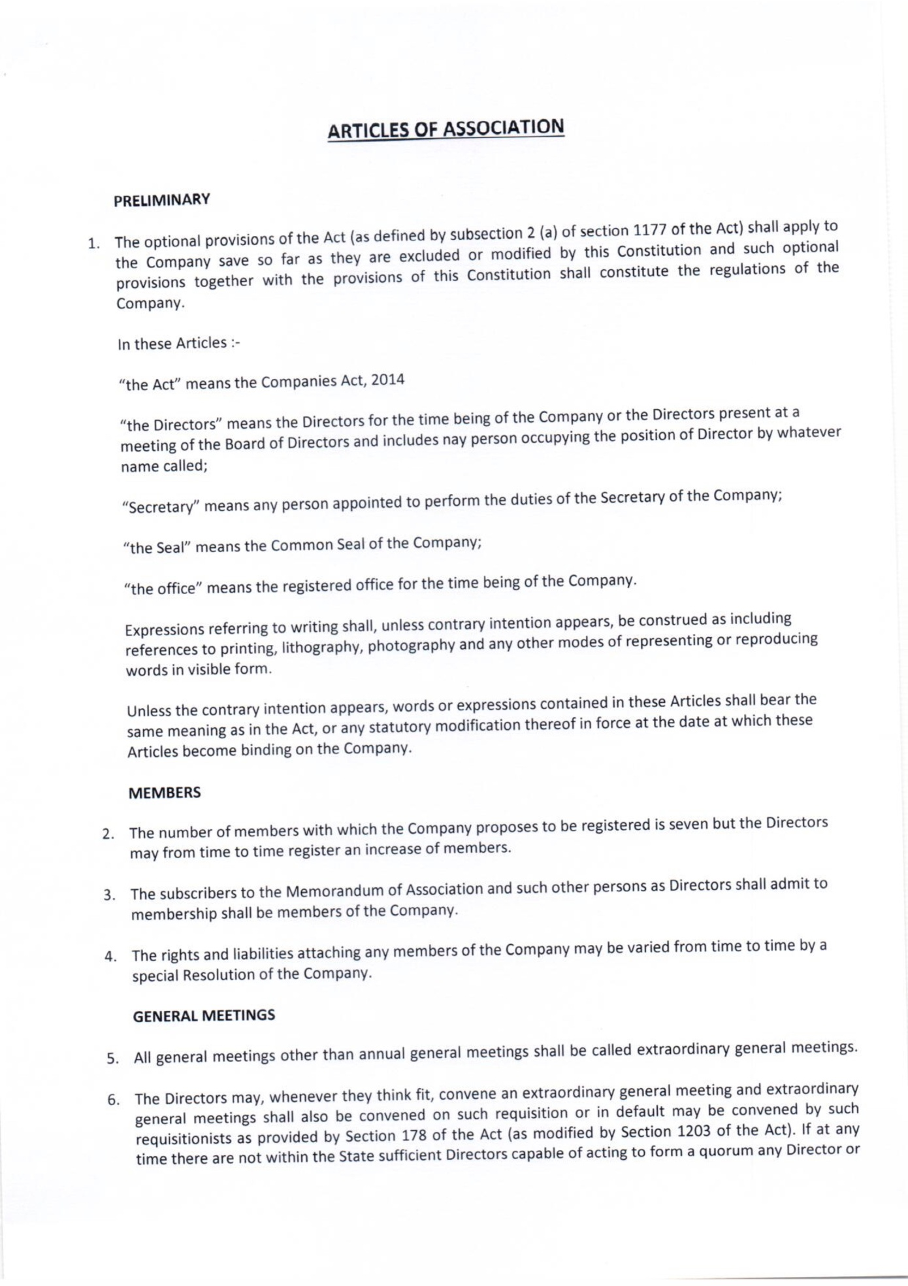
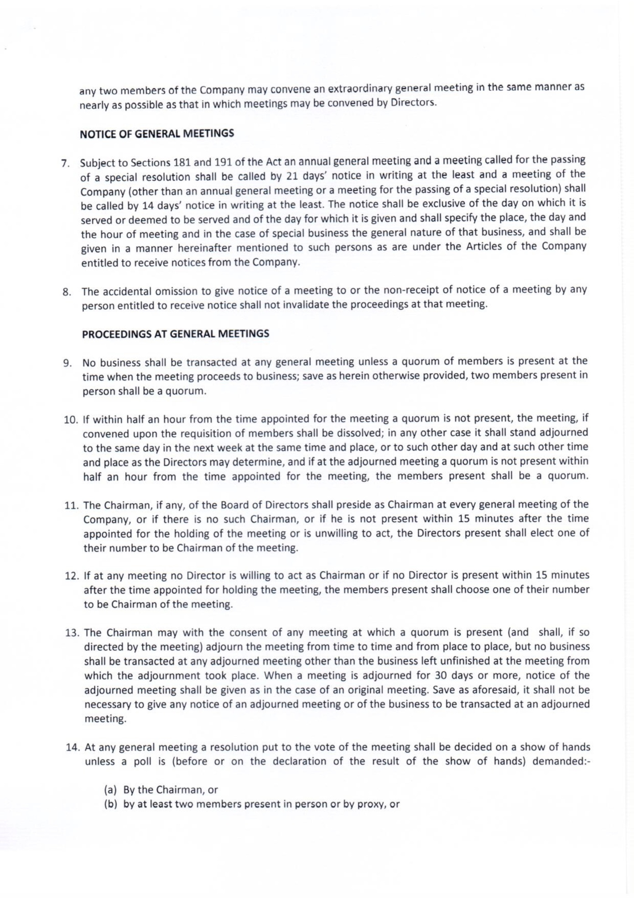
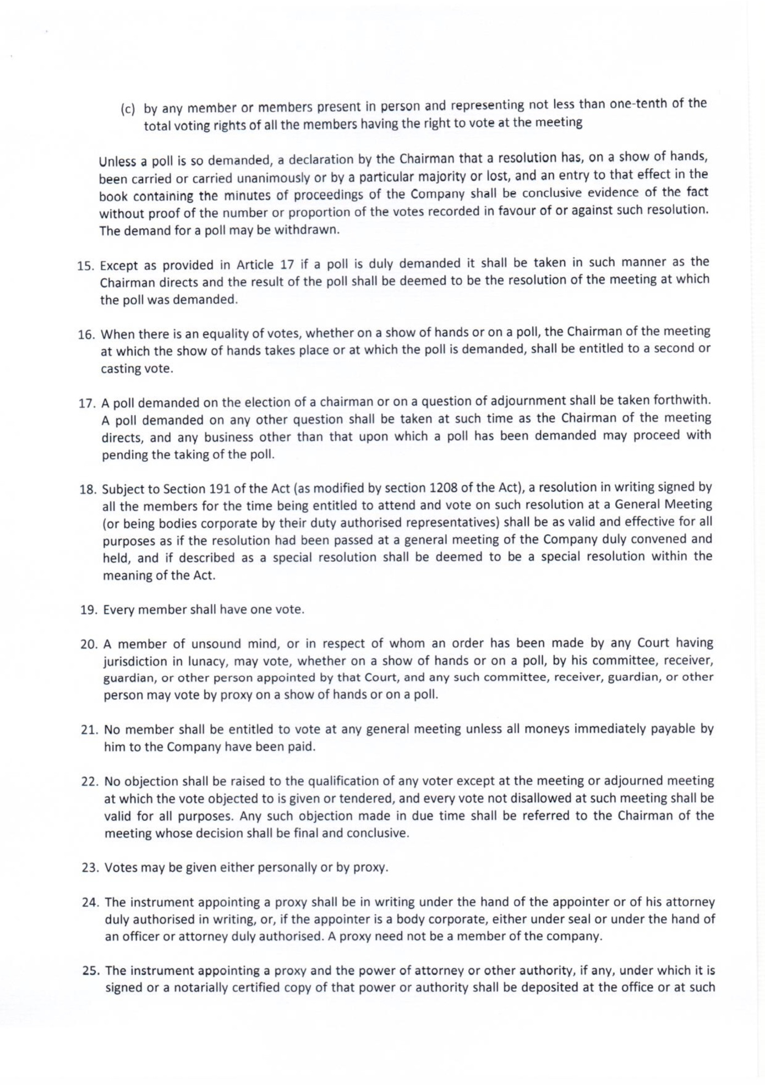
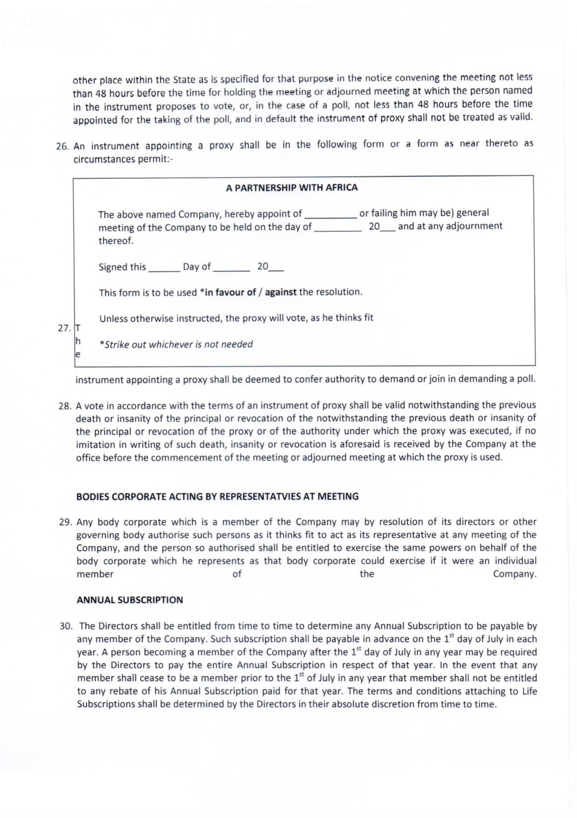
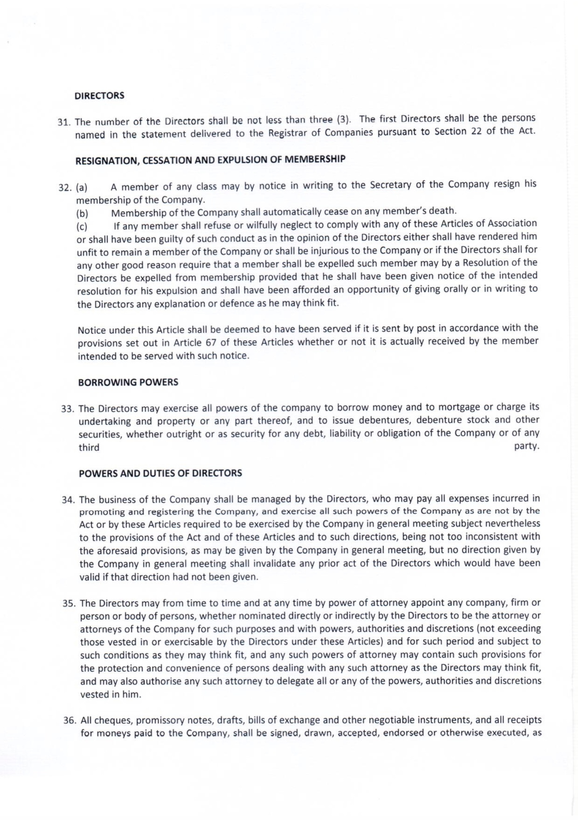
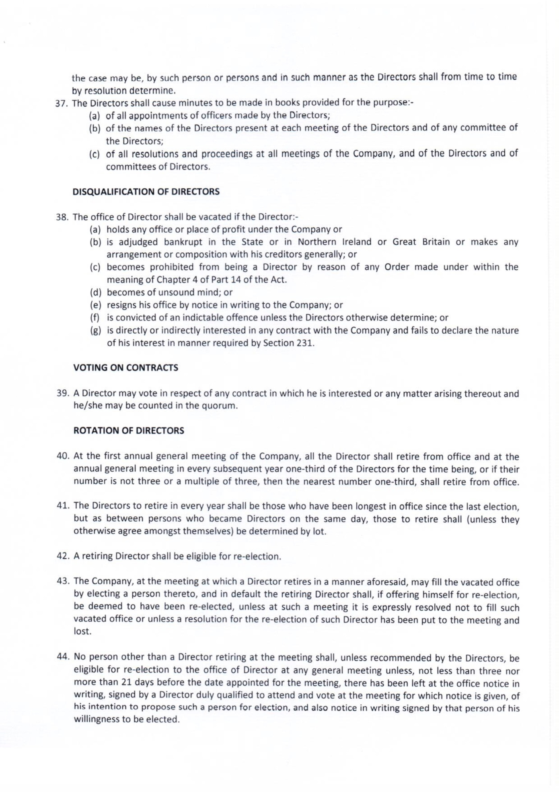
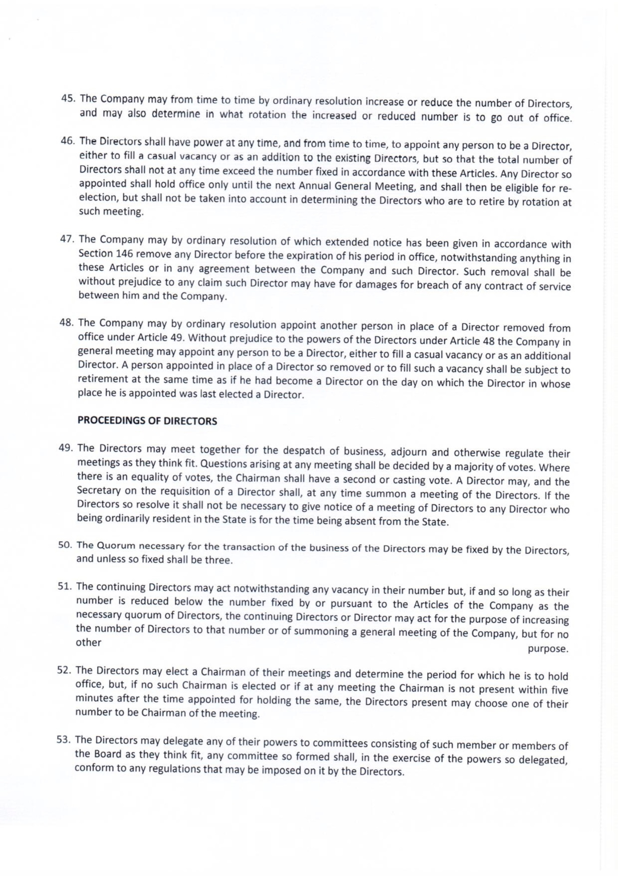
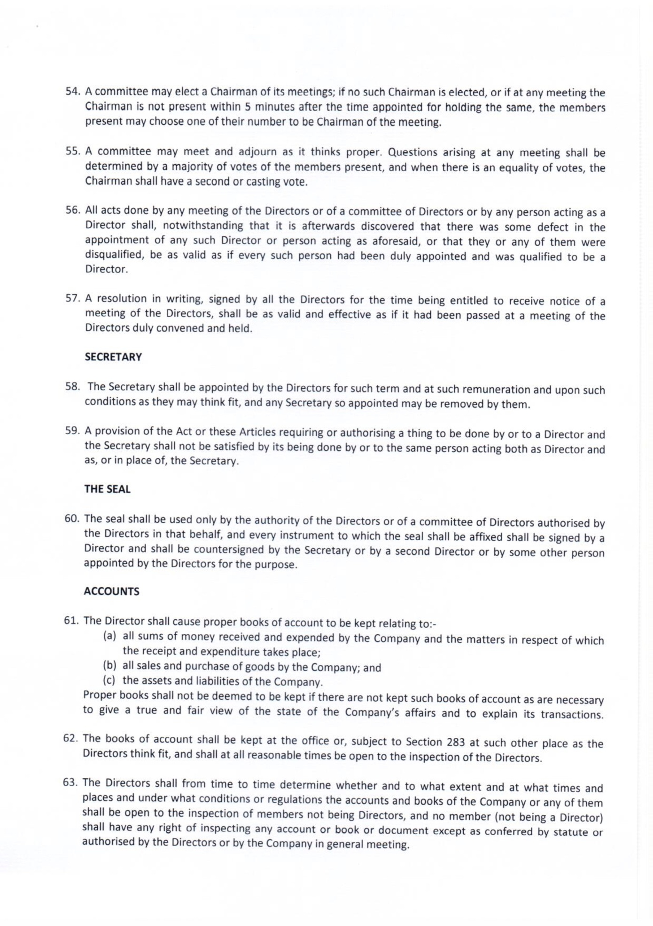
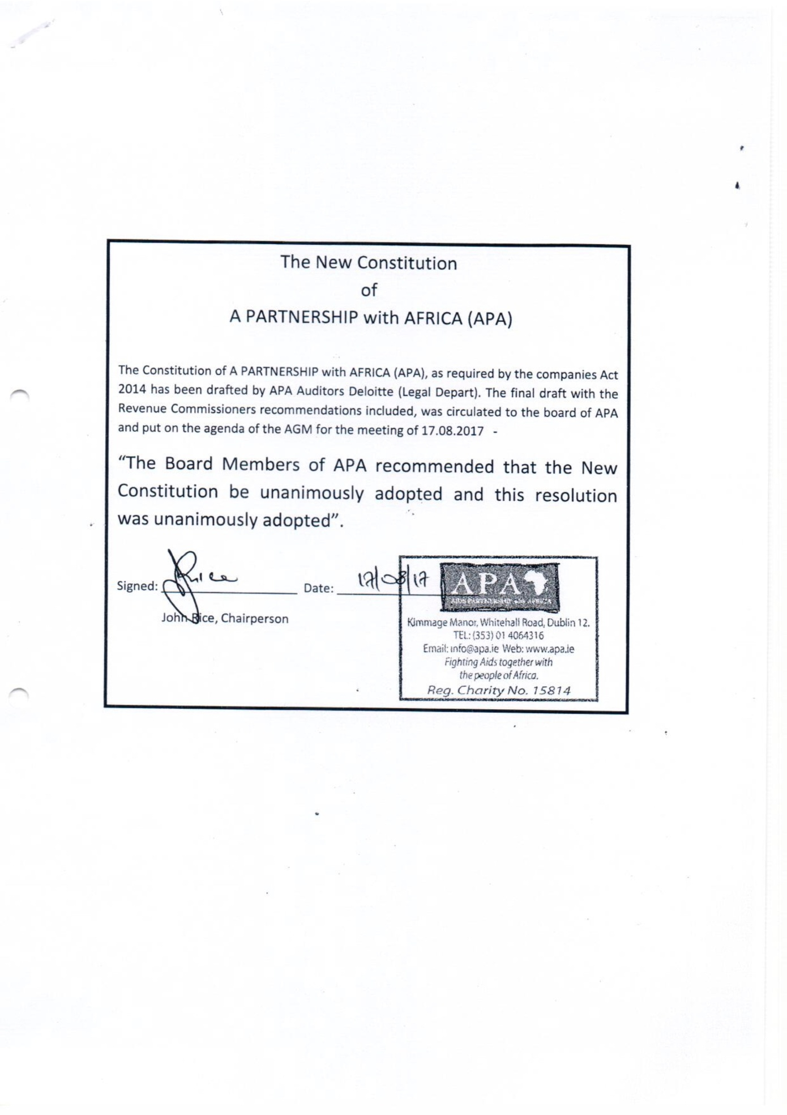
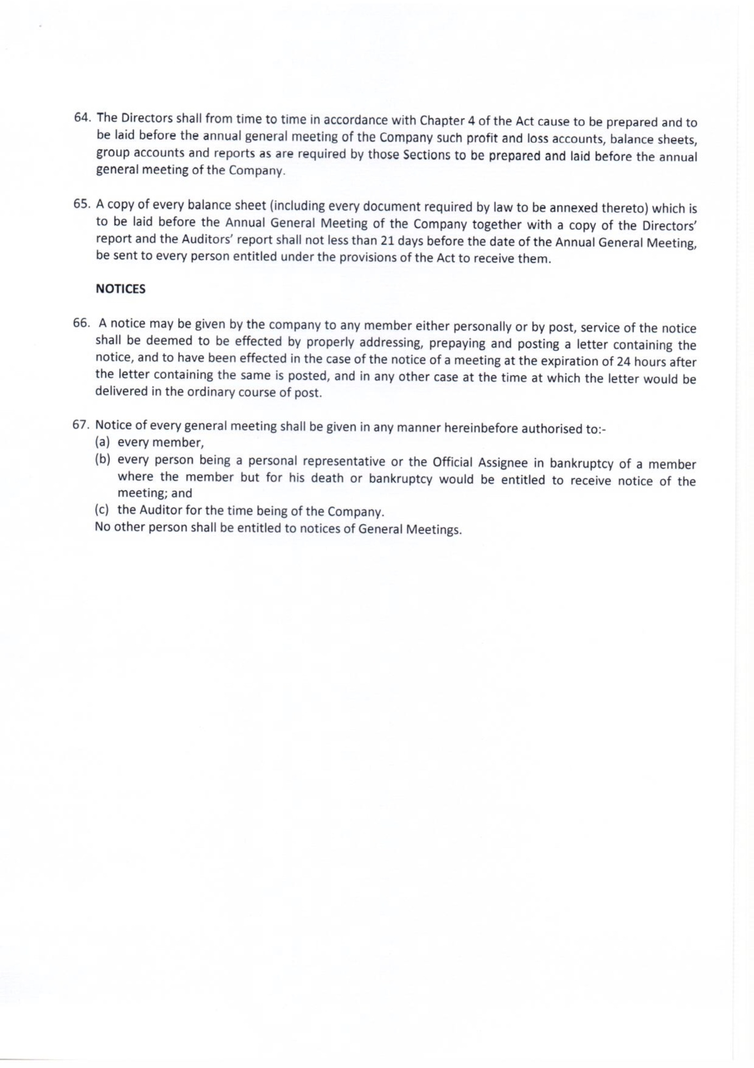
Appendix F: Certificate of Incorporation
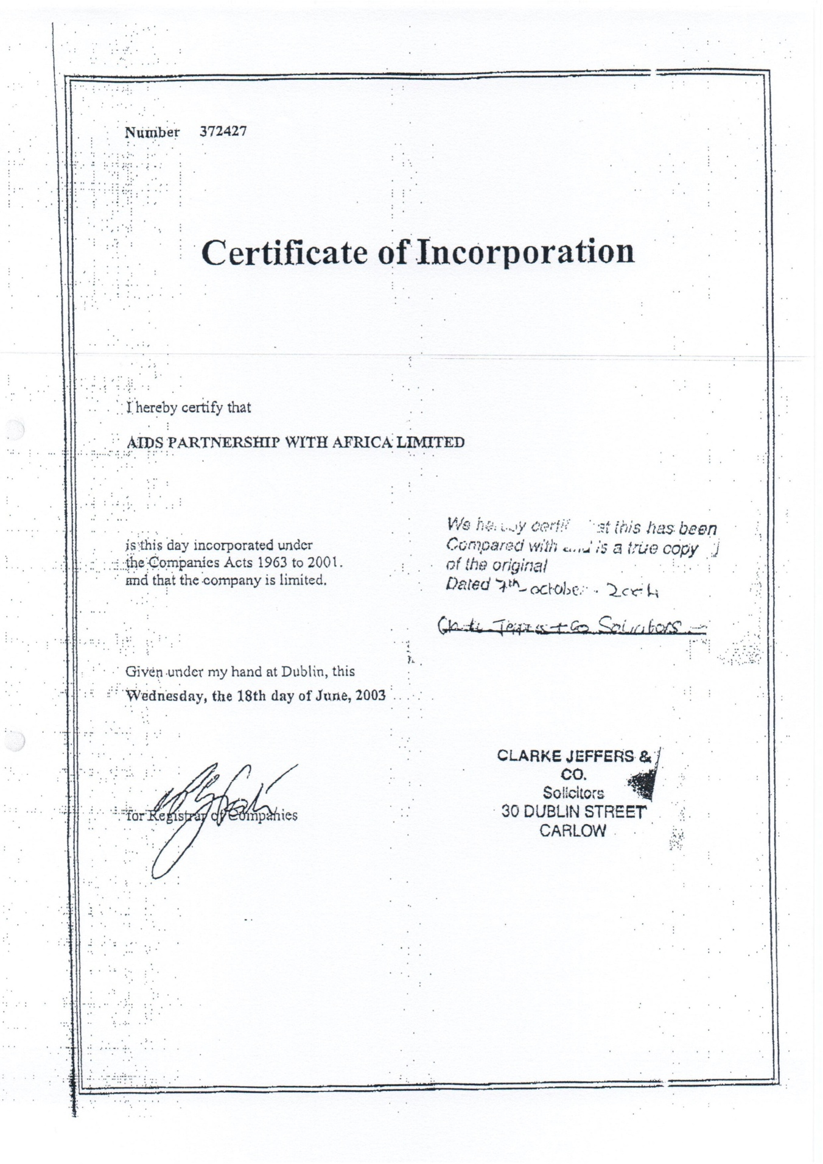

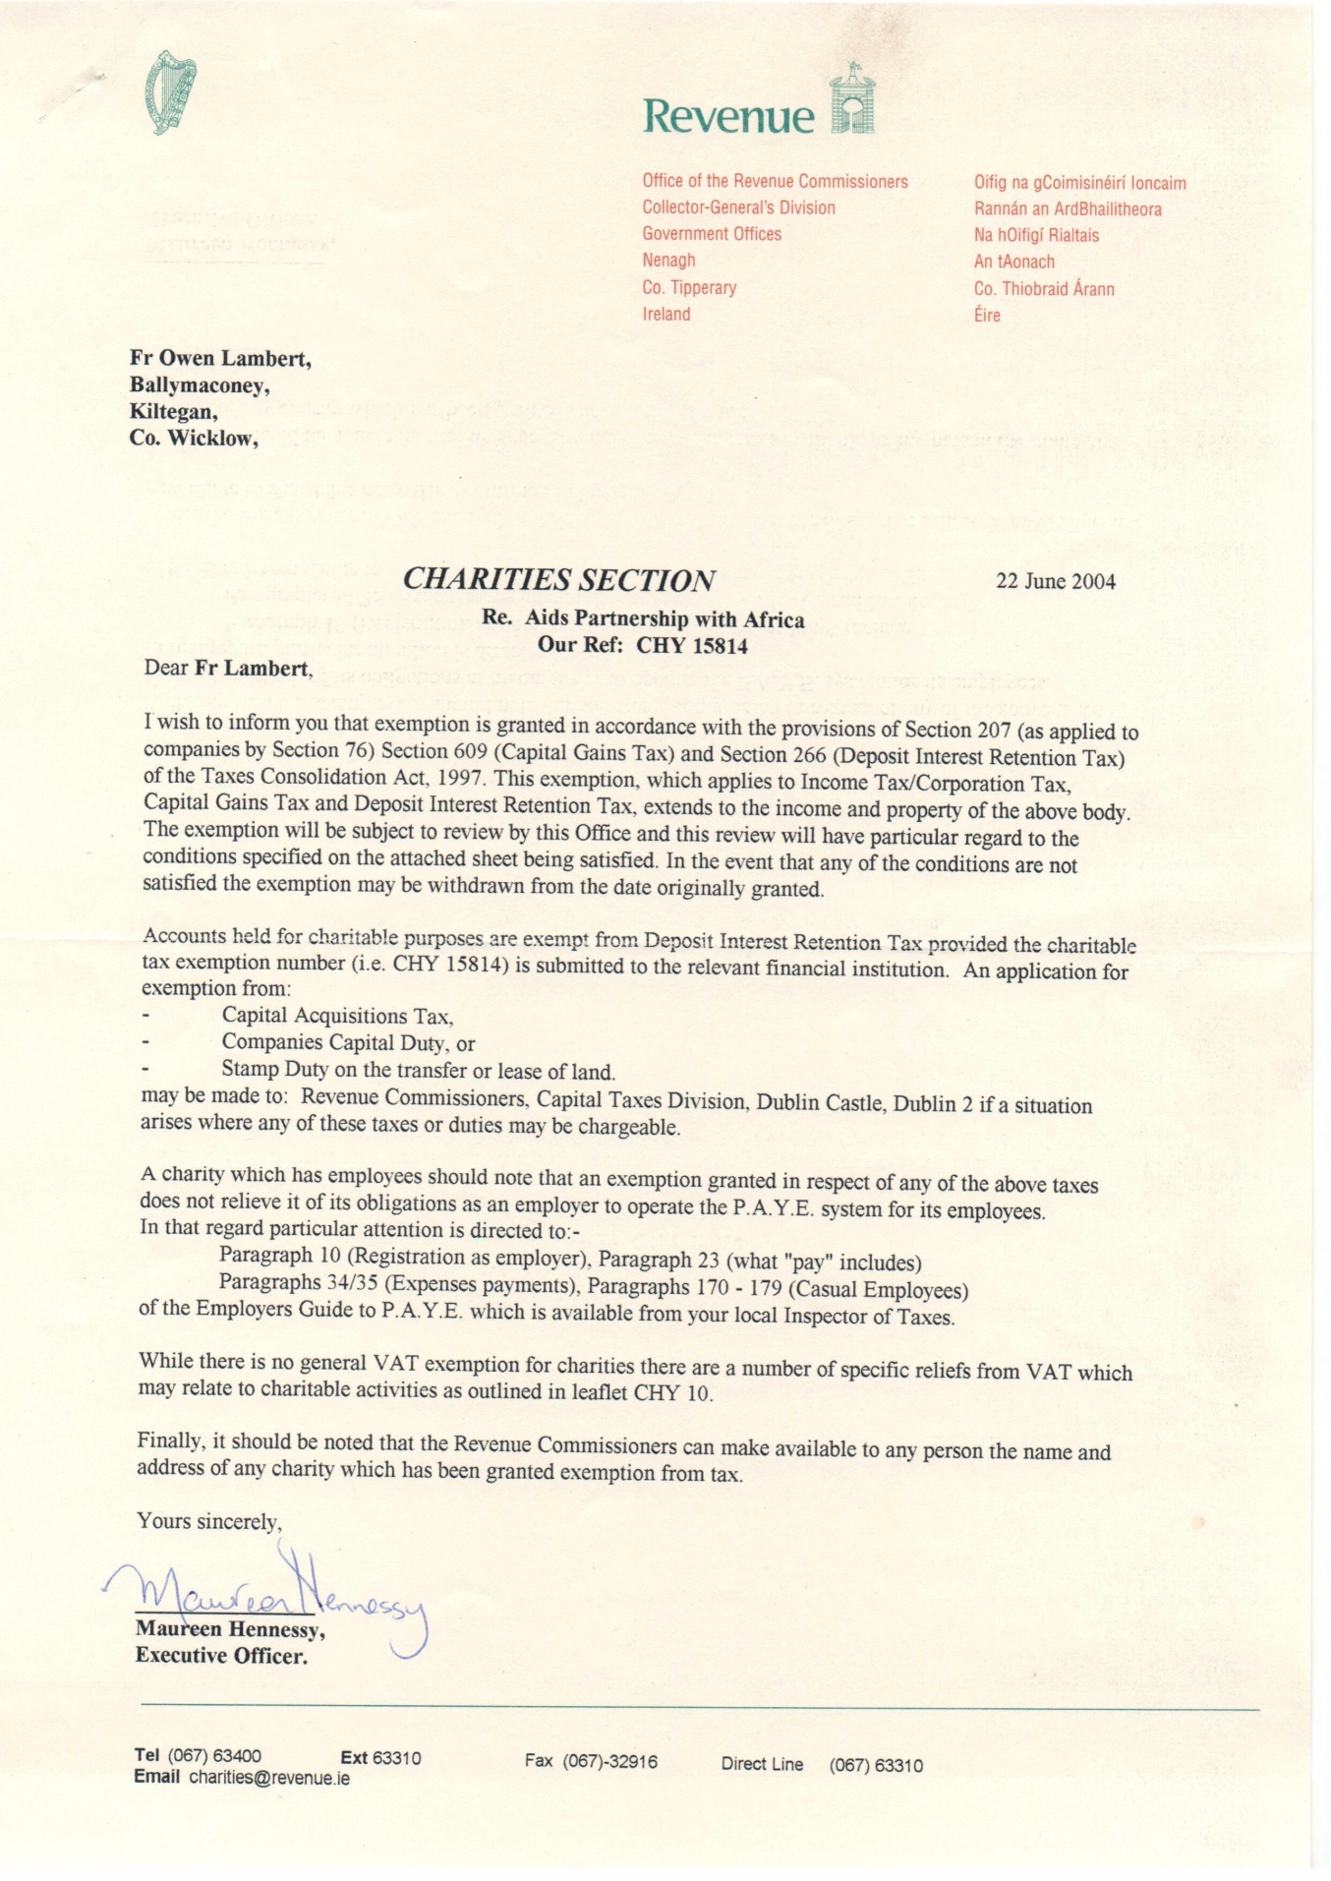
Appendix G: Charity Status
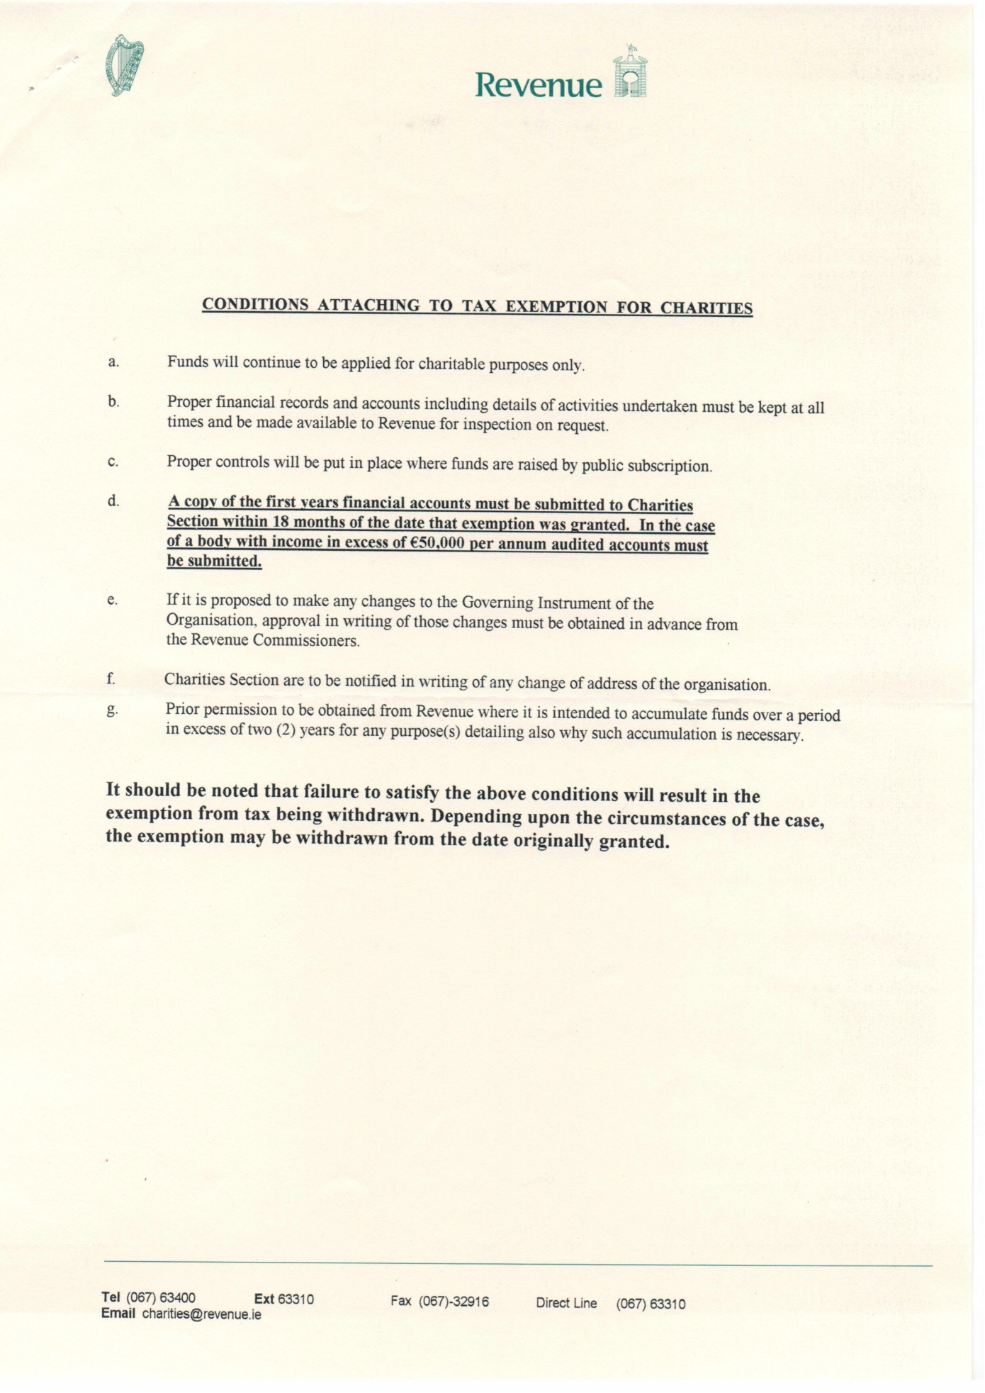
Appendix H: Consortium Agreement

CONSORTIUM AGREEMENT

THIS AGREEMENT is made on the……..day of ……………………20…

BETWEEN

- A PARTNERSHIP WITH AFRICA of Kimmage Manor, Whitehall Road Dublin 12, Ireland (hereinafter called “APA”) (which expression shall include where the context so admits or requires its successors and permitted assigns); and

- COMUNITA VOLONTARI PER IL MONDO of Viale delle Regioni, 6, Porto San Giorgio, (FM) Italy (hereinafter called “CVM”) (which expression shall include where the context so admits or requires its successors and permitted assigns).

- [insert other names and contact information as necessary here]

WHEREAS

- APA and CVM share a history of collaborating on projects in Ethiopia, Tanzania, and elsewhere. The reason behind the decision to join efforts was rooted in the shared missions and values of the two organisations. APA/CVM’s shared goal is to build a fairer world for its inhabitants as global injustice and marginalisation continue to oppress entire populations globally. Their primary objective has been and remains the development of each person and of all people. The collaboration between the two organisations originated with the HIV/AIDS pandemic response and has expanded to include the sectors of development education, minority advocacy, water sanitation, domestic workers’ rights, bar workers’ rights, and more. The recommitment to their partnership emphasises that APA/CVM intend to follow the model of enabling the most at-risk and marginalised groups who have been trapped in cycles of poverty and oppression especially focusing on bar workers, domestic workers, and others who seek recognition of their human rights, respect and acceptance from the local and global community moving forward in their joint efforts. Together, APA and CVM have endeavoured and will continue to ensure the maximum humanitarian response from the public, government and other organisations in Ireland, Italy, the United States, and other countries within and beyond the EU. The parties commit to continue promoting public awareness in Ireland, Italy and elsewhere with respect to sectors within which they operate. This document simultaneously defines and supports APA and CVM’s continued partnership through the alignment of their missions, values and goals as primary partnerships for projects based in Ethiopia and Tanzania.

- On June 18th, 2003 APA was incorporated as a Company Limited by Guarantee and not having a Share Capital. APA was established as a registered charity on 22 June 2004 to “engage in the relief of poverty, suffering, distress, illness and the provision of financial assistance to people suffering from AIDS in Africa”. APA originally supported and worked with the people of specific areas in Africa in their own efforts to cope with and address the consequences of HIV and AIDS.

- CVM was established as a nongovernmental organisation on 4 February 1978 to promote the sustainable, integral development of all human beings. On the 4th February 1982, CVM was officially recognised by the Italian Ministry of Foreign Affairs (Decree 128/0072). Since 1994, CVM has been active in countering the HIV and AIDS pandemic. Throughout 40 years of operation, CVM has sent over 50 volunteers to three African countries and one Asian country where they have served an average term of two years.

- On 7 October 2004 APA and CVM entered into a consortium agreement aimed at maximizing the parties’ input and best utilization of resources in tackling the HIV/AIDS crisis in Africa. The parties agreed to develop projects together, to allocate resources (including funding) to these projects and to search both individually and cooperatively for funding opportunities.

- As a key aspect of their missions, APA and CVM endeavour to avoid the duplication and expenditure of scarce resources to address their areas of focus, including but not limited to: HIV/AIDS, water sanitation, development education, bar workers’ and domestic workers’ empowerment and human rights, minority equalities, migrants and more. APA and CVM prefer to work with and through already existing structures in order to avoid establishing separate and redundant implementing structures. This philosophy is the basis for APA/CVM’s partnership-based approach. Not only do they commit to joining efforts in the aforementioned sectors, but they seek to expand partnerships with existing entities and organisations who already work in these areas in order to combine resources and efforts to affect greater impact. This principle exists not only in Ethiopia and Tanzania, but also extends to partnership with other organisations based in the EU, the USA or otherwise. ‘Partnership’ in this sense includes implementing partners, donors and funding sources, project partners and organisations which may share similar goals and ideologies to APA/CVM and can otherwise contribute to the organisations’ joint missions and values through direct action, awareness building or other forms of support.

- To date, CVM and APA have developed and implemented extensive HIV and AIDS prevention and care projects in Ethiopia, Tanzania mainland and Zanzibar Islands. Based on that success, both APA and CVM have expanded efforts to include support and mobilisation for MARPs (Most At-Risk Populations) such as bar workers, domestic workers, women, and minority groups. APA/CVM promote a people-centred development philosophy, and a multi-sectoral, multi-dimensional approach in the implementation and facilitation of their projects regardless of sector. APA and CVM wish to continue to jointly and independently assess and develop projects on a multi-sectoral and multi-dimensional approach. The projects and approaches could be further expanded and replicated in other countries to include more partners if adequate resources were available.

- As a result of their multi-sectorial, multi-dimensional approach, it is possible that APA or CVM might find opportunities to pursue independent projects and initiatives separate from each other. As both organisations are independent in their own right, this action is acceptable under the terms of the Consortium Agreement. It is important, however that their missions and visions remain aligned and in harmony with this consortium agreement. The consortium agreement indicates their commitment to APA/CVM’s partnership and joint efforts, understanding that their objectives for achieving their shared goal can simultaneously overlap and diverge.

- APA and CVM are committed to supporting individuals and communities to advocate for themselves in order to gain access to services such as water, sanitation, food, education, health, HIV prevention and sustainable energy. They aim to do so together through the following: the application of a multi-sectoral and multi-dimensional methodology; local capacity building and empowerment of peoples; supporting those who are affected to address the HIV and AIDS crisis within the scope of what is achievable through local human/material resources; respect for the cultural values and religious principles of peoples; raising awareness in western society related to extreme poverty and inequality and its consequences; and seeking the maximum partnership and funding response for the implementation of projects globally.

- In pursuance of their commitment to working globally in a spirit of partnership to facilitate equal access to basic services and empowering the most vulnerable citizens of the world to reach their full potential, APA and CVM have agreed to enter into this Consortium Agreement and welcome other partners, as well. Partnership can exist at various levels among both APA and CVM. Potential partners may consider joining into this Consortium Agreement or they may partner for the purpose of a specific project depending on the agreement of all relevant parties and the alignment of shared missions and visions.

- This Agreement secures the partnership and joint efforts of APA and CVM. However, it is acceptable and encouraged for additional parties to join into this Consortium in order to broaden the scope of impact for all parties involved. CVM/APA jointly agree to foster and support partnerships globally in order to expand the reach of their missions.

- This Agreement replaces and supersedes the previous consortium agreement between APA and CVM dated [insert date here].

NOW THIS AGREEMENT WITNESSETH as follows:

- Definitions and Interpretation

In this Agreement unless the context requires otherwise:

  - References to “Agreement” shall, where the context so requires, include this Consortium Agreement as supplemented, amended, modified or varied from time to time.

  - “Project” means a project, programme, initiative or intervention.

  - “Project Agreement” refers to the agreement between APA, CVM, and any other implementing partners with respect to a Project. Project Agreements may be amended by agreement between the parties from time to time or for the needs of a particular project. For the avoidance of doubt, each Project shall have its own Project Agreement.

  - “Project Proposal” means the plan approved by the APA Board and CVM Council which details a Project’s objective(s), financial plan, budget, and the specific roles and obligations of each party with respect to the Project and to each other, including in terms of personnel, monitoring, reporting and evaluation.

  - Any reference to a clause, paragraph or sub-paragraph shall be a reference to a clause, paragraph or sub-paragraph (as the case may be) of this Agreement and any reference in a clause to a paragraph or sub-paragraph shall be a reference to a paragraph or sub-paragraph of the clause or paragraph in which the reference is contained unless it appears from the context that a reference to some other provision is intended.

  - Any reference to the masculine gender shall include reference to the feminine gender. Any reference to the neuter gender shall include the masculine and feminine gender. Any reference to the singular shall include reference to the plural.

  - Words such as “hereunder”, “hereto”, “hereof” and “herein” and other words commencing with “here” shall, unless the context clearly indicates to the contrary, refer to the whole of this Agreement and not to any particular clause or paragraph thereof.

  - The clause headings and captions herein shall not affect the construction of this Agreement.

  - The Appendix forms an integral part of this Agreement and reference to this Agreement includes the Appendix.

- Entire Agreement

  - No modification, alteration or amendment of this Agreement shall be valid or binding unless in writing, approved by the Board of APA and by the Council of CVM and signed by both parties.

  - No officer, employee, agent or representative of either party has any authority to make any representation or promise not contained in this Agreement, and each party acknowledges that it has not executed this Agreement in reliance upon any promise or representation not expressly set forth in this Agreement.

- Images and Media

  - During the course of joint projects, all images and media attained in the field must follow the relevant Data Protection and Privacy Policies of both APA/CVM in accordance with the EU’s 2018 GDPR standards.

  - All media and images acquired for the purpose of joint projects should be made available to both organisations with the inclusion of appropriate consent forms (when necessary).

- Awareness Building

  - CVM and APA agree to jointly undertake, as may be possible for each party, campaigns in their respective countries to raise awareness of the issues of extreme poverty and inequality, gender-based violence and the risks of HIV transmission in Africa. CVM and APA agree to compile and share materials, expertise and resources for their respective awareness campaigns. Opportunities may be created by each party for the sharing of existing experiences on awareness education to facilitate the reciprocal development of these campaigns.

  - CVM and APA may actively search for partners, within and outside of their respective countries, to stimulate a wider reflection and the mounting of initiatives and responses towards the resolution global poverty, injustice and human rights.

  - CVM and APA shall facilitate the working together of people in Africa, including but not limited to Ethiopia and Tanzania, and between Africa and Europe, including but not limited to Italy and Ireland, in building awareness and response to global injustice.

  - APA and CVM may coordinate and arrange exposure visits to the Projects on which they collaborate for their Board and Council members, supporters, volunteers and interested groups (collectively referred to as “Visitors”). Each party shall be responsible for the payment of the costs of their respective Visitors on exposure visits. Induction training will be provided before any such visit.

- Funding

  - APA and CVM may independently search for and apply for funding in Ireland, Italy and elsewhere.

  - APA and CVM may jointly search and apply for funding in Ireland, Italy and elsewhere.

  - The sourcing and allocation of funding to each Project on which the parties collaborate, and APA’s and CVM’s respective roles and responsibilities with regard to said funds, shall be set out in the Project Plan approved by APA and CVM for the respective Project.

  - In order to avoid ambiguity with respect to the funding of each Project, the parties may provide partial or total funding from their own resources and/or secure partial or total funding from elsewhere.

- Financial Policies and Procedures

  - On an annual basis within 6 months of the end of the financial year, APA and CVM shall prepare together an overall plan of action (“POA”) and a budget of three years projection together with a detailed annual breakdown for presentation to their respective Board and Council for consideration and approval.

  - CVM and APA shall each arrange for preparation of an annual audited financial report of their respective organisations. Each party shall forward one copy or an approved certificate representing its annual audited financial report to the other party within thirty (30) business days of the report’s finalisation.

  - APA and CVM shall ensure that sufficient time is devoted by their respective management to financial analysis. The parties shall use the results of the financial analysis to improve financial management and control of Projects and activities on which they collaborate.

  - APA and CVM shall each develop a financial procedures manual which shall set out the financial procedures of their respective organisations. The financial procedures shall reflect the size and growth potential of the respective organisations and shall include a reserves policy, procurement policy, payment procedures and authorization limits.

- Meetings between CVM and APA

  - CVM and APA shall meet together twice per year, unless otherwise agreed, at a mutually agreed location in Europe or by conference call for annual and three-year planning, reporting and review of all activities on which they collaborate. At least two Board members from APA and at least two Council members from CVM, unless otherwise agreed, shall be present at meetings between CVM and APA.

- Projects

  - Roles and responsibilities for APA/CVM pertaining to each project are designated in the corresponding Project Agreement. Typically, APA has focused on networking for partners, fundraising, research, monitoring and evaluation while CVM has provided project management and executed implementation. It is acceptable for the organisations to maintain this model in future activities or to adapt it based on the project’s needs so long as the roles and responsibilities for a given project are detailed in the Project Agreement. It is expected that both APA and CVM will use their networks and strengths throughout all levels and processes of the Project in order to ensure the most positive execution of the Project’s goals and objectives.

  - APA and CVM shall continue each Project that they currently implement until each Project’s respective completion date.

  - APA and CVM shall continue to jointly assess and develop new Projects, based on the multi-sectoral approach, and this may involve multi-dimensional activities.

  - Each proposal for a new Project (the “Project Proposal”) which is over €15,000 Euro shall be prepared by the APA project team and/or CVM project team and shall be submitted to the APA Board and the CVM Council for approval. Each Project Proposal shall detail the respective Project’s objective(s), financial plan, and budget. Each Project Proposal shall also outline the specific roles and obligations of each party with respect to the Project and to each other, including in terms of personnel, monitoring, reporting and evaluation.

  - Project Proposals which are under €15,000 can be approved by APA/CVM management and reported to the IAFRC and Board Meetings.

  - The APA Board and/or CVM Council may consult with the APA project team and/or CVM project team to discuss the Project Proposal. The APA Board and/or CVM Council may request amendments to the Project Proposal. Following this consultation, the APA project team and/or CVM project team may submit a revised Project Proposal to the APA Board and/or the CVM Council for approval.

  - Reasons for rejection of a Project Proposal by the APA Board and/or the CVM Council may include without limitation the cost/value of the Project and/or the ability of either or both parties to secure the funds required.

  - The obligations and roles of APA and CVM with respect to each new Project upon which they agree to collaborate shall be set out in an agreement specific to each Project (the “Project Agreement”).

  - A Project Proposal which has been agreed and approved by the APA Board and CVM Council (with or without amendment(s)) shall be referred to as the “Project Proposal” and shall be attached as an Appendix to the APA-CVM Project Agreement for that Project.

  - APA and CVM shall develop and agree to general guidelines for monitoring (including field monitoring), reporting and evaluating all Projects on which they collaborate and they should follow the terms as dictated by the donor source. These guidelines, once agreed, shall be referred to as the “MRE Terms of Reference” and may be reviewed and updated periodically by agreement between the parties. The MRE Terms of Reference shall be attached as an Appendix to the Project Agreement for each Project. The parties’ roles and obligations set out in the Project Plan with respect to monitoring, reporting and evaluation of the proposed Project shall be in accordance with the MRE (Monitoring, Reporting & Evaluation) Terms of Reference.

  - APA and CVM shall develop and agree upon general guidelines for financial reporting for Projects on which they collaborate. These guidelines, once agreed, shall be referred to as “Guidelines for Financial Reports” and may be reviewed and updated periodically by agreement between the parties. The Guidelines for Financial Reports shall be attached as an Appendix to the APA-CVM Project Agreement for each Project. The parties’ roles and obligations set out in the Project Plan with respect to financial reporting shall be in accordance with the Guidelines for Financial Reports.

  - APA and CVM shall allocate resources (including funds) for each Project according to their respective roles and obligations set out in the Project Plan.

  - The following will be taken into consideration when APA and CVM apply to a third party for funding:
a) If the third party is Irish, then APA shall be responsible for liaising with the third party.
b) If the third party is Italian, then CVM shall be responsible for liaising with the third party.
c) Where the third party is neither Irish nor Italian, APA and CVM shall agree on a case by case basis which of them shall liaise with the third party, which will be noted in the Project Agreement.

  - Where a new Project is funded in whole or in part by a third party, the agreement signed between APA, CVM and the third party shall jointly create and sign the Project Agreement.

- Conflict of Interest

  - APA and CVM shall develop and agree upon a conflict of interest policy which shall be attached to the Consortium Agreement and each Project Agreement as an Appendix.

  - The Conflict of Interest Policy and Declaration of Interests Form may be reviewed and updated periodically by agreement between the parties and their respective Boards.

- Fraud Policy

  - APA and CVM shall develop and agree to a fraud policy which shall be attached as an Appendix to the Consortium Agreement as well as each Project Agreement.
  - The Fraud Policy shall include provisions covering the assignment of responsibility for the prevention, detection, investigation and reporting of fraud.
  - The Fraud Policy may be reviewed and updated periodically by agreement between the parties.

- Limitation of Liability

  - Save the consideration of provisions according to Clause 10.2, neither party shall be liable to the other party in respect of any claims, damages, costs, expenses, losses or liabilities whatsoever that the other party may suffer or incur as a consequence of the performance, non-performance or termination of its functions under this Agreement or for loss of any contract or for any indirect or consequential loss or damage which may be suffered by the other party.

  - This Clause shall not limit a party’s liability in any case of fraud, deliberate default or reckless misconduct by that party.

- Notice

  - Any notice given pursuant to this Agreement shall be in writing and shall be deemed to have been duly served if hand delivered or sent by fax or by pre-paid registered or recorded delivery post correctly addressed to the relevant party's address as specified at the Head of this Agreement or at such other address as either party may hereafter designate from time to time in accordance with this Clause 11 and any notice so given shall be deemed to have been served:

    - if hand delivered, at the time of delivery;

    - if sent by fax, when transmitted;

    - if sent by prepaid post, after forty-eight (48) hours of posting (exclusive of hours of Sunday) if posted to an address within the country of posting and seven (7) days of posting if posted to an address outside the country of posting.

  - Any notice or other communication given or made, or deemed to have been given or made, outside of Business Hours will be deemed not to have been made until the start of the next period of Business Hours. For the purpose of this Clause 11.2 “Business Hours” means 9am to 5pm on a Business Day and “Business Day” means a day when banks are open for normal business in Dublin (in respect of a notice or communication served to an address in Ireland) or in Rome (in respect of a notice or communication served to an address in Italy).

- Severability

  - Each of the provisions of this Agreement is severable and distinct from the others, and if at any time one or more of such provisions is or becomes invalid, illegal or unenforceable, the validity, legality or enforceability of the remaining provisions hereof shall not in any way be affected or impaired thereby save where such invalidity, illegality or unenforceability makes it impossible to conform with the affected remaining clauses.

- Duration

  - Subject to Clause 15 (Dispute Resolution) and Clause 16 (Termination) the duration of this Agreement is open-ended and may be reviewed and/or revised on the request of either party.

- Dispute Resolution

  - The parties shall use reasonable endeavours to resolve any dispute or difference arising under or in connection with this Agreement (the “Dispute”) without delay.

  - If the Dispute between the parties is not resolved within fourteen (14) days after it arises, the parties shall, if required by either party, refer such Dispute to their respective Board of Directors/Council for open and cordial resolution. If the Boards of Directors are unable to resolve the Dispute within twenty-five (25) days, or within a timeframe as otherwise agreed, the parties shall refer the Dispute to their respective Presidents/Chairpersons for resolution. If the Presidents/Chairpersons are unable to resolve the Dispute within another twenty-five (25) days, or within a timeframe as otherwise agreed, either party may terminate this Agreement in accordance with the provisions herein.

[APA/CVM: Board /Council will decide if they wish to build in provision for a third-party mediator]

- Termination

  - This Agreement shall be terminated when one of the parties provides written notice of termination to the other party.

  - Without prejudice to the generality of this Clause, the parties shall fulfil their commitments to each Project on which they have agreed to collaborate as provided in the respective APA-CVM Project Agreement.

- Variations

  - This Agreement may not be amended except by the written agreement of the duly authorised representatives of the parties. Any purported amendment to this Agreement which does not satisfy the terms of this Clause 17 shall be of no effect.

  - Without limitation to the generality of the foregoing, APA and CVM acknowledge and agree that they may wish to join one or more third parties to this Agreement from time to time. Where APA and CVM agree to join a third party they shall together agree such amendments to this Agreement as may be necessary to give effect to such change.

- Governing law and language

  - This Agreement shall be governed by the laws of Ireland.

  - The language of this Agreement is the English language, which shall be the ruling language through which the Agreement shall be construed and interpreted.

- Jurisdiction

  - The parties agree to submit to the exclusive jurisdiction of the courts of Ireland as regards any claim or matter arising out of this Agreement.

IN WITNESS whereof this Agreement is duly executed the day and year first hereinbefore written:

A PARTNERSHIP WITH AFRICA |  | COMUNITA’ VOLONTARI PER IL MONDO
__________________________________  Board Chairperson /Director] |  | __________________________________  Board Chairman
__________________________________  Director/Company Secretary |  | __________________________________  Director/[Council Member]
_________________________________  Witness |  | ________________________________  Witness

____________________________
Date

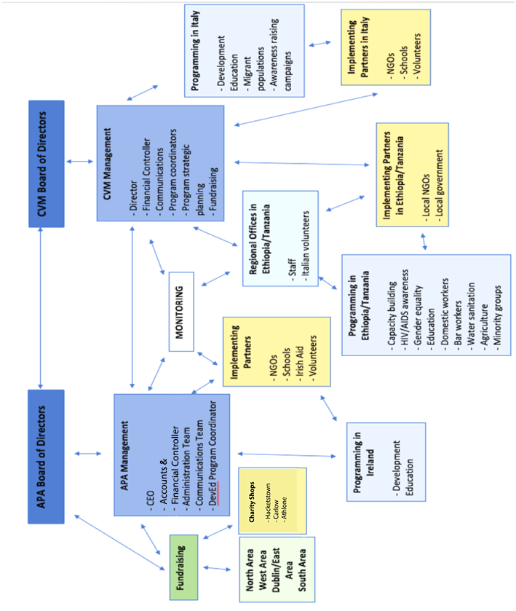
Appendix J: Board Meeting Evaluation Sheet
This form should be completed at the end of every Board Meeting and submitted to the company secretary.

Name of Organisation: _________________________________
Meeting Date: _________________________________

Part 1: Please rate each category on a scale of 1 – 5.
(1=strongly disagree, 2=disagree, 3=neither disagree nor agree, 4=agree, 5=strongly agree)
1. The broad focus of the meeting was very strategic. | 1 2 3 4 5
2. The meeting structure allowed for full participation. | 1 2 3 4 5
3. The materials provided arrived in a timely manner for my review. | 1 2 3 4 5
4. The materials provided were informative. | 1 2 3 4 5
5. The meeting’s discussion was focused. | 1 2 3 4 5
6. The issues addressed in the meeting were focused. | 1 2 3 4 5
7. The time given to each agenda item was adequate. | 1 2 3 4 5

Part 2: Please provide short responses for each of the following questions.

1. What was most helpful to you at this board meeting?

2. What was least helpful for you at this board meeting?

3. What are your expectations for the next meeting?

4. Other comments:

A Partnership with Africa

Partners in development with the people of Africa

Staff Policy
Manual

Updated: October 07, 2025
Address: Kimmage Manor, Whitehall Rd, Dublin D12 P5YP, Ireland
Email: info@apa.ie
Tel: (353.01) 406 4316
Website: www.apa.ie
Company No.: 372427
Charity No.: CHY 15814
CRA No: 20055547

Table of Contents

CHAPTER 1: Staff Procedures 68
1. Staff Selection and Employment 69
2. Leave 73
3. Staff Appraisal 74
4. Health and Safety 77

CHAPTER 2: General Staff policies 80
Child Protection 81
Safeguarding Vulnerable Adults 93
Gender 105
Conflict of Interest and Loyalty 108
Data Protection 109
Social Media 113
Volunteer 115

CHAPTER 3: Financial policies 120
Fraud 121
Risk Management 126
Fundraising 128
Reserve 135

Appendices 138
Appendix A: Travel Expenses Claim Form 138
Appendix B: CEO and Deputy Evaluation Template 139
Appendix C: Child Protection Referral Form 140
Appendix D: APA/CVM Code of Conduct 143
Appendix E: Vulnerable Adults Standard Referral Form 145
Appendix F: Volunteer Application Form 147
Appendix G: Volunteer Contract 149
Appendix H: Volunteer Induction Checklist 151
Appendix I: CII Fundraising Compliance Checklist 152
Appendix J: Written Statement of Agreement 158

Vision, Mission, and Values

Vision
APA’s vision is of a just world where all people are equally empowered to realise their full potential; where all will have universal access to basic services such as food, shelter, education and health.
Mission
APA’s mission is to work globally in a spirit of partnership with local communities and institutions to facilitate equal access to basic services and empower the most vulnerable citizens of the world to reach their full potential.

Values

Principles
APA upholds the following principles for the vision, mission and values of their work. All board members, volunteers, employees or other persons associated with the organisation should strive to uphold these principles not only in their professional activities but also in their personal attitudes and practices.

The Development of All People
APA’s goal is to build a fairer world for its inhabitants. Forms of global injustice and marginalization are widespread in all communities and continue to oppress entire populations around the globe. The development of each person and of all peoples remains the primary objective of the organisation. Historically, APA has supported marginalised and most at-risk groups and individuals by encouraging their own personal empowerment as well as the acceptance and advocacy from community members in positions of power and privilege. People living with HIV/AIDS, those living with unequal access to food, shelter and water and individuals and groups who have historically lacked fair access to education have been primary focuses for APA. The organisation follows the model of enabling the most at-risk and marginalised groups who have been trapped in cycles of poverty and oppression including bar workers, domestic workers, and others who seek recognition, respect and acceptance from the local, national and global community and their institutions.

Capacity Building
Widespread lack of awareness and disregard for of the rights of the most at-risk and marginalised groups of people should be considered a crime against humanity as it deprives such people of a fair and just chance to succeed either personally and socially. As a result, APA aims to combat these crimes against humanity in a way that builds the capacity of individuals around the world by unlocking their own potential. The increase of human dignity, hope and awareness offers an opportunity for people to freely define their own paths and projects for development, free from external economical oppression and within their own reasonable limits.

Partnership
Partnership is at the core of APA's vision and work, from facilitating communities to develop projects to collaborating with government, to enabling vulnerable groups like Domestic Workers or the Menja populations to access their rights through constitutional and legal avenues. APA also partners with other likeminded organisations in order to maximise the impact of its efforts with people who are poor. APA shares a unique relationship with Comunita Volontari per il Mondo (CVM), a non-profit organisation based in Porto San Giorgio, Italy. APA and CVM maintain a Consortium Agreement in which the two organisations have both aligned their missions and agreed to collaboratively implement their projects. Through its robust network of local and national partners in Ethiopia and Tanzania, CVM has established a strong basis of trust in the communities within which it works. APA and CVM have maintained a partnership for 15 years through which they have been able to maximise development efforts.

Education and Awareness
The organisation’s mission and policies should inform its projects, but at the same time, the projects should enter into a complete circular dialogue in order to inform the policies and mission. APA pledges to integrate its policies into its work so that the policies are not only reference points for board members, volunteers, staff and projects, but ultimately also support the mission and vision of all of the organisation’s work. APA pledges to approach their policies in a spirit of education and awareness, not only for those impacted by projects, but also for its board of directors, volunteers, staff, local authorities, and other community members with whom they engage.

Chapter 1
Staff Procedures

The following policies and procedures are in line with the aim of APA to be an equal opportunity employer that seeks to offer a positive and respectful work environment for all its employees on terms and conditions informed by the relevant employment legislation.

While cognisant of the need to see that all contractual obligations are fully observed by both employer and employee, APA places great emphasis on fostering an atmosphere of appropriate informality, mutual support and respect amongst all staff members, regardless of their role or status within the organization. Within such a culture of cooperation and understanding, all staff members are enabled to make their individual contributions towards sustaining the overall flexible and friendly working environment.

In this regard, APA sees the need to continually review its systems of staff support and appraisal, including the facilitation of ongoing training and education for all employees, in order to ensure that each and every member of staff is assured of the quality of esteem in which she/he is held. Such reviews should take place annually and involve consultation with staff and the Board. A copy of this document will be made available to all staff.

1. Staff Selection and Employment

APA is an equal opportunity employer that operates in accordance with the Employment Equality Acts (1998 and 2015).

Staff Recruitment for Management Positions: The procedures for recruiting for management positions will include the following:
- A selection committee is established, drawn from the staff and the Board of Directors.
- Advertisements concerning the position are placed in appropriate media, including the APA website.
- Job specifications are sent to all who seek further information on the position.
- Applications received are acknowledged by predetermined staff member, the forms and curricula vitae received and are then copied to all members of the Selection Committee.
- The selection committee meets within 2 weeks of the application deadline and either agree upon a shortlist of candidates for the position, or if no suitable candidates are agreed, to recommend re-advertising of the position at a future date.
- When a shortlist is agreed upon, invitations are sent out to all candidates on the list advising them to attend for an interview on a particular date and time.
- All unsuccessful applicants are informed by predetermined staff member in writing of the decision not to call them for interview at this stage.
- A 3-person panel comprised of the CEO, other staff members, and members of the Board of Directors conduct the interviews, and possibly, if it is seen as warranted for the post in question, by an invited external person with expertise in a relevant area.
- Following the interview process, the interview panel will make its recommendations in the form of a short list of suitable candidates to the Board of Directors. Following the recommendations of the interview panel, the Board will then either decide to award the post to the person deemed the most suitable candidate, or, in the event that the interview panel could not reach a decision in this regard, to consider another process of recruitment.
- The successful and unsuccessful candidates are informed by a predetermined staff member of the decision of the Board at the earliest possible time.

Staff Recruitment for Non-Management Positions: Non-management positions within APA may be advertised and appointments made following interviews by two or more staff from the senior management of the organization.

Commencement of Employment and Contracts: APA ensures that all staff members are employed under conditions in accordance with the Terms of Employment (Information) Acts 1994 and 2001 and that all full-time and part-time employees are provided with clear contracts of employment. In accordance with this, APA will provide all employees with a contract of employment outlining the following terms and conditions relating to their employment in the organization within 28 days of commencing employment:
- particulars of the terms of employment relating to the name and address of the employer
- the place of work
- job title
- job specification
- date of commencement of employment
- the expected duration of contract (if temporary contract) or the date on which the contract will expire (if fixed term contract)
- rate of pay
- pay intervals
- hours of work (including overtime)
- statutory rest period and rest break entitlements
- paid leave
- entitlements vis a vis incapacity for work due to sickness or injury
- pensions and pension schemes
- procedures relating to grievance and discipline
- notice entitlements

Any change to the above with be notified to the employee in a written statement within 1 month after the change takes effect.

Salary: All staff members will be appointed a grade on a salary scale associated with their roles as agreed by the Board. Any increases in salary will be associated with the staff appraisal process below and the financial considerations of APA. It is the responsibility of the CEO to make salary recommendations to the Board for their approval. Details of salary scales will be provided to staff in their terms and conditions and may be requested later again from the CEO. All salary scales will be reviewed every two years.

Payment for private work: Payment with respect to all activities carried out by a staff person in the name of APA, will be made to APA. Any activities which a staff person wishes to be privately contracted for and paid for must be carried out during non-working hours.

Expenses: APA will reimburse staff for any additional approved and receipted out of pocket expenses incurred by them in the course of their duties for APA.

Travel Expenses: APA will reimburse staff a pre-agreed amount (confirmed each year) to cover subsistence expenses that do not require documentation. Any additional expenses must be pre-approved in kind and receipted. Staff members should submit a Travel Expenses Claim Form (found in Appendix A) with receipts attached when seeking reimbursement.

Hours: All APA full-time staff members are expected to work a minimum of 33 hours exclusive of breaks, in general between the hours of 09:00 to 18:00, Monday to Friday, with the exception of part-time staff, whose hours will be contained within their individual contracts. The daily break periods include a 15 minute coffee/tea break, and minimum 30 minutes for lunch. In an effort to promote a flexible working environment, staff will be facilitated to complete their work away from the office, where and when possible, on agreement with their appropriate line manager. In addition, APA is open to providing job sharing arrangements where it is appropriate.

In addition to agreed work, full time staff may be requested to support APA activities, both within Ireland and abroad. Any additional hours relating to these activities will be regarded as part of the overall employment contract. If these activities result in additional work hours that take place outside of the normal scheduled times, time should be taken in lieu in consultation with the appropriate line manager. All other staff may also be requested to undertake activities additional to those in their contract. For any additional work hours that result, time should be taken in lieu in consultation with the appropriate line manager.

2. Leave

Annual Leave: The leave year runs as a calendar year, from the 1st of January to the 31st of December. All staff members are entitled to 20 days leave, or to a pro-rata amount for part-time staff, in addition to the legislated nine public holidays (New Year’s Day, St. Patrick’s Day, Easter Monday, the first day of May, June and August, the last Monday in October, Christmas Day, St. Stephen’s Day). The time at which annual leave may be taken will be determined by work requirements, taking into account the need for the employee to reconcile work and family responsibilities, and the opportunities for rest and recreation available to the employee. As such all staff leave must be agreed upon with the appropriate line manager, both in terms of timing and in terms of duration. All requests for leave should be sent in writing to said persons, who will respond in kind. Except in exceptional circumstances, staff are allowed carry over five days of unused leave, which must be taken before the end of April of the following year.

Other Statutory Leave: APA operates in accordance with the legislative requirements of the various acts relating to adoptive, carer's, maternity and parental. As with annual leave, all requests for leave must be made in writing through the appropriate line manager who will negotiate the terms of making up missed time.

Adoptive Leave: Employees are entitled to carer's leave in accordance with the terms of the Adoptive Leave Act 2005. Such employees are entitled to 24 weeks leave, and an additional 16 weeks unpaid after the adoptive leave ends. An employee must give 4 weeks’ notice to their line manager of their intention to take adoptive leave (for both foreign and domestic adoptions) before the expected placement of the child. As soon as reasonably practicable employees must give their employer the expected date of the placement. Adoptive Benefit paid to staff will be deducted from salaries paid during this leave.

Carer's Leave: Employees are entitled to carer's leave in accordance with the terms of the Carer's Leave Act 2001. An employee who has completed 12 months continuous service is entitled to a minimum of 13 weeks leave to enable him/her to personally provide full-time care and attention for a person who is in need of such care, once they meet the requirements as laid out in the Carer’s Leave Act 2001. Any benefit paid to staff during this period will be deducted from their salaries.

Maternity Leave: Employees are entitled to maternity leave in accordance with the terms of the Maternity Protection Act 1994 and the Maternity Protection (Amendment) Act 2004. The granting of maternity leave is subject to conditions laid down in the Act and must be complied with in any application for maternity leave. APA requires a certified notification of pregnancy and at least 4 weeks’ notice before the beginning of any maternity leave. All staff, regardless of length of service, will be entitled to 26 weeks maternity leave, of which, at least two must be taken before birth and an additional 16 weeks unpaid leave. Staff are also entitled to leave in accordance with the rights set out in the Work Life Balance and Miscellaneous Provisions Act 2023. Maternity Benefit - a social welfare entitlement based on employees PRSI contributions paid to staff - will be deducted from salaries paid during maternity leave. Staff members on such leave are asked to confirm whether or not they intend to return to work by the seventh week after the birth of the baby. Four weeks before the provisional date of return, a firm date in writing must be given to their line manager.

Paternity Leave: Three days paid paternity leave will be available to male staff that has been in employment with APA for at least 1 year. This leave must be taken within 14 days of the birth of the child.

Parental Leave: All employees with at least one year of continuous service are entitled to leave under the Parental Leave Act (1998). Up to 26 weeks unpaid leave is allowed for each child born after 3rd June 1996, until that child reaches the age of 8. Employees with less than one year's service are entitled to pro-rata parental leave entitlements after 3-month service.

Non-Statutory Leave: The following leave types are not covered under the employment rights legislation but have been decided upon by APA as part of the employee’s terms and conditions of employment.

Bereavement: Following the bereavement of a family member or partner, APA employees may take up to 5 days paid leave following the approval of their line manager.

Sick Leave and Pay: APA Employees who, due to illness, are unable to attend work, should contact their line manager as soon as possible on the first day of absence and inform them of the need to take time off work. Staff will be paid for the first two days without a doctor's certificate. A maximum of eight uncertified days are allowable per annum (January to December). A medical certificate will be required for continuous absence in excess of two days. In the event that employees become entitled to statutory sick pay benefit (currently up to 5 sick days per year, APA will make up any difference between those statutory benefits and the employee’s normal salary for the following periods of time within any period of 12 months service, depending on the employee’s length of continuous service with the organisation:
- Under 6 month’s continuous service - no entitlement
- 6 to 12 months continuous service - up to 6 weeks

Study and Training Leave: A staff training needs assessment will be undertaken annually as part of their annual performance review. A staff member who wishes to take leave in order to pursue a course or training that may be of benefit to APA should apply in writing to their line manager, outlining the purpose of the training, the proposed benefit to APA and the requested amount of time. If it is agreed that such training is in line with the requirements of APA and will assist the person concerned to carry out their role more efficiently and effectively, paid leave will be granted amounting to either all or some of the requested time.

3. Staff Appraisal

Performance Review: All staff members will undergo an annual performance review, which will be carried out by their appropriate line manager. The purpose of this exercise is to enable APA to learn more about how individual staff members feel about their jobs, to receive their ideas about possible improvements, to reflect upon further support including training that may be needed, and ultimately, to determine how as an organisation can work at its optimal level.
This appraisal will be undertaken in two stages:

Stage 1 – The staff person is requested to fill out an appraisal form.
Stage 2 – The form is used as a basis for appraisal discussions with the line manager. Following this process, adjustments to the original job terms and conditions may be made, as well as recommendations in terms of grades, and salary increases.

The annual appraisal of the CEO and Deputy will be conducted by (a) Director(s) and/or other members of the APA organization. See Appendix B for template.

Grading and Adjustments: All recommendations for significant adjustments to roles and responsibilities, promotion and salary increases, aside from normal salary increments, will be made by the CEO to the Board of Directors. The Board will make the final decision as to whether the recommendations should be approved.

Staff Appeals: If a staff person wishes to request a review of terms and conditions, they must do so first in writing to the CEO, who will formally respond in due course. If the staff person is dissatisfied with the response, the staff member has a right to ask for a special committee of the Board of Directors to be convened - within a maximum of one month depending on the availability of the Board - to review their request.

Trade Union Membership: APA recognises the rights of employees to become members of a trade union if they wish.

Behaviour in the Workplace and Disciplinary Procedures: In view of the core principle of respect for the individual, APA wishes to assert the rights of individuals to work in an atmosphere of reasonable comfort, safety, security, and intellectual freedom. In doing so, APA strictly and unequivocally opposes all attempts to infringe upon these rights. Such infringements of rights can occur with instances of discrimination, bullying and harassment. These forms of inappropriate behaviour can take on many forms, for example, racial discrimination, gender discrimination, wherein individuals are mistreated because of their racial or ethnic identity or because of their sex. Sexual harassment and other actions that are perceived as unwelcome, humiliating, intimidating or generally offensive to the victim are also considered completely inappropriate within this organization.

Misconduct: The Minimum Notice and Terms of Employment Acts 1973 to 2001 do not affect the right of an employer or employee to terminate a contract of employment without notice due to the misconduct of the other party. As such APA reserves the right, in the event of gross misconduct and in accordance with appropriate disciplinary procedures, to dismiss employees without notice and without payment in lieu of notice. Grounds for misconduct can include criminal conviction as well as issues relating to inappropriate behaviour and misuse of drugs and alcohol.

Procedures for Responding to Inappropriate Behaviour: Any staff person within APA wishing to make a complaint should take the following steps:
- The person or persons responsible for the inappropriate behaviour should be told by the person aggrieved to cease such conduct. If the victim of the mistreatment does not feel confident in confronting the alleged harasser/bully, he/she should consider asking someone to speak on his/her behalf.
- If the mistreatment does not stop, or if the victim is uncomfortable about pursuing the options mentioned above, he/she should make a formal complaint to the appropriate line manager. However, if the victim is uncomfortable or unwilling for any reason, to make the complaint to a staff member, he/she should address it to a member of the Board of Directors. The complaint should be made in writing.
- All complaints will be dealt with seriously and treated with sensitivity. Anyone is entitled to make a complaint and no complainant will be victimized as a result. If the complaint is found to be unwarranted or malicious, disciplinary action may be taken. The person against whom the allegation is made is entitled to representation, to a fair and impartial hearing, and to the right to challenge the complaint. This will take place under a specifically constituted Special Hearings Committee.
- This Committee will normally be constituted of the CEO of APA, and at least two other management personnel, with the provision that no one against whom the allegation is made can sit on such a committee. The person against whom the allegation is made will be offered the opportunity, if they wish, to be present at the meeting and/or represent themselves, or be represented, as will the complainant, who may also choose to be represented.
- The Committee will keep a record of its decisions, which are arrived at by a simple majority. The discussion of the case by the Committee will take place in the absence of both the parties to the issue being discussed.
- The decision of the Special Hearings Committee will then be communicated in writing to the person against whom the allegation is made.
- If, after an investigation, the allegation is upheld, disciplinary sanctions will be put in place, which may include dismissal or suspension.
- The person against whom the allegation is made may then, within a period of two weeks of the Special Hearings Committee decision, appeal that decision to the Board of Directors of APA. The Board may decide then to appoint a review committee – with members drawn from APA executive and directors, which will then examine the appeal and decision of the Special Hearings Committee. The decision of the Review Committee shall be deemed final, save in exceptional circumstances.

Misuse of Drugs and Alcohol: The inappropriate use of drugs and alcohol may be construed as misconduct as will being in possession of, or using, distributing, or selling illegal substances is not permitted on APA premises or whilst on APA business. It is prohibited for employees to come to work under the influence of alcohol or non-prescription drugs. It is prohibited for staff to distribute non-prescription drugs. If written allegations of misconduct of this sort are made to the appropriate line manager, a special hearings committee will be arranged to investigate the matter. It will operate in the manner outlined in the previous section on inappropriate behaviour. If found to be true, the employee concerned will face a range of disciplinary measures including, depending on the severity of the incident, dismissal on the grounds of gross misconduct.

Termination of Employment: APA will, in accordance with The Minimum Notice and Terms of Employment Acts 1973 to 2001, provide that employees in continuous service for at least 13 weeks will be provided with a minimum period of notice before being dismissed. In accordance with the Protection of Employment (Part-Time Work) Act 2001, this process also applies to part-time employees. The period of notice given varies according to length of service as follows:
- Thirteen weeks to less than two years - One week
- Two years to less than five years - Two weeks
- Five years to less than ten years - Four weeks
- Ten years to less than fifteen years - Six weeks
- More than fifteen years - Eight weeks

APA, under the Acts, is entitled to at least two weeks’ notice of termination from employees who have been employed by them for thirteen weeks or more. The Acts do not, however, preclude APA or the staff person from waiving their right to notice or accepting payment in lieu of notice.

Redundancy Payments: Under the Redundancy Payments Acts 1967-2003, APA has a statutory obligation to pay compensation to employees dismissed for reasons of redundancy. This obligation arises when an employee’s job ceases to exist and he or she is not replaced for such reasons as the financial position of the APA, because there is not enough work, APA closes down altogether, or because of reorganization. Under the Acts, an employee with 104 weeks’ continuous service, aged between 16 and 66, and whose employment is terminated because of redundancy is entitled to a redundancy lump-sum payment. Part-Time workers are included in this by virtue of the Protection of Employment (Part-Time Work) Act 2001 and the Redundancy Payments Act 2003. The statutory redundancy lump-sum entitlement is calculated as follows:
- 2 weeks’ pay for every year of service under the Redundancy Payments Act 2003, subject to the statutory ceiling of €600.00 per week.

4. Health and Safety

APA strives to take the appropriate measures to make the workplace a safe and secure environment. Details of the responsibilities of staff and the procedures required to provide such an environment are outlined below.

Staff Member Responsibility: All staff members have a responsibility for safety and should recognise that they are all inter-dependent in ensuring each other’s well-being. Employees, therefore, will assist APA through informal consultation to ensure that the safest possible working environment is maintained. In addition to the previously mentioned general responsibilities, all staff must comply with specific job rules and procedures, use any prescribed protective equipment, practice good housekeeping and refrain from conduct which might endanger herself/ himself or others. All employees have a duty under section 9(d) of the Safety, Health and Welfare at Work Act, 1989, to "report to his/her employer or the Safety Officer, without unreasonable delay, any defects in plant, equipment, place of work or systems of work, which might endanger safety, health or welfare of which he/she becomes aware". They may report such matters to their immediate line manager.

Safety Officer: APA management will select from amongst the staff a person to deal with matters concerning safety, health and welfare. This representative will be afforded all the rights and training required under section 13 of the Safety, Health and Welfare at Work Act, 1989.

Training in Health and Safety Issues: All employees will receive induction training to ensure they fully understand the hazards of the operations within which they will be engaged, and what safety precautions and emergency procedures are required. Training will also be given as necessary to all management and technical staff to ensure that they have the necessary skills and knowledge to operate safely without risk to health.

Reporting Accidents: If an accident does occur (whether causing injury, property damage or not), it should be reported to the CEO who will investigate it in order to determine the causes and decide what action is required in order to prevent a recurrence.

Hazards: APA will seek to ensure that the identification of hazards and an assessment of risks is carried out in APA offices on a regular basis - this will be done by the Safety Officer and the Equipment Manager. Physical hazards include:
- Faulty equipment
- Falling objects
- People slipping, tripping or falling
- Fire
- Electricity
- Poor housekeeping

Hazard Report/Safety Book: A Hazard Report/Safety Book will be maintained by the Safety Officer. Employees are invited to enter in it details of any hazards or deficiencies affecting safety, health or welfare, of which they become aware. They may also make suggestions for improvement they see fit. All entries must be signed. The book will be inspected weekly by the Safety Officer and these issues will be discussed as necessary at regular staff meetings.

Housekeeping: All employees are responsible for ensuring that all passages are to be kept clear of materials, power cables, telephone wires, etc. Access to desks, cabinets, etc., are to be kept clear and tidy. Waste bins should be regularly emptied, and paper (e.g. computer paper) should not be stored on ground. Spillages (tea, etc.) should be cleared up immediately. If appointed, the Safety Officer will be responsible for ensuring good housekeeping. Computers and photocopiers are to be used in accordance with supplier’s instructions. Care must be taken with electrical equipment so that power sockets are not overloaded, and wires do not cause trip hazards, etc. Only correctly fused plugs must be used. Report frayed or damaged cables so that they can be repaired. If employees need to lift heavy items, they should ask for help.

Chemicals: Most offices contain some harmful/toxic substances. Sources of harmful or toxic chemicals in the office include Tipex, thinners, some inks, marker fluids, photocopier toner, fly spray, clearing fluids, etc. Therefore, it is extremely important that all chemicals and other substances be used only in accordance with manufacturer’s instructions (e.g. in well-ventilated areas, etc.). Any spills must be cleared up immediately in a safe and appropriate manner.

Other:
- The recommendations of the Department of Enterprise and Employment on the use of Visual Display Units (VDU’s) will be followed to ensure compliance with the relevant E.U. directive. APA undertakes to keep up-to-date and make available any new information concerning possible health effects of VDU's.
- Cabinets/shelves must not be overloaded, nor must items be stacked on them in an unsafe manner. All employees share this responsibility.
- Chairs must not be used as makeshift ladders to access high shelves. Doors on cabinets should be kept closed when not in use. Sufficient space must be provided to allow staff to access open drawers without blocking passageways.

Provisions for Emergencies: A comprehensive fire and emergency plan has been drawn up to ensure a coordinated site response to any fires or emergencies. Details of this plan are available from the Safety Officer. The fire and emergency plan will be reviewed on an annual basis and will be revised when names of responsible persons change, or risks change or changes in legislation occur. The Safety Officer will carry out regular hazard audits internally. The following will be checked by the Administrator or other delegated Staff member every 6 months:
- Access/egress problems including floors, steps etc.
- Water supply, piping and fittings
- Electrical safety
- Lighting and ventilation
- Use of VDU's, protective equipment
- Heating
- First Aid

Useful material:
Workplace Relations Committee, Guide to Employment, Labour and Equality Law (2016): https://www.workplacerelations.ie/en/Publications_Forms/Guide-to-Employment-Equality-and-Labour-law-final-June-2016-.pdf

Chapter 2
General Staff Policies

Child Protection Policy

*
Statement: APA and CVM are committed to the well-being of the children they serve. APA and CVM aim to safeguard children from abuse and exploitation in all that we do, in line with Article 19 of the UNCRC. One of the core values of the organisations is to embrace the intrinsic worth of each person, each child and all persons.

The purpose of this policy is first to protect all children affected by APA/CVM’s work. The policy also aims to bring awareness to the issue of child protection on behalf of the organisations’ staff, volunteers and representatives. In reviewing this policy, all representatives of APA/CVM should be made aware of methods for protecting children from abuse so that they may conduct themselves in an appropriate manner and take preventative measure of protection on behalf of children everywhere. Additionally, this policy should seek to inform all projects so that they are designed with protection in mind. Every project implemented by APA/CVM should include carefully selected components that aim to prevent child abuse and support their protection.

APA and CVM strive to promote and create positive environments in which children can grow up amidst respect, hope and social justice.

Recognising the inherent worth of each child, APA/CVM accept their responsibilities to protect children from harm, to promote children’s rights and to ensure children’s healthy development.

APA/CVM continually examine, develop, and apply standards and implement projects designed to protect children, many of whom are exposed to abuse, neglect, harassment and exploitation by virtue of their lives’ circumstances. APA and CVM ensure these same standards are promoted and adhered to by all staff members and representatives everywhere, by employees, volunteers and visitors, by its partners and communities, by individuals and families and by all who have contact with children through APA and CVM work.

APA and CVM (in Ireland, Italy, Ethiopia and Tanzania or other areas of engagement) are committed to a culture that empowers adults and children with knowledge of their rights, of what is acceptable and unacceptable, and of what to do when there are problems.

At the centre of child protection is the commitment that APA/CVM representatives everywhere work energetically so that the Code of Conduct becomes a way of life for all the children, families, communities the affect.

1. APA and CVM’s Child Protection Policy

Introduction: Framed by the UNCRC, APA and CVM’s work to promote children’s holistic development aims to strengthen family and community systems that support child protection and well-being. Consistent with their mission, the organisations strive to promote children’s best interests and create positive environments in which children grow up amidst respect, hope, and social justice. Recognising the inherent worth of each person and each child, APA and CVM accept their responsibilities to protect children from harm, to promote children’s rights, and to ensure children’s healthy development. Since APA and CVM work in situations that present serious physical, emotional, and social risks to the well-being of children and that involve unequal power relations, it is vital to define APA’s and CVM’s commitments to child protection clearly. Through this policy, APA and CVM define the Code of Conduct to which all Representatives everywhere involved with any project, partner institution and/or community must adhere.

APA and CVM recognise that each country has its own legal system. The policy and standards must be interpreted and enforced in accordance with the law of each respective country. There may be instances where the policy and standards are more stringent than the law of the country in question.

1.1. Discrimination

Definition: Discrimination is unequal treatment of individuals or groups on the basis of personal characteristics such as disability, “race, colour, sex, language, religion, political or other opinion, national or social origin, property, birth or other status.”

Examples of discrimination include, but are not limited to:
- Services that benefit male above female or one ethnic or political group above another
- Preferences for members of one religion over members of other religions
- Use of demeaning labels or images regarding particular ethnic groups
- Passive acceptance of a situation in which disabled or HIV+ children are socially isolated and kept out of school
- Stigmatisation of or services denial to people on the basis of their HIV/AIDS status

Policies:
- APA and CVM will not discriminate in its employment, programmes, or services on the grounds of religion, gender, race, ethnicity, national origin, language, sexual orientation, marital status, HIV/AIDS status or disability, age, or political conviction.
- APA and CVM will not discriminate against or show favour of particular children.
- APA and CVM will respect the cultures, best practices, and traditions of all people and display cultural sensitivity to host communities and countries where they work.
- APA and CVM will promote gender equity in all programmes according to APA/CVM’s Gender Policy.

1.2. Harassment

Definition: Harassment is any improper and unwelcome conduct that might reasonably be expected or be perceived to cause offence or humiliation to another person. Harassment may take the form of words, gestures or actions which tend to annoy, alarm, abuse, demean, intimidate, belittle, humiliate, or embarrass another or which create an intimidating, hostile or offensive environment. Harassment normally implies a series of incidents.

Examples of harassment include, but are not limited to:
- Actual or threatened fighting
- Name calling or use of threats, slurs or degrading jokes
- Use of visual means such as leering, gesturing, or displaying intimidating or demeaning pictures, cartoons, or posters
- Writing of offensive or threatening letters, memos, texts or emails

Policies:

- APA and CVM prohibit harassment of any kind of a colleague, employee, programme participant, partner, vendor, or of a member of the communities in which they conduct programmes.
- APA and CVM Representatives will treat each other and those whom they serve with respect and dignity. They will not use their relationship of authority inappropriately.
- APA and CVM will recruit and train persons who treat all involved with the highest standards of respect and who are of the highest integrity, who are accountable, responsible and create an environment of openness for all involved.
- APA and CVM will maintain a safe environment for children where beneficiaries come to participate in activities.

1.3. Sexual Harassment

Definition: Sexual harassment consists of unwelcome sexual advances, comments, jokes, or conduct of a sexual nature, or any other behaviour of a sexual nature that might reasonably be expected or be perceived to cause offence or humiliation to another. This can take the form of a single incident.

Examples of sexual harassment include, but are not limited to:
- Unwelcome sexual comments about a person, their manner or appearance
- Sexually suggestive or obscene letters, posters, texts or emails
- Actual or threatened physical contact such as patting, pinching or other offensive touching
- Degrading jokes which have a sexual connotation

Policy:
- APA and CVM prohibit sexual harassment of any individual, employee, volunteer, or programme participant, regardless of their work relationship.

1.4. Exploitation

Definition: Exploitation refers to the use of children for someone else’s advantage, gratification or profit often resulting in unjust, cruel, and harmful treatment of the child. These activities are to the detriment of the child’s physical or mental health, education, moral, social, or emotional development.

Examples of exploitation include, but are not limited to:
- Children’s involvement in heavy, dangerous, or forced labour
- Selling or buying children for economic gain (child trafficking)
- Recruitment of children into armed groups
- Sending children to work in dangerous situations
- Coercion to actions which violate an individual’s rights

Policies:
- APA and CVM prohibit the exploitation of any individual, whether staff, children, or participants in work of the organisations or their project activities.
- APA and CVM Representatives will uphold the child labour laws of the respective country and ensure children are protected by these laws by reporting any witnessed or suspected exploitation.

1.5. Sexual Exploitation

Definition: Sexual Exploitation is the abuse of a position of vulnerability, differential power, or trust for sexual purposes; this includes profiting monetarily, socially or politically from the exploitation of another as well as personal sexual gratification.

Policies: APA and CVM adhere to six core elements (arising out of the Inter Action Task Force on the Prevention of Sexual Exploitation of Displaced Children):
- Sexual exploitation and abuse by humanitarian workers constitute acts of gross misconduct and are therefore grounds for termination of employment.
- Sexual activity with children (persons under the age of 18) is prohibited regardless of the age of majority or age of consent locally. Mistaken belief in the age of a child is not a defence.
- Exchange of money, employment, goods, or services for sex, including sexual favours or other forms of humiliating, degrading or exploitative behaviour is prohibited. This includes exchange of assistance that is due to beneficiaries.
- Sexual relationships between humanitarian workers and beneficiaries are strongly discouraged since they are based on inherently unequal power dynamics. Such relationships undermine the credibility and integrity of humanitarian aid work.
- Where a humanitarian worker develops concerns or suspicions regarding sexual abuse or exploitation by a fellow worker, whether in the same agency or not, s/he must report such concerns via established agency reporting mechanisms.
- Humanitarian workers are obliged to create and maintain an environment, which prevents sexual exploitation and abuse and promotes the implementation of their code of conduct. Managers at all levels have particular responsibilities to support and develop systems that maintain this environment.

1.6. Prostitution and Sex Trafficking

Definition: Prostitution consists of providing sexual favours or activities in exchange for money or other economic gain.

APA and CVM follow the definition of sex trafficking outlined in the UN Protocol to Prevent, Suppress and Punish Trafficking in Persons, which prohibits the recruitment, transportation, transfer, harbouring, or receipt of persons, or the sale, or transfer of person for purposes of commercial exploitation, including sexual exploitation.

Policy:
- APA and CVM oppose prostitution, sex trafficking, and other forms of trafficking in persons.

1.7. Child Abuse, Neglect and Safety

Definition: Child abuse consists of children’s exposure to situations that cause children harm, usually as a result of the failure of the parent or caretaker to ensure a reasonable standard of care and protection. Abuse may be physical, sexual, or emotional harm resulting from the actions of the parent or caretaker. Abuse also includes neglect, the failure to meet a child’s basic needs or to protect the child from hazards such as extreme cold or playing in dangerous places.

Examples include, but are not limited to:
- Sexual abuse of children through touching, fondling, or rape
- Involvement of children in pornography or showing child pornography via the internet
- Harsh emotional treatment of children through isolation, rejection, or teasing
- Severe physical punishment of children
- Allowing children to play in dangerous places such as building rooftops and minefields

Policies:
APA / CVM Representatives will not:
- Abuse of children through either action or neglect
- Condoning participation in behaviour of children which is illegal, unsafe or abusive
- Providing shelter in their homes for a child or children,
- Putting themselves in situations where their actions (physical, verbal or otherwise) are offensive, inappropriate, abusive, neglectful or exploitative

APA / CVM Representatives will:
- work in a proactive manner to protect children from preventable harm
- avoid being placed in compromising or vulnerable situations
- realise that they are always the responsible parties, even if a child behaves inappropriately, initiates an inappropriate relationship, or behaves in an unacceptable manner
- ensure that all confidential information is handled appropriately

1.8. Reporting

All Representatives have an obligation to report violations of these policies by using the Child Protection Referral Form as found in Appendix C. APA and CVM will not tolerate any form of coercion, intimidation, reprisal, or retaliation against any representative who makes a report regarding a possible violation of this policy or who provides information or assistance in an investigation. See Child Protection Standards in the following section for details on reporting and investigating concerns.

Policies:
- Due to the sensitivity of reporting and underreporting, APA in Ireland and CVM in Italy and its Country Offices will democratically select two staff or volunteer members (one man and one woman) who will act as Focal Persons for receiving incident reports regarding suspicions of violations, child abuse or known breaches of the Code of Conduct.
- Representatives will report alleged violations to these Focal Persons who, in turn, will report alleged violations simultaneously to the Country Representative or Acting Representative. If a Director, Country Representative or Acting Representative is under suspicion of violation, the Focal Persons will report to the delegated person, to CVM, headquarters or APA.
- If a person knowingly chooses not to report an incident, then s/he will be removed from any association with APA/CVM organisations and activities.
- Anyone found in violation of the Code of Conduct will be subject to appropriate disciplinary action, up to and including dismissal from employment.

1.9. APA/CVM Child Protection Code of Conduct
APA and CVM maintain a code of conduct for their employees which can be found in Appendix D. The points in the code of conduct that speak directly to the protection of children are as follows:

APA/CVM Representatives:
- will not discriminate against or show favour of particular children.
- will maintain a safe environment where beneficiaries come to participate in APA/CVM activities.
- will not exploit any individuals, whether staff, children, or participants in projects.
- will uphold the child labour laws of the country and ensure children are protected by these laws by reporting any witnessed or suspected exploitation.
- will not abuse children through either action or neglect.
- will work in a proactive manner to protect children from harm.
- will avoid being placed in compromising or vulnerable situations.
- will realise that they are always the responsible parties, even if a child initiates an inappropriate relationship or behaves in an unacceptable manner.
- will not condone or participate in behaviour of children which is illegal, unsafe or abusive
- will not provide shelter for a child or children in their homes.
- will not put themselves in positions where their actions (physical, verbal or otherwise) are offensive, inappropriate, abusive, neglectful or exploitative.
- will ensure all confidential information is handled appropriately.

Anyone found in violation of the Code of Conduct will be subject to appropriate disciplinary action up to and including dismissal from employment

2. Child Protection Standards

2.1. Organisational Awareness & Advocacy

Awareness: The respective management of APA and CVM organisations will ensure that each of their staff members shall sign a written statement (found in Appendix J) indicating that s/he has read, understands and will abide by the APA and CVM Code of Conduct. All APA/CVM Representative/s are to be informed of the organisations’ Child Protection Policy and are to be made aware that they are expected to comply with such policies and standards. Partner organisations’ staff members are required to acknowledge receipt and understanding of the APA/CVM Child Protection Policies and standards.

Child protection awareness will be included in recruiting, hiring, and contracting of Representatives to understand and adhere to the policies and guidelines contained in this policy document. Administration Manuals will include a section on child protection and awareness. For those individuals having direct contact with children, additional orientation may be provided.

Advocacy: APA and CVM endorse the United Nations Convention on the Rights of the Child. The organisations encourage their headquarters and country offices to collaborate with governmental organisations, childcare organisations and other professional agencies to promote children’s rights, raise awareness of the plight of children and seek public policy changes where necessary. Increased awareness ensures staff and donors are sensitised to issues negatively affecting children. Increased awareness leads to actions that minimise or prevent risks for children.

APA and CVM believe that one of the greatest defences against child abuse and neglect is a raised consciousness among children and families of children’s rights and therefore of adult behaviours which are unacceptable. APA’s and CVM’s promotion of responsibility for child rights by communities, youth groups, street children and housemaids’ associations, all local government authorities and faith-based organisations create an environment in project areas where strong community feedback and protection mechanisms are developing and becoming central.

2.2. Recruiting of Personnel

A critical part of APA and CVM commitment to the protection of children requires that staff be aware of and meet basic requirements of employment, including police clearance and those of local country requirements related to child protection. Prospective volunteers [board, committees, volunteers], employees, interns, contracted consultants, affiliated and partner organisations to be engaged with or visiting APA/CVM activities will be informed of and expected to understand APA/CVM Child Protection Policy during their recruitment and hiring processes.

2.3. Project Planning

Children are considered active participants in their own protection. APA and CVM projects will give them a voice and provide them with skills for protecting themselves. However, the primary responsibility for the protection of children lies with the parents, carers and other adults within the community. APA and CVM project planning includes the rights of children and child protection as primary concerns and objectives of all countries’ activities and plans. These plans include working with communities, local agencies, governments, etc. to build up their capacity to reduce the risks of and respond to abuse, neglect and exploitation facing children especially through the impact of the HIV/AIDS pandemic.

APA and CVM are prioritising the promotion of the Rights of the Child in all their activities and projects in Ireland, Italy, Ethiopia and Tanzania (and other countries as may arise in the future) and have based their approach on the core elements of the UNCRC and are promoting local awareness to child issues and developing participants skills and capacity to respond significantly.

Another integral part of project planning includes ongoing assessments of most vulnerable children’s circumstances and needs together with local government sectors, faith-based organisations and communities.

2.4. Training and Support

All APA and CVM offices will have copies available of this APA/CVM Child Protection Policy and leadership at all levels will ensure that Representatives understand and adhere to the policies and guidelines contained in this document. In situations where local law is in conflict with this policy, the CEO or Country Representative and/or deputy representative is responsible for bringing the situation to headquarters’ attention and for ensuring that the exception is appropriately documented in the Administration Manual. They may develop their own written procedures to ensure compliance with the local country Child Protection Policy and will also work together to develop, document and implement country orientation to the APA/CVM Child Protection Policy.

2.5. Duty of Care

APA/CVM take their duty of care toward children seriously and aim to ensure that all our programmes comply with child protection policies. Written material and visual images used by AAP/CVM and all representative visitors are checked as being appropriate and not denigrating for any child. Photographs, films of children and websites must show respect for children, be in their best interest and conform with best practice guidelines.

3. Allegation and Incident Management

3.1. Management System

Effective child protection policies have two parts:
- A strong system of prevention defined by clear-cut expectations, effective hiring and orientation, top-level awareness, and effective monitoring.
- A supportive system for allegation and incident management.

The development of an effective allegation and incident management system is critical to APA and CVM efforts to protect children from abuse and ensure due process for Representatives cited in an allegation. This Child Protection Policy provides for reporting, documenting, investigating and action to be taken as a result of an allegation and/or determination that child abuse has occurred.

Child abuse is a very serious matter. It is difficult to accept that child abuse may have occurred. There is denial. There is fear. All of these factors can lead to a potential of under-reporting which in turn leads to continued abuse. Therefore, APA and CVM management at all levels must encourage reporting by instilling trust in the involved parties.

3.2. Reporting

All APA and CVM Representatives are required to report immediately to the designated Focal Persons any suspicions of violations of the Code of Conduct or child abuse by using the referral form found in Appendix C. If a person knowingly chooses not to report an incident, then s/he will be removed from any association with APA or CVM. It is also imperative that children and parents understand their responsibilities to report any concerns they may have regarding the safety of children.1Regardless of who is reporting an allegation (Representative, child, parent, etc.), the allegation must be reported directly to the Focal Persons, who should provide details about what happened, including the date, location, and the name of the witness/s and transmit the report to the Country Representative or CEO within twenty-four hours. Procedures for reporting suspected cases of child abuse to external agencies are to follow the local and national laws of the respective country.

3.3. Confidentiality

It is essential to maintain the trust of the person reporting possible abuse. Focal Persons must protect the gathered information by maintaining confidentiality in an effort to protect all parties. All information gathered and developed is held in the strictest confidence and will be disclosed only on a need-to-know basis in order to report, investigate and resolve the matter.

In some cases, APA/CVM may act against the wishes of the reporter in the best interests of the child and/or children. Such a situation is difficult and must be handled with the utmost care. It must be made clear to all concerned that information of this nature cannot be kept wholly confidential. Resolution requires sharing with the appropriate people in a confidential manner.

3.4. Investigation and Disposition of Incident

The APA/CVM Representatives must follow established local country procedures once an allegation has been reported and ensure that a confidential, thorough, immediate and impartial investigation and resolution are performed. Procedural actions by the APA/CVM Representative include, but are not limited to:
- Taking immediate preventative action if there is risk to a child/children
- Following respective country law requirements on reporting the incident to external authorities
- Performing an internal investigation (which may include interviews of witnesses and others)
- Collecting factual information, gathering documentation and informing the headquarters
- An APA/CVM Representative who has been brought under investigation internally by a report to the Focal Persons or by official law enforcement authorities of the respective country for the abuse of a child will immediately be temporarily suspended with pay until the investigation is complete and have no access to beneficiary children of the APA and CVM projects or in its activities during the course of the investigation.
- The person will be informed that allegations have been made against him/her and given an opportunity to respond.
- The individual alleged to have violated this policy will have the opportunity to present his or her view of the events in question before any determination of guilt or innocence has been reached.

The investigation team will be composed of the 2 Focal Persons with the possibility of a third member to be appointed by the chairperson/president in Ireland or Italy and the director or the country representative for Ethiopia or Tanzania. This team will consider the incident top priority until the incident is closed and should undertake the following:

- The team will develop a detailed written investigation plan based on established respective country procedures.
- The team will submit a written report (findings, recommendations, actions) to the appropriate Representatives.
- Following the completion of the investigation, both the person(s) bringing the allegation and the person(s) alleged of a violation will be informed of the results of the investigation.
- In cases where a person is determined to be guilty of charges brought against him/her, the Focal Persons and/or CEO should report the accused to both local authorities and authorities in the individual’s country of origin (in cases where they are not natives to the place where the abuse took place).

APA/CVM reserve the right, in the event an employee is discharged for proven child sexual abuse, to disclose such information if requested by a prospective employer. Disclosures shall be made in accordance with applicable country laws and/or customs.

APA/CVM will not tolerate any form of coercion, intimidation, reprisal or retaliation against any representative/employee who makes a report regarding possible violations of the Child Protection Policy or any person who provides information or assistance in an investigation.

The APA chairperson and the CVM president, director, country representative or deputy representative are responsible for implementing all recommended/approved actions.

Safeguarding Vulnerable Adults Policy

Statement: All adults have the right to be safe from harm and must be able to live free from fear of abuse, neglect and exploitation. The purpose of this policy is to outline the duty and responsibility of staff, volunteers and trustees working on behalf of the organisation in relation to Safeguarding Vulnerable Adults. Additionally, the purpose of this policy is to protect all vulnerable adults affected by APA/CVM’s work. The policy also aims bring awareness to the issue of vulnerable adults on behalf of the organisations’ staff, volunteers and representatives. In reviewing this policy, all representatives of APA/CVM should be made aware of methods for protecting vulnerable adults from abuse so that they may conduct themselves in an appropriate manner and take preventative measures of protection on behalf of vulnerable adults everywhere. Additionally, this policy should seek to inform all projects so that they are designed with protection in mind. Every project implemented by APA/CVM should include carefully selected components that aim to prevent the abuse of vulnerable adults and support their protection.

Objectives: With this policy, APA intends to:

- Explain the responsibilities the organisation and its staff, volunteers and trustees have in respect of vulnerable adult protection.
- Provide staff with an overview of vulnerable adult protection.
- Provide a clear procedure that will be implemented if vulnerable adult protection issues arise.
- Educate APA/CVM representatives about the necessity to protect vulnerable adults so that they will be informed, aware and prepared to prevent instances of abuse arising when possible.

Staff, Volunteer, and Trustee Roles: All staff, volunteers and trustees working on behalf of the organisation have a duty to promote the welfare and safety of vulnerable adults. Staff, volunteers and trustees may receive disclosures of abuse and observe vulnerable adults who are at risk. This policy will enable staff/volunteers to make informed and confident responses to specific adult protection issues.

1. Legal Frameworks

1.1. Ireland

There is no specific legal recognition of elder abuse in Ireland. There is recognition that some adults are vulnerable and legislation relating to the reporting of certain offences against vulnerable adults has been enacted. The Criminal Justice (Withholding Information on Offences Against Children and Vulnerable Adults) Act 2012 makes it an offence for certain groups and organisations to withhold information on crimes against children and vulnerable adults, and compliments section 9 of the Offences Against the State (Amendment) Act 1998 which already prescribes penalties for those with information on serious crimes against adults who do not disclose this information to the Garda. The crimes include murder, rape, sexual assault, assault, assault causing harm, assault causing serious harm, threats to kill or cause serious harm, endangerment, false imprisonment, incest and various human trafficking offences. Prescribed persons are nurses and midwives, doctors, social workers and psychologists. While APA is not a prescribed organisation under the 2012 Act, and, as an organisation, has no statutory reporting duties, as a best practice, it mandates that its staff members and volunteers should report any instances of abuse of vulnerable adults. The 1998 Act is very rarely used in this context and it remains to be seen whether the 2012 Act will result in any successful prosecutions.

Legislation which may be applied to elder abuse includes all relevant aspects of the criminal law for offences against the person and against property such as the following:

- The Domestic Violence Act 2018 which allows barring and safety orders to made against spouses, cohabitees and adult children in cases of domestic violence
- The European Convention on Human Rights Act 2003
- The specified and unspecified rights under the Constitution
- Wardship proceedings under the Lunacy Regulations (Ireland) Act 1871
- The Assisted Decision Making (Capacity) Bill 2013, will repeal the Lunacy Regulations and introduce various safeguards for older people who may lack or partially lack the ability to make decisions for themselves.
- The Powers of Attorney Act 1996 into sections on Enduring Powers of Attorney.

Institutional abuse may represent a poor standard of care and both the HSE and HIQA (established by the Health Act 2007) can investigate. HIQA is responsible for both inspecting and registering residential care homes for older people.

1.2. United Kingdom

- Kent and Medway Multi-Agency Adult Protection Policy, Protocols and Guidance (May 2005): Can be found at www.kent.gov.uk following links to Adult Protection
- Human Rights Act 1998, the Mental Capacity Act 2005 and Public Interest Disclosure Act 1998
- Data Protection Act 1998, Freedom of Information Act 2000, Safeguarding Vulnerable Groups Act 2006, Deprivation of Liberty Safeguards, Code of Practice 2008
- The Mental Capacity Act 2005, covering England and Wales, provides a statutory framework for people who lack capacity to make decisions for themselves, or who have capacity and want to make preparations for a time when they may lack capacity in the future. It sets out who can take decisions, in which situations, and how they must go about this.
- The Human Rights Act 1998 gives legal effect in the UK to the fundamental rights and freedoms contained in the European Convention on Human Rights (ECHR).
- The Public Interest Disclosure Act 1998 (PIDA) created a framework for whistle blowing across the private, public and voluntary sectors. The Act provides almost every individual in the workplace with protection from victimisation where they raise genuine concerns about malpractice in accordance with the Act’s provisions.

2. Definitions

2.1 Abuse

Definition: Abuse is a violation of an individual’s human and civil rights by another person or persons (Kent and Medway Safeguarding Vulnerable Adults, 2010).

Abuse of a vulnerable adult may consist of a single act or repeated acts. It may occur as a result of a failure to undertake action or appropriate care tasks. It may be an act of neglect or an omission to act, or it may occur where a vulnerable person is persuaded to enter into a financial or sexual transaction to which they have not, or cannot, consent. Abuse can occur in any relationship and may result in significant harm to, or exploitation of, the individual.

Concerns about abuse may be raised and reported to the social services agency as a result of a single incident or repeated incidents of abuse. However, for some clients the issues of abuse relate to neglect and poor standards of care. They are ongoing and if ignored may result in a severe deterioration in both physical and mental health or even death.

Anyone who has concerns about poor care standards and neglect in a care setting may raise these within the service, with the regulatory body and/or with the social services agency.

Where these concerns relate to a vulnerable adult living in their own home, with family or with informal care givers, they must be reported to the social services agency. These reports must be addressed through the adult protection process, and a risk assessment must be undertaken to determine an appropriate response to reduce or remove the risk.

2.2. Vulnerable Adults

Definition: For the purpose of this policy, the term adult refers to a person aged 18 years or over.

Definition: The term vulnerable adult refers to an adult who “is or may be in need of community care services by reason of mental or other disability, age or illness; and who is or may be unable to take care of him or herself, or unable to protect him or herself against significant harm or exploitation”. ('No Secrets' March, Department of Health, 2000).

This could include people with learning disabilities, mental health problems, older people and people with a physical disability or impairment. It is important to include people whose condition and subsequent vulnerability fluctuates. It may include an individual who may be vulnerable as a consequence of their role as a care giver in relation to any of the above.

It may also include victims of domestic abuse, hate crimes and anti-social abuse behaviour. The persons’ need for additional support to protect themselves may be increased when complicated by additional factors, such as, physical frailty or chronic illness, sensory impairment, challenging behaviour, drug or alcohol problems, social or emotional problems, poverty or homelessness.

A vulnerable adult may include individuals or groups of people who are marginalised or lack recognition and, as a result, do not have institutional support. This may include but is not limited to sex workers, bar workers, domestic workers, immigrants, refugees, victims of gender-based violence, victims of female genital mutilation, victims of human trafficking, victims of early marriage, and more. These individuals either do not have rights or do not know their rights and are consequently vulnerable to exploitation.

Many vulnerable adults may not realise that they are being abused. For instance, an elderly person, accepting that they are dependent on their family, may feel that they must tolerate losing control of their finances or their physical environment. They may be reluctant to assert themselves for fear of upsetting their care givers or making the situation worse.

2.3. Significant Harm

Definition: Significant harm includes not only ill treatment (including sexual abuse and forms of ill treatment which are not physical), but also the impairment of, or an avoidable deterioration in, physical or mental health; and the impairment of physical, intellectual, emotional, social or behavioural development (“Who Decides, The Law Commission, 1997).

3. Types of Abuse and Procedures

Abuse may consist of a single act or repeated acts. It may be physical, verbal or psychological, it may be an act of neglect or an omission to act, or it may occur when a vulnerable person is persuaded to enter into a financial or sexual transaction to which he or she has not consented or cannot consent. Abuse can occur in any relationship, and it may result in significant harm to, or exploitation of, the person subjected to it.

The Department of Health in its ‘No Secrets’ 2000 report suggests the following as the main types of abuse:

- Physical abuse - including hitting, slapping, pushing, kicking, misuse of medication, restraint, or inappropriate sanctions.
- Sexual abuse - including rape and sexual assault or sexual acts to which the vulnerable adult has not consented or could not consent or was pressured into consenting.
- Psychological abuse - including emotional abuse, threats of harm or abandonment, deprivation of contact, humiliation, blaming, controlling, intimidation, coercion, harassment, verbal abuse, isolation or withdrawal from services or supportive networks.
- Financial or material abuse - including theft, fraud, exploitation, pressure in connection with wills, property or inheritance or financial transactions, or the misuse or misappropriation of property, possessions or benefits.
- Neglect and acts of omission - including ignoring medical or physical care needs, failure to provide access to appropriate health, social care or educational services, the withholding of the necessities of life, such as medication, adequate nutrition and heating.
- Discriminatory abuse - including race, sex, culture, religion, politics, that is based on a persons’ ability, age or sexuality and other forms of harassment, slurs or similar treatment, hate crime.
- Institutional abuse - Institutional abuse although not a separate category of abuse in itself, requires specific mention simply to highlight that adults placed in any kind of care home or day care establishment are potentially vulnerable to abuse and exploitation. This can be especially so when care standards and practices fall below an acceptable level as detailed in the contract specification.
- Multiple forms of abuse - Multiple forms of abuse may occur in an ongoing relationship or an abusive service setting to one person, or to more than one person at a time, making it important to look beyond single incidents or breaches in standards, to underlying dynamics and patterns of harm. Any or all of these types of abuse may be perpetrated as the result of deliberate intent and targeting of vulnerable people, negligence or ignorance.

3.1. Domestic Abuse

Definition: Domestic Abuse is defined as any incident of threatening behaviour, violence or abuse (psychological, physical, sexual, financial or emotional) between adults who are, or have been, intimate partners or family members, regardless of gender or sexuality (Home Office, 2004).

Domestic violence is physical, sexual, psychological or financial violence that takes place within an intimate or family-type relationship and that forms a pattern of coercive and controlling behaviour. This can also include forced marriage and so-called “honour crimes”. Domestic violence may include a range of abusive behaviours, not all of which are in themselves inherently “violent” (Women’s Aid).

Most research suggests that domestic violence occurs in all sections of society irrespective of race, culture, nationality, religion, sexuality, disability, age, class or educational level. Both definitions would therefore also include incidents where extended family members may condone or share in the pattern of abuse, for example in the form of forced marriage, female genital mutilation and crimes rationalized as punishing women for bringing ‘dishonour’ to the family.

It is important to recognise that Vulnerable Adults may be the victims of Domestic Abuse themselves or be affected by it occurring within their household. This is likely to have a serious effect on their physical and mental wellbeing. Where Vulnerable Adults are victims of Domestic Abuse, they may need extra support to plan their future. The violence or threat of violence may continue after a victim has separated from the abuser. It is important to ensure that all the vulnerable people in this situation have appropriate support to enable them to maintain their personal safety.

A separate Domestic Abuse Protocol is in place between Police, Social Services and Health. Incidents reported by the Garda through the domestic abuse protocols will be addressed under the adult protection processes if it is considered that a vulnerable adult may be at risk of abuse. (See Joint Police, Social Services and Health protocol for dealing with cases of domestic abuse where vulnerable adults are involved).

Children: It is essential that the needs of any children within an abusive or domestic violence situation where there is a vulnerable adult involved are considered and acted upon. Please contact the Lead for Safeguarding or Senior Manager and/or the local social services Safeguarding Children’s team.

3.2. Procedure in the Event of a Disclosure

It is important that vulnerable adults are protected from abuse. All complaints, allegations or suspicions must be taken seriously. This procedure must be followed whenever an allegation of abuse is made or when there is a suspicion that a vulnerable adult has been abused. Promises of confidentiality must not be given as this may conflict with the need to ensure the safety and welfare of the individual. A full record shall be made as soon as possible of the nature of the allegation and any other relevant information. See Appendix E for the Vulnerable Adults Standard Referral Form.

3.3. Responding to an Allegation

Any suspicion, allegation or incident of abuse must be reported to the Designated Adult Protection Lead or Senior Manager on that working day where possible. The nominated member of staff shall telephone and report the matter to the appropriate local adult social services duty social worker. A written record of the date and time of the report shall be made and the report must include the name and position of the person to whom the matter is reported. The telephone report must be confirmed in writing to the relevant local authority adult social services department within 24 hours. In the event of an incident or disclosure:

Do…
- Make sure the individual is safe.
- Assess whether emergency services are required and if needed call them.
- Listen.
- Offer support and reassurance.
- Ascertain and establish the basic facts.
- Make careful notes and obtain agreement on them.
- Ensure notation of dates, time and persons present are correct and agreed.
- Take all necessary precautions to preserve forensic evidence.
- Follow procedures as outlined in this document.
- Explain areas of confidentiality.
- Immediately speak to your manager for support and guidance.
- Explain the procedure to the individual making the allegation.
- Remember the need for ongoing support.

Do not…
- Confront the alleged abuser.
- Be judgmental or voice your own opinion.
- Be dismissive of the concern.
- Investigate or interview beyond that which is necessary to establish the basic facts.
- Disturb or destroy possible forensic evidence.
- Consult with persons not directly involved with the situation.
- Ask leading questions.
- Make assumptions.
- Make promises.
- Ignore the allegation.
- Elaborate in your notes.
- Panic.

It is important to remember that the person who first encounters a case of alleged abuse is not responsible for deciding whether abuse has occurred. This is a task for the professional adult protection agencies, following a referral from the designated Vulnerable Adult Protection Officer. It should also be noted that all staff and volunteers associated with APA are mandatory reporters according to Irish law.

The APA/CVM Representatives must follow established local country procedures once an allegation has been reported and ensure that a confidential, thorough, immediate and impartial investigation and resolution are performed. Procedural actions by the APA/CVM Representative include, but are not limited to:

- Taking immediate preventative action if there is risk to (a) vulnerable adult(s).
- Following respective country law requirements on reporting the incident to external authorities
- Performing an internal investigation (which may include interviews of witnesses and others)
- Collecting factual information, gathering documentation and informing the headquarters
- An APA/CVM Representative who has been brought under investigation internally by a report to the Focal Persons or by official law enforcement authorities of the respective country for the abuse of a child will immediately be temporarily suspended with pay until the investigation is complete and have no access to beneficiary children of the APA and CVM projects or in its activities during the course of the investigation
- The person will be informed that allegations have been made against him/her and given an opportunity to respond
- The individual alleged to have violated this policy will have the opportunity to present his or her view of the events in question before any determination of guilt or innocence has been reached

The investigation team will be composed of the 2 Focal Persons with the possibility of a third member to be appointed by the chairperson/president in Ireland or Italy and the director or the country representative for Ethiopia or Tanzania. This team will consider the incident top priority until the incident is closed and should undertake the following:

- The team will develop a detailed written investigation plan based on established respective country procedures.
- The team will submit a written report (findings, recommendations, actions) to the appropriate Representatives.
- Following the completion of the investigation, both the person(s) bringing the allegation and the person(s) alleged of a violation will be informed of the results of the investigation.
- In cases where a person is determined to be guilty of charges brought against him/her, the Focal Persons and/or CEO should report the accused to both local authorities and authorities in the individual’s country of origin (in cases where they are not natives to the place where the abuse took place).

APA/CVM reserve the right, in the event an employee is discharged for proven vulnerable adult abuse, to disclose such information if requested by a prospective employer. Disclosures shall be made in accordance with applicable country laws and/or customs.

APA/CVM will not tolerate any form of coercion, intimidation, reprisal or retaliation against any representative / employee who makes a report regarding possible violations of the Safeguarding Vulnerable Adults Policy or any person who provides information or assistance in an investigation.

The APA chairperson and the CVM president, director, country representative or deputy representative are responsible for implementing all recommended / approved actions.

3.4. Confidentiality

Vulnerable adult protection raises issues of confidentiality, which must be clearly understood by all. Staff, volunteers and trustees have a professional responsibility to share relevant information about the protection of vulnerable adults with other professionals, particularly investigative agencies and adult social services. Clear boundaries of confidentiality will be communicated to all.

All personal information regarding a vulnerable adult will be kept confidential. All written records will be kept in a secure area for a specific time as identified in data protection guidelines. Records will only record details required in the initial contact form. If an adult confides in a member of staff and requests that the information is kept secret, it is important that the member of staff tells the adult sensitively that he or she has a responsibility to refer cases of alleged abuse to the appropriate agencies. Within that context, the adult must, however, be assured that the matter will be disclosed only to people who need to know about it.

Where possible, consent must be obtained from the adult before sharing personal information with third parties. In some circumstances obtaining consent may be neither possible nor desirable as the safety and welfare of the vulnerable adult is the priority. Where a disclosure has been made, staff must let the adult know the position regarding their role and what action they will have to take as a result. Staff must assure the adult that they will keep them informed of any action to be taken and why. The adults’ involvement in the process of sharing information must be fully considered and their wishes and feelings taken into account.

3.5. Role of Key Individual Agencies

Health Service Executive (Ireland): The Irish Health Service Executive’s Social Care Division instituted a policy for “Safeguarding Vulnerable Persons At Risk of Abuse” in 2014. The policy applies to all statutory and public-funded non-statutory service providers, which includes APA. The policy publicly declares “no tolerance” for the abuse of vulnerable adults and maintains the following six principles: human rights, person-centeredness, advocacy, confidentiality, empowerment and collaboration.

The Garda: The Garda play a vital role in Safeguarding Adults with cases involving alleged criminal acts. It becomes the responsibility of the police to investigate allegations of crime by preserving and gathering evidence. Where a crime is identified, the police will be the lead agency and they will direct investigations in line with legal and other procedural protocols.

3.6. Roles and Procedures for Staff

Designated Vulnerable Adult Protection Officer: The role of the designated officer is to deal with all instances involving adult protection that arise within the organisation. They will respond to all vulnerable adult protection concerns and enquiries. The designated Vulnerable Adult Protection Lead for the organisation is the Deputy CEO. Should you have any suspicions or concerns relating to Adult Protection, contact the APA office at 01 4064316 or via email at info@apa.ie or accounts@apa.ie.

Managers: The role of the Managers is to support the member of staff, trustee or volunteer involved with the incident and to ensure the correct procedures are followed. The manager could, if agreed upon with the person dealing with the incident, contact the designated Adult Protection Lead in the first instance. The manager must ensure that all those within their team are familiar with the organisation’s vulnerable adult protection procedures and ensure that all staff members undertake training, where appropriate.

Training: Training will be provided, as appropriate, to ensure that staff are aware of these procedures. Specialist training will be provided for the member of staff with vulnerable adult protection responsibilities.

Complaints Procedure: The organisation has a complaints procedure available to all staff, volunteers and trustees.

Recruitment Procedure: The organisation operates procedures that take account of the need to safeguard and promote the welfare of vulnerable adults, including arrangements for appropriate checks on new staff, volunteers and trustees where applicable.

3.7. References and Other sources

- “Safeguarding Vulnerable Persons At Risk of Abuse”: https://www.hse.ie/eng/about/who/socialcare/safeguardingvulnerableadults
- “No Secrets” Report: The first national policy developed for the protection of vulnerable adults in the UK, for use by all health and social care organisations and the police. It introduced guidance around local multi-agency arrangements and was issued under Section 7 of the Local Authority Social Services Act 1970. Its implementation is led by local authorities with social services responsibilities.
- http://www.dh.gov.uk/en/Publicationsandstatistics/Lettersandcirculars/Dearcolleagueletters/DH_4002849
- Action on Elder Abuse (AEA): A charity working to protect, and prevent the abuse of, vulnerable older adults.
- http://www.elderabuse.org.uk
- The Centre for Policy on Ageing: Established in 1947 by the Nuffield Foundation with a remit to focus on the wide-ranging needs of older people
- http://www.cpa.org.uk/index.html
- Health Service Executive Ireland: https://www.hse.ie/eng/about/who/socialcare/safeguardingvulnerableadults/
- National Policy: https://www.hse.ie/eng/services/publications/corporate/personsatriskofabuse.pdf

Gender Policy

1. Introduction

The rationale for mainstreaming a gender perspective in all the programme activities of CVM and APA lies in the APA and CVM mission statements and objectives to work together for a more humane world. Gender equality ensures that there is no sex-based discrimination in the allocation of resources, benefits or access to services. The purpose of this policy is to define the main principles and approach of CVM and APA and how to address gender issues in APA and CVM programme activities.

2. Principles

The achievement of gender equality requires that:
- Gender equality and equity are vital to CVM’s and APA’s work.
- The empowerment of women and girls is recognized as basic to our mission because women and girls benefit least from services/resources, carry the largest share of work and are more exposed to poverty and most at risk to HIV infection.
- Every individual understands and promotes attitudes and behaviours that facilitate gender equity and equality.
- Adequate resources are allocated to ensure that gender is prioritized as a fundamental aspect to all programming and efforts. All activities of the programmes are continuously monitored against gender indicators.
- The cross-cutting nature of gender concerns are recognized (gender equality is both everyone’s responsibility and an area that warrants specialized attention and resources).

3. Objective

The gender policy aims to ensure that gender equality and women’s empowerment are central to APA’s and CVM’s:
- Programmes in all countries
- Organizations, culture and behaviour
- Organizational identity

4. Programmes

All programmes must support women’s empowerment and promote women’s rights through the use of the following strategies:
- Apply gender analysis at all stages of the programme, including planning, implementation, impact assessment and development of measurable gender indicators.
- Develop the capacity of programme staff to carry out monitoring and evaluation related to gender.
- Develop gender-sensitive approaches and methods of work, which are empowering, building on lessons learnt from monitoring and evaluation of activities through participation at all levels.
- Ensure project staff take responsibility for promoting gender equality.
- Initiate and promote structures and opportunities for women’s participation in decision-making at all levels of the organisations and programmes.
- Ensure that women’s and girls’ voices are heard in mainstream development processes.
- Include gender equality perspectives in all advocacy work and spheres of influence.
- Support women and girls to ensure their economic, social, political, civil and cultural rights.
- Promote women’s and girls’ independent access to and control over resources, employment, services and institutions, including their ability to exercise rights over their own lives (free of early marriage, FGM, and violence).
- Develop, promote and use creative ways to bring about attitudinal and behavioural change of men and boys so they become agents of change to facilitate gender equality.
- Support and seek out development partners who are working together in our programmes and aligned to our gender principles.

5. Organization Development

Gender equality and equity are vital to CVM’s and APA’s work and missions and will continue to be maintained through the following strategies:
- Ensure that gender balance is sought for employment, contracting, and within the Board of Directors.
- Recognize knowledge related to gender concerns and gender-related analysis as one of the core areas of capacity for staff and build capabilities throughout the organisations’ projects.
- Build a common understanding around gender through quarterly meetings and trainings.
- Ensure that all trainings of the organizations are gender sensitive.
- Staffing and implementation of gender sensitive projects and integrate gender indicators into staff objectives, accountabilities and performance management systems.

6. Organizational Identity

The external presentation of CVM and APA should promote a balanced view of the issues surrounding gender equality and equity through the following strategies:
- Gender analysis will be the basis of the development of all fundraising and campaign work.
- Gender concerns will be incorporated into activities where possible.
- Inform donors about CVM and APA gender objectives and principles.
- All materials and general communications will be formulated to reflect APA’s and CVM’s objectives and principles on gender equality/equity through challenging gender stereotypes and recognising diversity.
- Gender sensitive language and images will be used in all internal and external communications.

7. Implementation

The following guidelines detail the responsibility of different parts of the organisations for the achievement of gender equality:
- All those involved in all levels of the organisations will be responsible for implementing this policy including project coordinators, representatives and teams.
- The implementation process will be included in all annual reports.
- Country representatives and project facilitators will demonstrate the political will to implement the required changes implied by the policy.
- Country representatives are responsible for implementation details for country programmes.
- All staff will be expected to show a gender perspective in attitude and behaviour as well as in their work.
- The organisational mechanisms and gender posts necessary for implementation of the gender policy will be an essential part of all project funding resourced.

Conflict of Interest and Loyalty Policy

1. Conflict of Interest
In the event that competition for a procurement involves an immediate relative or related party (father, mother, brother, sister, child, spouse, in-laws, business associate or friends) of an officer or official of the organization who would ordinarily be part of the procurement decision making process, that person must declare this relationship by written notice to the relevant APA senior staff or board meeting or chairperson in advance and absent him/herself from the process. In the Case of a Conflict of Interest for the Executive Director or a Board member, the written notice must be presented to the Chairperson or at the Board of Directors meeting.

In the case of conflict of interest for a Chairperson, the written notice should be presented to the Deputy Chairperson or at the Board of Directors Meeting. In the event that failure to comply with this policy results in the subsequent awarding of the procurement to the immediate relative/related party, APA reserves the right to undertake whatever action possible to recover disbursed funds for the goods or service from the official or officer who had thus entered into the conflict of interest. It also reserves the right to take appropriate disciplinary action up to and including dismissal against the officer involved.

This conflict of interest policy also applies to any hiring of related parties as staff members, or any other APA related transaction.

2. Loyalty to the Organisation
All persons associated with the organisation including staff, employees, volunteers and board members are expected to exhibit loyalty to the organisation. Such a person is expected to render loyal service to the employer and act in good faith at all times. While working with the organisation, the associated person must agree not to act in a way that supports his/her own personal gain, but instead supports the interests of the organisation. Persons associated with the organisation must agree to the following principles:
- Confidentiality: During his/her time with the organisation and following termination, the person agrees not to divulge or make use of confidential information, intellectual property, or other relevant information.
- Non-Compete: During his/her time with the organisation, the associated person agrees not to engage in the same or similar activities in other organisations that are competition without first informing the employer.
- Non-Solicitation: Should the associated person leave the organisation, from that time up to a period of two years after leaving, s/he agrees not to solicit customers, clients or employees of the organisation.

Data Protection Policy

APA is committed to protecting the privacy of those we interact with, particularly members of the public who donate funds to help us with our work. We collect, store and use some personal information so we can help those in need. We are bound by the Data Protection Acts 1988 and 2003 and by the General Data Protection Regulation (EU) 2016/679 (GDPR) with effect from 25 May 2018.

1. General Information

What information is collected? The kind of personal information we collect to store will depend on how individuals interact with APA. APA is defined as the data controller under the GDPR. Personal information collected by A Partnership with Africa may include:
- Contact information: name, address, email address, phone number, mobile phone number
- Bank account or credit card details.
- A history of donations, correspondences and other interactions with APA.

How we collect information: The information collected depends on the type of relationship with APA. There are a number of ways we collect information. These include:
- Directly from donors when information is provided by phone, in person, via our website or email, or response forms
- From our own records of how much has been donated or the level of interaction with us
- From application forms and other documentation related to employees, volunteers and event participants
- If we are legally required to do so, such as security and police checks.

How information is used: Personal information may be used to:
- Process donations and provide receipts
- Provide donors with confirmation of donations and advise of any changes to its
- status
- Confirm the identity of donors when they make enquiries about their donations
- Communicate with individuals about the work that APA is undertaking
- Address any feedback or complaints that may be raised
- Answer queries

If donors do not want APA to communicate with them about activities other than the ones they have engaged in, please contact the General Data Protection Officer at phone number 01 406 4316, email: info@apa.ie or at address: A Partnership with Africa, Kimmage Manor, Whitehall Road, Dublin 12. If an email address is provided, we will try to communicate with individuals most via email.

A Partnership with Africa may send you information relating to the projects and activities of organisations that also provide financial support to APA. We do not disclose personal information to these organisations. We comply with the requirements of the General Data Protection Regulation and do not rent, sell or give your information to other organisations.

When we disclose personal information: If you become a donor, personal details such as your name, address, and contact details will be held on file securely in our office. In order to communicate with you in relation to the activities of APA we will contact you directly.

Whom we may disclose personal information to:
- Credit providers
- Fraud checking organisations
- An authorised legal representative nominated by a donor
- Our accountants, auditors and lawyers
- Law enforcement, government or other organisations, as required by law,
- particularly in relation to protecting the privacy and protection of children
- When we are legally required to do so, such as security and police checks

How long do we keep your information? We will keep and use personal information after a donation has been provided or an individual has interacted in some other way with A Partnership with Africa and as long as you have given us your consent. How long we hold and use the information after the interaction will depend on the type of interaction with A Partnership with Africa and any requirements under law and the GDPR.

2. Individuals’ Rights

What individual rights do you have? You have certain rights under the Irish Data Protection legislation in relation to how we process your data. If you would like to exercise these rights please contact the General Data Protection Officer in writing by email: info@apa.ie or by post at: A Partnership with Africa, Kimmage Manor, Whitehall Road, Dublin 12.
You have the right to be informed about any personal data which we hold which relates to you, including how we acquired such data, and the purposes for which it is being used. This right requires that you will be given a copy of your personal data which you may have supplied to us on the website, donor forms, email or in other communication.
To exercise this right, you must make your request in writing by email or post as specified above and including with the request details of your name, email address and what was the last contact we made with you. We will respond to your request as soon as possible but no later than one month from the date on which your request was received.
You have the right to have inaccurate personal data corrected. If you discover that we hold inaccurate personal data about you, you have a right to request that we correct that information. Such an instruction must be in writing and must contain evidence of the correct information. We will respond to your request as soon as possible but no later than one month from the date on which your request was received.
You have the right to be ‘forgotten’ in certain circumstances. You can request that APA removes all references to you from our records and systems. We will comply with all such requests in a timely manner, as required by the General Data Protection Regulation, unless other operational or legal obligations require us to retain such data for a particular purpose or period of time.
You have the right to object to processing of your personal data which you find intrusive, excessive or unwarranted. APA will comply with such request unless we need to continue such processing where required do to so by law, or within the terms of an existing contractual arrangement.

3. Privacy and the Internet

Cookies: Like most websites www.apa.ie uses cookies. These allow us to deliver a personalised, responsive service as well as to improve the site by storing information about visitors and how they use the site. This is done by using text files called cookies, which sit on visitors’ computers. You can find out more about cookies on websites like this one www.allaboutcookies.org. The cookies we use are safe and secure and should never contain any sensitive information like your payment details.

What information is tracked by cookies? APA may collect statistics on visitor traffic to our website. To do this we use Google Analytic as trusted online analytical tool. All such statistics are anonymous and do not identify visitors in any way. By analysing how visitors use our site we can improve it, add more content and create a better online experience.

When an individual makes a donation, personal information is stored temporarily. This allows us to process the actual donation and to receive contact details to save the donation. All forms collecting your personal data are further secured through in our office.

How long is your data held online? Once your session on the internet has ended, your information collected using cookies will no longer be held. Your details are securely transferred to our office after you have confirmed these, where we handle it as described on the first pages of this document.

How to stop cookies/tracking: If you want to restrict, block or delete cookies from www.apa.ie, or any other website, you can do this in your Internet browser. Each browser is different, so check the ‘Help’ menu to learn how to change your cookie preferences. Please note that your online experience on www.apa.ie will be compromised and donations won’t be processed if you disable or restrict cookies in your browser settings. However, you can of course contact us on 01 406 4316 or to make a donation, etc.

Protecting information provided via the Internet: Our site uses security encrypted response forms when personal details are requested. The security we use between your browser and our web site is SSL (Secure Sockets Layer) encryption. You see this becoming active when the browser changes from http to https.

Links with other sites: A Partnership with Africa’s website contains links to other sites. Other sites may also have links to our website. In either case, we are not responsible for the content, privacy practices or business practices of any website or company except our own.

Contacting us about privacy: If you have any questions or comments about this privacy statement or if you have a complaint about a breach of your privacy, you can contact us by calling 01 406 4316 or posting a letter to APA, Kimmage Manor, Whitehall Road, D12 P5YP.

Social Media Policy

1. Introduction

Social media platforms such as Google+, Facebook, Twitter and LinkedIn offer an opportunity to APA to communicate with our supporters and other groups/individuals who share an interest both the organisation and in overseas aid in general. APA encourages feedback of all kind – positive and negative. APA also aims to answer all queries and use social media as appropriate to communicate directly with users.

2. Guidelines

Social media is treated as a source of information for APA’s supporters, and thus APA offers general information about the organisation as well as about its supporters (following agreement) and overseas development aid. As most social media platforms are open mediums, APA has set a number of rules in order to guide their users. In instances where users (whether internal or external) post content on APA’s social media accounts that are deemed incongruous with APA’s guidelines, those users will receive a warning and the content will be removed. If the behaviour continues, APA reserves the right to both block the user and report the behaviour to the social media platform in question.

APA’s guidelines are as follows:
- Respect: All users should engage with each other in a respectful manner. This includes all interaction with APA directors, staff and volunteers. The same applies to staff members who communicate with our visitors on Facebook, Instagram, etc.
- Ownership: Only comments made by A Partnership with Africa staff with access to administrator rights or following agreement by management reflect the views of APA. Comments from supporters are encouraged, but they may not reflect the views and policies of A Partnership with Africa – APA.
- Removal of Content: Occasions may arise when APA needs to remove content from its social media platforms. The following content will be deleted from all social media platforms:
- Comments that are racist, sexist, sectarian, homophobic, ageist or otherwise abusive.
- Comments that include threats of physical violence or advocate the use of force or physical violence.
- Comments selling or advertising commercial products or services.
- Spam.
- Defamatory remarks.
- Defamation: Defamation occurs where a false statement is published about a person, which tends to lower that person in the eyes of “right-thinking” members of society. Defamation is a generic term – slander is defamation in a transient form, while libel is defamation in written or permanent (or equivalent) form. Comments that are defamatory will be deleted.
- Off-topic conversations: Should conversations on APA’s social media platforms move in a direction unsuitable to organisation or the platform, the APA team will intervene or perhaps even remove these comments if necessary.

Volunteer Policy

Statement: A Partnership with Africa (APA) is committed to providing a professional and efficient service in supporting volunteerism in the organisation. It recognises that in order to achieve its goals, it is necessary to involve volunteers in the work of the organisation. It is essential to present a model of good practice in volunteer management. At APA, volunteers are regarded as valuable resources and are encouraged to get involved at all levels of the organisation within all appropriate activities. APA aims to train, support and supervise volunteers, and to act quickly and fairly if difficulties arise.

Purpose: The purpose of this document is to provide guidance on all aspects of volunteering at APA. It does not constitute a binding contract. It supplements other APA policies and procedures, as well as APA’s understanding of volunteering, its mission statement and its value base. These procedures apply to all non-elected volunteers who undertake tasks on behalf and at the direction of APA.

1. General Guidelines for Volunteers

Responsibility: APA Management is responsible for ensuring that the policy and the procedures in this document are implemented efficiently and effectively. All other staff and volunteers are expected to facilitate and participate in this process.

Eligibility: APA will consider involving anyone as a volunteer. Individuals must, however, be able to demonstrate a commitment to the aims of the organisation. Any person who has a conflict of interest should declare such on application.

Roles: Volunteers are sought to enhance the capacity of paid staff not as a substitute for them. Conversely, APA does not accept the services of its paid staff as volunteers. Clear roles are established to differentiate between paid staff and volunteers to foster mutually beneficial and complementary relationships.

Working conditions: Volunteers are treated as full members of the APA team. They are treated as equally and fairly as paid staff and are included in the organisation’s functions and decision-making processes wherever practical. Volunteers are provided with appropriate materials and have access to the equipment and facilities necessary to volunteer effectively and comfortably.

Working times: Working times are negotiated between the APA Manager and the volunteer and are as flexible as the tasks allow. Voluntary time commitment is never expected to match that of full-time paid staff, but unscheduled absences can create organisational problems. When expecting to be absent, volunteers should inform their supervisor as soon as possible, so that alternative arrangements can be made.

Appropriate Behaviour: Volunteers are expected to work within the policies and procedures of APA and adhere to its ethos. As representatives of the organisation, they are responsible for presenting a positive image of APA to the outside world.

Representation of APA: Volunteers must seek prior approval from the APA Manager before undertaking anything that might affect the organisation. This includes, but is not limited to the following:
- statements to the press
- joint initiatives with other bodies
- agreements involving contractual or financial obligations

Confidentiality: APA respects the volunteers’ rights to privacy and confidentiality. In turn, volunteers are responsible for maintaining the confidentiality of all privileged information to which they are exposed while volunteering with APA.

Records: Volunteer records are accorded the same confidentiality as staff records.

Termination of Service: It is important to note that any voluntary service is at the discretion of APA. APA may, at any time, and for whatever reason, decide to terminate volunteer’s relationships with the organisation. Similarly, volunteers may at any time, and for whatever reason, decide to terminate their relationships with APA. Notice of such decisions should be communicated at the earliest opportunity, preferably in writing.

2. Recruitment

Applications: Volunteers are recruited on a pro-active basis by the organisation using publicity avenues that are suitable for the roles that need to be filled. Potential volunteers may also apply speculatively or via a partner agency. Volunteers are recruited in accordance with APA’s equal opportunities ethos. All volunteers are required to complete an application form, as seen in Appendix F and if working with children, may have to submit a Garda vetting certificate.

Interviews: If necessary, applications are short-listed and suitable candidates are invited to attend an informal chat with the APA Manager to ascertain their interest in and suitability for the role. Written records of interviews are kept. All unsuccessful candidates are thanked for applying and encouraged to reapply for other volunteering opportunities, either current or in the future.

References and Other Checks: Where it is deemed necessary for a particular role, references are sought. If the role requires it, health checks may be requested. Other checks may also be completed (for example, ascertaining professional qualifications). Volunteers are always warned in advance of the intention to make these checks. If they refuse permission and cannot provide an acceptable reason, they will not be placed.

Role descriptions and person specifications: Like paid staff, volunteers require a clear and accurate description of the tasks and responsibilities they are expected to undertake. Prior to any volunteer assignment or recruitment effort, a role description must be developed for each volunteer opportunity. This must include a title of the volunteering role, starting and finishing dates, hours and place of work, name of supervisor and tasks to be undertaken. If appropriate, a brief person specification may also be drawn up. The role description may be amended in joint agreement with the volunteer and APA Manager. A copy of the final version must be given to the volunteer before commencing voluntary work, as it will be used in supervision and evaluation sessions. Volunteers should expect to sign a contract (included in Appendix G) that outlines their work expectations. Role descriptions must define a time limit (no longer than one year) for voluntary involvement, after which time they are reviewed and updated if appropriate.

Appointment: Formal appointments are made only after the role description has been agreed and all necessary checks have proved acceptable. No placements are made unless the requirements of the volunteer and the volunteer’s supervisor can be met.

Probation (where applicable): If it is deemed necessary for the position, an initial trial period of one month will be utilised. At the end of this period, the APA Manager meets with the volunteer to discuss the volunteer’s suitability for their role. At this point, the volunteer may continue in their current role, be reassigned to a more suitable role if available, or discontinue volunteering.

3. Training

Induction: All volunteers receive induction when they begin voluntary work with APA. This consists of a general introduction to the organisation, as well as a specific orientation on the purposes and requirements of their volunteering role. The Volunteer Induction Checklist can be found in Appendix H.

On-the-job training: Volunteers receive initial and on-going on-the-job training to provide them with the information and skills necessary to perform their tasks well. The training must be appropriate for the demands of the position and the capabilities of the volunteer.

Additional training: Volunteers are actively encouraged to identify training courses, seminars, conferences, and so on, which would help them to perform their roles better and which would aid their personal development. Approval to undertake such training free-of-charge must be given by APA Management and this will only be done if sufficient funds are available. Priority is given to long standing volunteers and those who have received little or no training in the past.

Training information: If additional training was paid for by APA, any course or other materials belong to the organisation and must be filed in APA office. All volunteers are required to submit a short report outlining the content and usefulness of the course or meeting attended. Training information must be disseminated to relevant people within the organisation.

4. Supervision

Lines of communication: Lines of communication should operate in both directions and should exist formally and informally. Volunteers must have access to all appropriate information and materials relevant to their tasks. Volunteers must be consulted on all decisions that would substantially affect their volunteering conditions.

Supervisors: Depending on the task involved, volunteers may have a supervisor who is responsible for the day-to-day management of that volunteer. APA Management normally takes on the supervisor’s role, but in some cases it may be another volunteer. All those in supervisory roles have the necessary skills and experience for the role and if required will receive training and guidance on how to involve volunteers effectively in the work of the organisation.

Supervision sessions: In some cases, volunteers will receive regular appraisals of their work, based on their role descriptions. Evaluation sessions take place regularly (at least once a year) between the volunteer and his or her supervisor. These review the performance of the volunteer, suggest any changes in work style, seek suggestions from the volunteer on means of enhancing the volunteer’s relationship with APA, convey appreciation to the volunteer and ascertain the continued interest of the volunteer in serving in his or her role. The sessions also serve as an opportunity to plan future tasks.

Corrective action: If appropriate, corrective action may be taken following evaluation sessions. Examples include the organisation of training for an identified training need, the reassignment of a volunteer, or the dismissal of a volunteer.

Dismissal: Volunteers who do not adhere to the organisation’s rules or who fail to perform their volunteer assignments satisfactorily may be subject to dismissal. No volunteers’ involvement will be terminated in writing until the volunteer has had an opportunity to discuss the reasons for possible dismissal with their supervisor. Grounds for dismissal include, but are not limited to, the following: gross misconduct, being under the influence of drugs (including alcohol), theft, misuse of equipment and materials, abuse of clients and co-workers, breaches of confidentiality, failure to abide by APA policies and procedures and failure to complete duties to a satisfactory standard.

Concerns and Grievances: If volunteers are not satisfied that issues relating to their work are being handled appropriately, they are entitled to have their concerns reviewed by APA Management. The relevant staff members will discuss the issue as soon as practical after receiving a written complaint and take appropriate action. The CEO and/or Deputy CEO will make the ultimate decision.

5. Support and Recognition

Support: APA endeavours to provide the support necessary to encourage and empower volunteers to make a meaningful contribution and gain significant benefits from their voluntary work. Volunteers are encouraged to express their ideas on how their contribution can be improved by contacting APA Management.

Recognition: Volunteers provide a unique service to APA, the benefits of which are difficult to quantify. It is essential that their efforts are recognised and rewarded. APA staff is responsible for thanking all volunteers informally on a regular basis for the valuable contribution that they make to the organisation. APA Manager is responsible for ensuring that more formalised recognition takes place at key times.

Expenses: Volunteers give their time and skills free of charge, so it is essential that APA offers to reimburse any out-of-pocket expenses they may incur in the course of undertaking voluntary work for the organisation. The costs of volunteering should never be allowed to discourage those on low incomes. Current rates and procedures for claiming expenses are agreed by the management committee and publicised to all volunteers.

Insurance: Insurance is provided by APA to cover all volunteers working on behalf and at the direction of the organisation.

Personal and vocational development: Volunteers are encouraged to develop their skills while involved with the organisation. APA will support volunteers to take on additional, greater responsibilities over time if they desire this and/or if it is possible given the positions and opportunities available.

Monitoring and Evaluation: APA monitors and evaluates volunteer involvement in the organisation on a regular basis and seeks to make on-going improvements.

Chapter 3
Financial Policies

Fraud Policy

It is the policy of APA/CVM to identify and promptly investigate any possibility of fraudulent or related dishonest activities against the organisation and, when appropriate, to pursue legal remedies available under the law. APA aims to promote an organisation culture which encourages the prevention of fraud by raising awareness of the need for high standards of personal conduct supported by clear procedures and definitions.

Any act of fraud ascertained upon investigation, or pursuant to a criminal conviction, or through written acknowledgement by the employee(s) concerned, shall result in the possibility of termination of employment, restitution and/or forwarding information to the appropriate
authorities for criminal prosecution. The repayment of losses will be sought in all cases and the organisation would normally expect to recover all costs in addition to the recovery of losses.

1. Fraud Definition

For the purposes of this policy, fraud shall include but not be limited to:
- Theft or misappropriation of APA/CVM assets
- Submitting false claims for payments or reimbursement
- Accepting or offering a bribe or accepting gifts or other favours under the circumstances that might lead to the interference that the gift or favour was intended to influence an employee’s decision-making while serving the organisation
- Accepting a commission from or paying same to a third party
- Blackmail or extortion
- ‘Off Books’ accounting or making false or fictitious entries
- Knowingly creating and /or distributing false or misleading financial reports
- Paying of excessive prices or fees where justification thereof is not documented
- Violation of APA procedures with the aim of personal gain or to the detriment of the organisation
- Wilful negligence intended to cause damage to the material interest of APA
- A dishonourable, irresponsible or deliberate act against the interests of the organisation

For the purposes of this policy, an employee refers to a staff member who receives remuneration, either full or part time, from APA/CVM. The term also includes any volunteer who provides services to the organisation through an official arrangement with the organisation.

2. Responsibilities

Responsibility for the Detection and Prevention of Fraud: Board members, IAFRC, managers, employees and volunteers at all levels are responsible for exercising due diligence and control to prevent, detect and report acts of fraud. Those who fail to carry out these responsibilities will be subject to disciplinary action up to and including termination of employment.

Responsibility of Management: It is the responsibility of the Executive Director or Deputy, IAFRC and managers to be familiar with the types of improprieties that might occur in their area and be alert for any indication that improper, misappropriated or dishonest activity is or was in existence in his or her area. It is also his or her responsibility to put in place controls to avoid such occurrences. Board members, Executive Director or Deputy, IAFRC and area managers are required to support and work together with law enforcement agencies in the detection, reporting and investigation of dishonest or fraudulent activity, including the prosecution of offenders. If a fraud is detected, the adequate controls should extend to prevent reoccurrence of improper actions.

Responsibility of Employees/Volunteers: It is the responsibility of all employees and volunteers to conduct their APA business in such a way as to prevent fraud occurring in the workplace. Employees must also be alert to the possibilities for fraud and be on guard for any indications that improper or dishonest activity is taking place.

3. Reporting Fraud

It is the responsibility of all APA/CVM staff or volunteers to report any suspicion of fraud without delay, according to the procedure laid out below. Persons who cover up, obstruct, fail to report, or monitor a fraud that they become aware of, or ought to have been aware of because of their position, will be considered to be an accessory after the fact and may be subject to disciplinary action and/or discharge. Persons who threaten retaliation against fraud reporters shall be subject to disciplinary action up to and including termination of employment.

Great care must be taken in dealing with suspected dishonest or fraudulent activities to avoid:
- Incorrect accusations
- Alerting suspected individuals to an investigation underway
- Treating employees unfairly
- Making statements that could lead to claims of false accusations or other charges.
In the case of all employees and management, the incident, facts, suspicions or allegations should not be discussed with anyone inside or outside the organisation unless specifically directed to do so by the APA/CVM Officer investigating the incident. In particular, the matter should not be discussed with the individual suspected of fraud.

Fraud can be detected at any level within the organisation, and the following general principle should apply in the reporting of suspected fraud:
- A person who suspects that fraudulent practice may be operating should immediately report the matter to his/her superior. Should it be inappropriate to make such a report to an immediate superior, the report should be made to that person’s manager or directly to the Executive Director or Deputy, Board Member or Board Chairperson.
- Once a report of suspected fraud is made to supervisor/manager, that person should report the suspicion to his/her immediate superior and directly to the Executive Director or Deputy, Board Member or Board Chairperson.
- In cases where instances of fraud take place in the field, a report should be made to the Country Representative as well as the CEO/Executive Director in Ireland/Italy.
- On receipt of a report of suspected fraud, an immediate superior should report the matter to the CEO or Deputy, Administration Staff and the Board Secretary in respect of all management staff.
- A Fraud Incident Report should be completed by the person who is reporting the suspected fraud.
- No investigation of the suspected fraud should take place until the immediate superior has been informed.

4. Procedures for the Investigation of Alleged Fraud

In the event of an alleged fraud, the organisation will proceed through the following steps:
- The CEO will (except in any case involving him or her) have responsibility for co-ordinating the organisation’s response and will seek expert advice from the organisation’s legal advisors or other advice (if required). The CEO will inform the relevant Board Member/Chairperson and other heads as appropriate and keep them informed of developments. The CEO or Deputy will also notify the organisation’s Insurance Brokers to ensure that insurance matters are dealt with promptly and properly.

- The CEO will notify the Internal Financial Audit and Risk Committee (IAFRC) who will, if appropriate, conduct an initial investigation to gather factual information and reach a preliminary view as to whether further action is required. The IAFRC will report the findings, conclusions and any recommendations to the CEO or Deputy, who will keep the Board informed.

- Where the initial investigation provides reasonable grounds for suspecting a member or members of staff of fraud or a dishonest activity, the CEO, in consultation with the Secretary of the Board and other relevant Officers, will decide if any actions are necessary to prevent further loss. This may require, in consultation with the Senior Staff, the suspension with or without pay of the member or members of staff (which will take place in accordance with APA Staff Policy and Procedures and /or the decision as to whether further investigation is required.

- Each case will be considered individually in accordance with the expert advice obtained with a view to minimising the losses (both monetary and otherwise) to the organisation. Having reached a decision as to what further action is necessary and how such actions should be undertaken, the CEO will liaise with the Board Chairperson and with the Board.

- When further investigation is required, an Investigating Committee and its Chair will be appointed by the Board for each case. All meetings of the Committee will be treated as confidential and shall be fully documented with investigation work normally led by the IAFRC. In circumstances where the investigation requires the use of technical expertise which the IAFRC does not possess, the Investigating Committee may appoint external specialists (subject to the approval of the CEO) to lead and/or contribute to the investigation.

- Upon completion of its investigation, the Investigating Committee will submit a written report of its findings and its recommendation(s) to the CEO who, in consultation with the Senior Manager or Board, will issue a decision on the matter and determine whether internal disciplinary procedures should be invoked or whether the Gardaí should be notified. The CEO will communicate the decision to the person(s) accused of the fraud or related dishonest activity and will submit a copy of the report to the IAFRC and Board.

- Employees who are under investigation shall be entitled to have a member of APA staff or other appropriate individual present during the course of any interview that is conducted in connection with the alleged fraud or related dishonest activity with a view to defending their case.

- The CEO will be responsible for dealing with any enquiries from the press or other media.

- The IAFRC will, at an appropriate time, consider the results of the investigation and assess whether there is a weakness in the organisation’s systems of internal control which need to be addressed. The IAFRC will report the findings, conclusions and recommendations, following completion of consultation with the relevant persons to the Board of APA.

5. Accounting for Loss, Restitution and Recovery

The section or project incurring the loss from a dishonest or fraudulent act will normally suffer the loss until monies can be recovered through insurance or restitution.

6. Notifying the APA Auditors

The CEO and other relevant APA Officers will consider reporting to the APA Auditors the confirmed cases of fraud indicating what steps have been taken to address the weaknesses in the systems of internal control related to the fraud.

7. Additional Notes on Fraud

References for Employees Disciplined or Prosecuted for Fraud: Where there is a request for a reference for a member of staff who has been disciplined or prosecuted for fraud or a dishonest activity, the Executive Director or Deputy shall prepare a reply to a request for a reference having regard to APA policies and employment law.

Review of Fraud Policy: This fraud policy will be reviewed every three years by the IAFRC.

Note: If the suspected incident involves the CEO of the organisation, the Board shall decide who will undertake the role and functions specified for the CEO of the Organisation in the interim.

Risk Management Policy

1. Purpose

APA’s Board of Directors is aware that some risks will always exist and cannot be eliminated. The Board recognises that it has a responsibility to manage risks (both positive and negative) and to support a structured, systematic and focused approach to manage them by approval of the risk management strategy.

In this way, the Board of APA will:
- Demonstrate effective corporate governance.
- Better achieve its corporate objectives.
- Enhance the value of services it provides to the beneficiaries.

2. Objectives

- Integrate risk management into the culture of the board and APA at all levels.
- Manage risk in accordance with best practice.
- Anticipate and respond to changing social, environmental and legislative requirements.
- Prevent injury, damage and losses and reduce the cost of risk.
- Raise awareness of the need for risk management by all those involved with the delivery of organization’s services.

These objectives will be achieved by:
- Establishing clear roles, responsibilities and reporting lines within the Board and throughout the organisation for risk and fraud management prevention/detection.
- Providing opportunities for shared learning on risk management to employees and volunteers.
- Offering a framework for allocating resources to identified priority risk areas.
- Providing training to employees and volunteers in order to reinforce the importance of effective risk management as part of the everyday work
- Incorporating risk management into business planning.
- Incorporating risk management considerations into partnership arrangements, project management, change management, programmes and contracts.
- Monitoring arrangements on an on-going basis by including risk reporting as a standing agenda item on both the Internal Audit Finance and Risk Assessment Committee (IAFRC) and Board meeting agendas.

3. Risk Register

The risk register is a tool that will be used to measure and prioritise the risks faced by APA. The template and the key terms used in the creation of this tool are shown below.

Risk Identification |  | Qualitative Rating |  |  |  | Risk Response
Risk | Risk Category | Probability | Impact | Risk Score | Risk Ranking | Risk Response | Trigger | Risk Owner

Fig. 1 Risk Register template

D. Key Terms
- Risk: The risk stated in a complete sentence that states the cause of the risk, the risk, and the effect that the risk causes to the project.
- Risk Category: Categorization of risks by area of project affected, source of risk or other useful category.
- Probability: The likelihood that a risk or opportunity will occur (on a scale from 0 to 10 with 10 being the highest).
- Impact: The impact of the risk on the project if the risk occurs (scale from 0 to 10 with 10 being the highest).
- Risk Score: Determined by multiplying probability and impact (scale from 0 to 100).
- Risk Ranking: A priority list that is determined by the relative ranking of the risks (by their scores) within the project with the number one being the highest risk score.
- Risk Response: The action that is to be taken if this risk occurs.
- Trigger: Something that indicates that a risk is about to occur or has already occurred.
- Risk Owner: The person who the project manager assigns to watch for triggers and manage the risk response if the risk occurs.

Fundraising Policy

Introduction: The purpose of this policy is to enable A Partnership with Africa (APA) to have a clear and consistent ethical policy in relation to fundraising. Irrespective of any internal delegation procedures within APA, the ultimate responsibility in respect of fundraising practices rests with the legally appointed Board of Directors. The first part of the policy statement will deal with the general governance and ethical position of APA in relation to fundraising and specifically acceptance/refusal of donations, and the second part will deal with our relationship with businesses, the most common area where ethical issues arise. The Charities Act of 2009 provides guidance in relation to this. However, there are other relevant legal principles that the Board and their advisors should ensure are met when deciding whether or not to accept donations. The law requires directors, in deciding whether to accept or refuse a particular donation, to consider which course will be in the charity’s overall best interests. The law allows practical and ethical factors to be taken into account as long as they are ones that are likely to affect the interests of the charity. Given the difficulties of predicting all the various scenarios that may arise, this policy seeks to provide some general guidance.

APA commits to the following principles:
- Conducting all fundraising within the law.
- Not damaging APA’s reputation in the pursuit of raising money.
- Never exploiting our clients or staff or to compromise their situation or reputation in any way.

If fundraising is conducted outside the law, APA reserves the right to involve outside forces and/or law enforcement. The second two principles will be regarded as internal matters for APA as they are at the core of our values and of our principles.

1. Policies

1.1. Policy on the Acceptance/Refusal of Donations

Justification: A clear policy on the acceptance and/or refusal of donations is important for all charitable organisations. APA’s policy, which has been formally agreed upon by all those
associated with APA and the Board of Directors, will achieve the following:
- Ensure compliance with legal regulations
- Clarify the legal obligations with regard to the acceptance/refusal of donations
- Clarify who has the authority to make decisions related to donations
- Help to ensure that decisions are not made on an ad hoc basis but are grounded in the mission of APA and agreed objectives of the organisation
- Provide a clear objective standard against which external regulatory bodies can judge the actions of the charity in cases of potential or actual dispute
- Provide a clear, unambiguous policy statement making decisions intelligible, justifiable and credible to the public at large
- Protect the reputation of the charity against adverse public reaction from existing or potential supporters

Policy:
- Responsibility for all decisions rests with the legally appointed Board of Directors of APA.
- The Board will, at all times, endeavour to take all decisions related to the acceptance/refusal of donations in an effort to safeguard the interests of APA.
- The Board will aim to demonstrate that they have acted in the best interests of APA irrespective of any individual or collective personal interest or predilection, in each and every case.
- The Board will exercise due diligence when refusing donations based solely on the grounds of expediency, as judged by them.
- The Board will derive no personal benefit (individually or collectively) from donations, loans or other material support offered to APA. Where material personal benefit results from a donation, the support, the benefit, or both will be declined.
- Where it is clear that the activities of a donor or donating organisation are directly unfavourable or adverse to the objectives of APA, the agreed policies of APA, or to the beneficiaries of APA, the Board may decide to refuse a donation.
- Where it can be clearly shown that the cost to APA of accepting a donation will be greater than the value of the donation itself, the Board may decide to refuse the donation.
- Where the offer of support is dependent upon the fulfilment of certain conditions placed upon APA, the Board may decide to refuse that support. Such cases could include the following:
- any condition linked to the support is, in itself, contrary to the objectives of APA
- any condition linked to the support is regarded as unreasonable in regards to the nature of the support versus size or impact on the work of APA
- any conditions linked to the support will divert APA from pursuing its current objectives, policies or work priorities as a necessary result of the fulfilment of the conditions alone
- any conditions linked to the support tie the funds and/or property offered to a specific activity, that activity must itself be:
  - charitable in nature
  - within the scope of legitimate action permitted by the charitable objects of APA and the powers granted to achieve those objects
  - practically achievable by APA
- Where an offer of support is itself dependent upon APA first spending its own money or resources in order to facilitate the execution of the original offer of support, great care will be taken by the Board to avoid placing charitable assets under undue and inappropriate risk.
- Practical considerations might mean that an otherwise acceptable donation must be refused. Such cases might include the following:
- Support is tied to a particular project or activity which, in regards to the charitable objectives of APA, is impractical given the current standing of the organisation.
- Support is presented in an unconventional manner and the cost of processing the donation exceeds the value of the donation.
- Support consists of goods, services or property which APA cannot lawfully use, convert, exchange or sell in direct support of its charitable objects.
- Where a change in the donor’s circumstances prompts a request for the return of all or part of the donation, the Board will exercise due diligence.
- On occasion, the Board may wish to refuse a donation, or delay its acceptance, with a view to inviting the donor to make the gift in a more tax efficient manner.

1.2. Business & Corporate Partnerships Relationships and Policies

Purpose: The purpose of this section is to enable the staff and management within APA to make clear and consistent decisions regarding the formation of partnerships with the corporate sector.
The fundraising strategy, as outlined in the Strategic Plan for APA in Ireland makes reference to the formation of partnerships with the corporate sector. All of our relationships with the corporate sector will be guided by our commitment to helping most at-risk women, children, men and minorities who are experiencing infringement to their basic rights and lack of access to services, resources and opportunity. Partnerships with the corporate sector must be formed with great care, and due consideration should be given to their potential effects on the most vulnerable and at-risk persons and groups in Ethiopia, Tanzania and other locations where APA may decide to operate.

At the same time, opportunities for corporate partnerships are becoming available because of the following factors:
- The widening role of the private sector in civil society
- The growth of mutually beneficial alliances between the corporate and voluntary sectors
- The increasing potential to secure corporate support for our work
- The ability of companies to promote our services to a wider audience

Irrespective of any internal delegation procedures within APA, the ultimate responsibility in respect of corporate partnerships and all activities arising from them rests with the legally appointed Board. There is no single, specific statute to guide the Board in law in this area. However, there are relevant ethical and other principles that the Board and staff will wish to consider when deciding whether or not to establish a partnership with a particular company. In addition, the Voluntary Fundraising code arising from the Charities Act 2009 offers high level guidance.

Definitions: The following definitions apply in this policy:
- The corporate sector means any registered business in Ireland or abroad.
- Corporate partnership refers to a public, active and on-going association with a business, which has been solicited either by APA or the business and has been established for the mutual benefit of the business and APA activities.

A clear policy on the formation of corporate partnerships is important for all charitable organisations. APA’s policy, which has been formally agreed upon by all those associated with APA and the Board of Directors, will achieve the following:
- clarify the considerations which the Board sees as determining APA’s relations with the private sector
- ensure compliance with legal regulations
- clarify the Board’s responsibilities and obligations with regard to corporate partnerships
- clarify who has the authority to make decisions related to corporate partnerships
- help to ensure that decisions are not made on an ad hoc basis but are grounded in the mission and agreed policy objectives of APA
- provide a clear objective standard against which external regulatory bodies can judge the actions of the charity APA in cases of potential or actual dispute
- provide a clear, unambiguous policy statement making decisions intelligible, justifiable and credible to the public at large
- protect the image and reputation of APA against adverse public reaction from existing or potential supporters

While the policy cannot anticipate every situation, it can be used as a reference point against which decisions can be made in the best interests of APA.

Policy:
- The formation of corporate partnerships is an important element of the fundraising strategy of APA. Partnerships may be formed as a result of proactive targeting of specific companies or as a result of companies approaching APA.
- Responsibility in respect of corporate partnerships and all activities arising from them rests with the legally appointed Board of Directors of APA.
- All significant new partnerships must be notified and approved by the Board.
- Corporate partnerships may encompass a range of activities including the following:
- Cause-related marketing
- Employee Fundraising
- Promotion of APA brand on or with its products
- Joint or sponsored events
- Research projects
- Sponsorship of aspects of APA’s services
- Sponsorship of APA publications
- Gifts in kind, such as equipment, vehicles and the use of premises
- Before forming a partnership with a company, an assessment will be made by the APA Internal Audit, Financial and Risk Committee (IAFRC) of the potential benefit and the risks attached to the association. This assessment will take account of the following;
  - The financial stability of the company: This may involve scrutiny of the company accounts and an assessment of its financial stability.
  - The reputation of the company: If there are any concerns regarding the public image of the company, they will be considered with regard to any negative effect this could have on the image of APA, whether or not that negative public image may be justified.
  - Exclusions: Companies whose business include the following will be excluded from a partnership with APA because partnerships with such companies will pose a potentially serious threat to APA’s integrity:
- Manufacturers of appliances the purpose of which is to inflict torture
- Producers of pornographic material or material which may be judged to be abusive of individuals
- Publishers of materials which are clearly inimical to the interests of vulnerable adults and children
- Companies involved in the nuclear industry
- Any companies whose activities are inimical to vulnerable children and adults as decided by the Board
- In cases where the results of an assessment indicate that it is unclear whether a partnership with the company in question should be pursued, the decision will be taken by the CEO in consultation with the Chairperson who may refer the matter to the Board.
- Should regulations relating to charity/corporate partnerships change significantly or new legal obligations come into force, the CEO will undertake to draw these to the attention of the Board.

2. Statement of Guiding Principles for Fundraising

2.1. Purpose

The purpose of this section is to document APA’s intention to comply with the Statement of Guiding Principles for Fundraising issued by Charities Institute Ireland (CII, formerly ICTR) in 2008. The Statement of Guiding Principles for Fundraising is a guide to best practice developed by a steering group set up in response to the Charities Act 2009. More details regarding these principles can be found at the REF CII website under Statement of Guiding Principles for Fundraising.

A Partnership with Africa (APA) is fully committed to achieving the standards contained within the Statement of Guiding Principles for Fundraising. We commit to doing this by:
- Maintaining professional and ethical fundraising practice
- Providing high levels of accountability and transparency to our donors and prospective donors from the public
- Providing clarity and assurances about how we spend your money
- Publishing current APA fundraising activities in annual reports

APA has considered the Statement and believes that it meets the standards it sets seeks. We have adopted the recommended elements, including the following:
- Donor Charter
- Disclosure Statement
- Feedback & complaints procedure
- Statement of compliance
All the relevant information is also available on our website where we communicate our commitment to comply with the statement of guiding principles publicly.

2.2. Donor Charter

- We commit to being accountable and transparent so that donors can have full confidence in APA.
- We promise we will use donations effectively.
- We pledge to treat all of our donors with respect, honesty and openness and maintain transparency.
- It is not enough that we uphold only what is expected of us by law; we provide the best services and show the utmost respect to our donors.

2.3. Disclosure Statement

APA is open about whether those seeking donations on its behalf are volunteers, employees of the organisation, or third-party agents. Anyone fundraising on behalf of the APA must ensure that donors are aware of the role they play within or in relation to the organisation.

2.4. Feedback and Complaints Procedure

Feedback on APA’s fundraising work is very gratefully received. As a result, there is a “Contact Us” page on the APA website where supporters and donors can provide feedback in the following ways:
- Email: info@apa.ie
- Phone: (01) 4064316
- Post: APA, Kimmage Manor, Whitehall Road, D12 P5YP.
- In person at the same address

2.5. Statement of Compliance

In accordance with the Statement of Guiding Principles for Fundraising, A Partnership with Africa (APA):
- Is committed to complying with the Statement for Guiding Principles for Fundraising and has formally discussed and adopted the Statement at a meeting of the Board of Directors.
- Confirms its commitment to the principles set out in the Statement of Guiding Principles for Fundraising by a statement to that effect in its annual report.
- Has a Donor Charter that is consistent with the Statement of Guiding Principles for Fundraising.
- Regularly monitors compliance with the Statement of Guiding Principles for Fundraising, and compliance reports are received regularly by the Board of Directors.
- Considers the Statement of Guiding Principles for Fundraising when planning all fundraising activity.
- Provides honest, open and transparent disclosure when fundraising from the public.
- Has appointed a senior member of staff to be responsible for compliance with the Statement of Guiding Principles for Fundraising.
- Ensures that fundraising staff are provided with information and training on the Statement of Guiding Principles for Fundraising and its implementation.
- Ensures that the Fundraising Department has a feedback and complaints procedure consistent with the Statement of Guiding Principles for Fundraising. Feedback is recorded for review by relevant staff including the CEO and the Board of Directors. Feedback is responded to promptly and appropriately.
- Prepares financial reports consistent with the requirements of the Charities Act 2009 that includes a statement concerning the extent to which control of the organisation is independent of its funding sources.
- Ensures that all donations are tracked and recorded and complies with data protection requirements.
- Is accessible to the public via telephone, email and our website

See the ICTR Fundraising Compliance Checklist included in Appendix I.

Reserves Policy

A Partnership with Africa (APA) - Reserves Policy

Introduction
In accordance with best practice as recommended by the Charities Regulator in Ireland, the Board of Directors of A Partnership with Africa (APA), has developed this reserves policy for the organisation.
The purpose of the policy is to ensure transparency and clarity for all stakeholders about what APA reserves are, how they are accumulated, how and when they are spent and how adherence to this policy is monitored by the Board to ensure compliance.

What are reserves?
Reserves are made up of funds that are available for expenditure in a future period.

In the APA balance sheet reserves are clearly split between restricted and unrestricted reserves.
Restricted reserves are funds that must be used for a specific purpose or project.
Unrestricted reserves are funds that are available for expenditure at the discretion of the Board in furtherance of any of APA objectives. This policy is concerned with the management and oversight of APA unrestricted reserves.
The APA reserves are maintained in a separate bank account designated for that purpose.
Transfers from this reserve fund account will only be made with the approval of the majority of the Board of Directors.

Why APA holds unrestricted reserves?
The Board is responsible to ensure that APA has adequate funds on hand to ensure the long-term viability of the organisation and to maintain the smooth operation of APA. To allow for an unexpected shortfall in revenue or an unexpected increase in expenditure the Board has decided that APA should maintain a certain level of unrestricted reserves.
In determining the appropriate level of reserves to maintain the following are considered:
• Strategic and financial plans and budgets
• Sources of income and how it is generated – donations, charity shops and public fund raising.
• Recurring expenditure
• Contractual obligations e.g. direct project cost, staff, rents, insurance
• Nonrecurring expenditure
• Unplanned expenditure
• Risks and external events putting pressure on APA

The nature of holding reserves is not a static position and the above issues will be considered annually by the Board when reviewing the level of reserves being maintained.

Target level of reserves:
The Board has currently set the target level of unrestricted reserves at one year of APA budgeted committed, recurring unrestricted expenditure (approx. minimum level of €150,000 in 2021)
Recurring expenditure is considered to be all expenditure that is incurred annually by APA in the project activities.
Nonrecurring expenditure is considered to be expenditure that is incurred in any given financial year that is not expected to recur annually, eg investment in infrastructure (computers, web) The APA budget template facilitates differentiation between recurring and non-recurring expenditure.

Free reserves
As part of its annual financial planning APA can calculate its “free” reserves at the end of the financial period. Free reserves are those unrestricted reserves that exceed the target level of one year budgeted, recurring and committed expenditure. Designated reserves are part of its review of the level of reserves, the Board will consider annually whether to specifically designate some of the free reserves to be spent on a specific project, or otherwise earmark some of the reserves to cover possible but unplanned expenditure.
In the event of designated reserves not being expended in a financial year the Board can redesignate these reserves at the end of the financial year.

Principles
The principles underlying this policy are:-
• APA will manage its finances so as to ensure that the level of year end reserves is adequate to meet one year budgeted, recurring and committed expenditure.
• APA will not build up excessive reserves but if they have arisen, we will plan to reduce them over a limited period of time, as agreed by the Board.
• APA will only use unrestricted reserves to deal with a sudden unexpected drop in its core income or necessary increased expenditure not included in its budget.
• APA reserves will always be used for the furtherance of APA strategy and objectives.
• APA Board may on occasion approve the use of unrestricted reserves to fund cash flow eg. Due to a delay in a grant payment.
• APA will identify non-recurring expenditure as part of its annual budgeting procedures and determine if any of this non-recurring expenditure should be funded from reserves.

Monitoring this policy
The APA Internal Audit, Finance and Risk Committee (“IAFRC”) will review the level of unrestricted reserves at its quarterly meetings and report to the Board on whether the target for unrestricted reserves is being met. The IAFRC will also monitor the spending of any designated reserves in each financial year. Reserves are then reported annually in the APA Directors’ Report and Annual Report. Members are asked to approve these, as well as APA Annual Budget at the respective Board Meeting. This policy, as with all APA Policies is posted on our website so it is fully accessible to all stakeholders.

Appendix A: Travel Expenses Claim Form
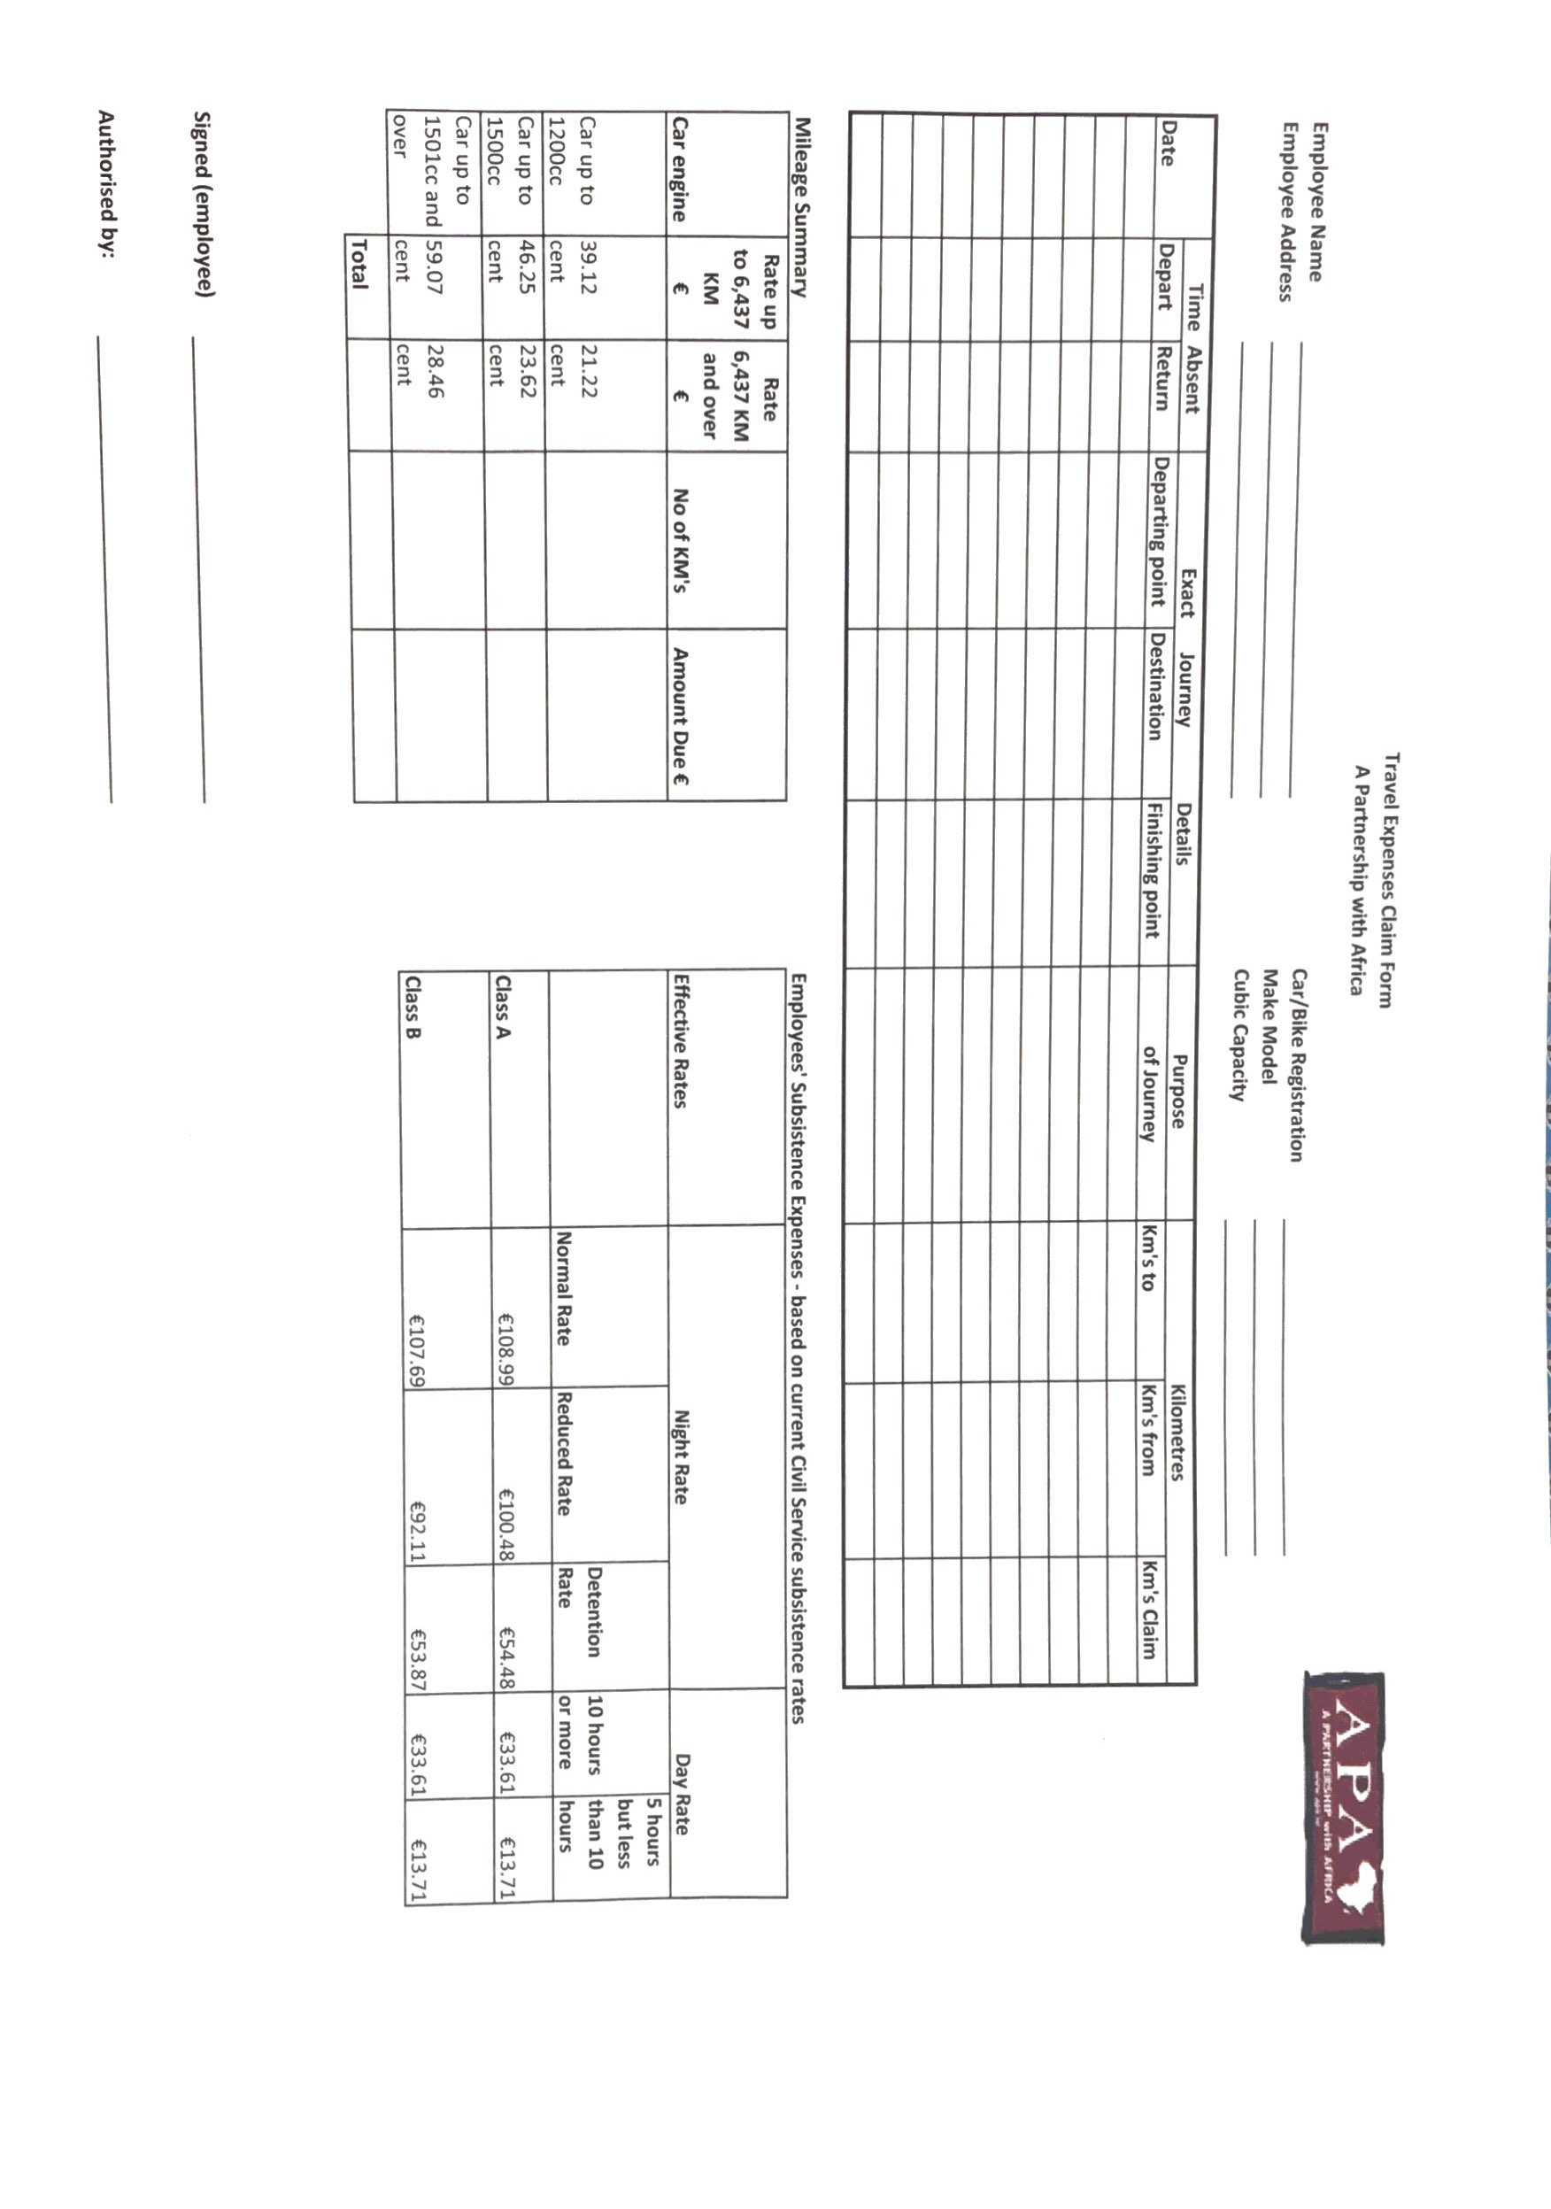

Appendix B: CEO and Deputy Evaluation Template

Appendix C: Child Protection Referral Form

1. About YOU (the reporter):

Reporter’s Name: ___________________________________

Reporter’s Email: ___________________________________

Reporter’s relationship to APA/CVM:
__________________________________________________________________________________________________________________________________________________________________________

Reporter’s relationship to the child concerned (if relevant):
__________________________________________________________________________________________________________________________________________________________________________

2. About THE CHILD/CHILDREN:

Name of Child: ___________________________________

Age/Date of Birth of Child: ___________________________________

Whom does the child live with?
__________________________________________________________________
Address/ place of residence of the child (and telephone number if available):
__________________________________________________________________________________________________________________________________________________________________________

3. About YOUR CONCERN:

Are you reporting your own concern or passing on those of someone else? Give details:
__________________________________________________________________________________________________________________________________________________________________________

Brief description of what has prompted the concerns (include dates and times of any specific incidents):
_____________________________________________________________________________________
_____________________________________________________________________________________

__________________________________________________________________________________________________________________________________________________________________________
_____________________________________________________________________________________

Observations made by you including physical signs, behavioural signs, other indirect signs:
_______________________________________________________________________________________________________________________________________________________________________________________________________________________________________________________________
_____________________________________________________________________________________

Have you spoken to the child? If so what was said?
_____________________________________________________________________________________
_____________________________________________________________________________________
_____________________________________________________________________________________
_____________________________________________________________________________________

Has anybody been alleged to be the abuser? If so give details:
_____________________________________________________________________________________
_____________________________________________________________________________________
_____________________________________________________________________________________

Have you consulted a government department or any other agency, or reported this to anyone else? Give details (name of person, organisation, date and time):
_____________________________________________________________________________________
_____________________________________________________________________________________
_____________________________________________________________________________________
_____________________________________________________________________________________

Does the child require any medical attention? Give details:
_____________________________________________________________________________________
_____________________________________________________________________________________
_____________________________________________________________________________________
_____________________________________________________________________________________

___________________________________________ _____________________________________

Signature Date

Appendix D: APA/CVM Code of Conduct

Anyone found in violation of the Code of Conduct will be subject to appropriate disciplinary action up to and including dismissal from employment

APA/CVM acknowledge that its representatives will:
- maintain a safe environment where beneficiaries come to participate in activities.
- organise work to minimise risks.
- hire/train Representatives of the highest integrity who are accountable, responsible and create an environment of openness for all involved.
- hire/train Representatives who treat all involved with the highest standards of respect.
- establish a culture that empowers beneficiaries to be knowledgeable of their rights, to know what is acceptable and unacceptable, to know what to do when there are problems
- ensure that all confidential information is handled appropriately.
- encourage that breaches of the Code of Conduct are immediately reported to management, where prompt action is expected.
APA/CVM Representatives:
- will not discriminate in employment, projects, or services on the grounds of religion, gender, race, ethnicity, national origin, language, sexual orientation, marital status, health status, disability, age, or political conviction.
- will not discriminate against or show favour of particular children.
- will respect the cultures, best practices and traditions of all people and display cultural sensitivity to host communities and countries where APA / CVM works.
- will respect the cultures, best practices and traditions of all people and display cultural sensitivity to host communities and countries where APA / CVM works.
- will promote gender equity in all its projects.
- will not harass any employee, project participant, partner, vendor, or member of communities in which APA / CVM conducts programmes.
- will treat each other and those whom they serve with respect and dignity.
- will hire and train representatives who treat all involved with the highest standards of respect.
- will hire/train representatives of the highest integrity who are accountable, responsible, and create an environment of openness for all involved.
- will maintain a safe environment where beneficiaries come to participate in APA / CVM activities.
- will not use relationships of management inappropriately.
- will not sexually harass any individuals, employee or programmes participant, regardless of their work relationship.
- will not exploit any individuals, whether staff, children, or participants in projects.
- will uphold the child labour laws of the country and ensure children are protected by these laws by reporting any witnessed or suspected exploitation.
- will not abuse children through either action or neglect.
- will work in a proactive manner to protect children from harm.
- will avoid being placed in compromising or vulnerable situations.
- will realize that they are always the responsible parties, even if a child initiates an inappropriate relationship or behaves in an unacceptable manner.
- will not condone or participate in behaviour of children which is illegal, unsafe or abusive
- will not provide shelter for a child or children in their homes.
- will not put themselves in positions where their actions (physical, verbal or otherwise) are offensive, inappropriate, abusive, neglectful or exploitative.
- will ensure all confidential information is handled appropriately.

Finally, in line with the core principles of the United Nation’s Task Force on Preventing Sexual Exploitation and Abuse in Humanitarian Crises 2001, APA/CVM Representatives Understand the following:
- Sexual exploitation and abuse by humanitarian workers constitute acts of gross misconduct and are therefore grounds for termination of employment.
- Sexual activity with children (persons under the age of 18) is prohibited regardless of the age majority or age of consent locally. Mistaken belief in the age of a child is not a defence.
- Exchange of money, employment, goods, or services for sex, including sexual favours or other forms of humiliating, degrading or exploitative behaviour is prohibited. This includes exchange of assistance that is due to beneficiaries.
- Sexual relationships between humanitarian workers and beneficiaries are prohibited since they are based on inherently unequal power dynamics. Such relationships undermine the credibility and integrity of humanitarian aid work.
- Where a humanitarian worker develops concerns or suspicions regarding sexual abuse or exploitation by a fellow worker, whether in the same agency or not, s/he must report such concerns via established agency reporting mechanisms.
- Humanitarian workers are obliged to create and maintain an environment, which prevents sexual exploitation and abuse and promotes the implementation of their code of conduct.
- Managers at all levels have particular responsibilities to support and develop systems that maintain this environment.

The guiding principle is that the protection of the child is always the overriding consideration.

Appendix E: Vulnerable Adults Standard Referral Form

Initial cause for concern form, which must be discussed with Manager/Safeguarding Lead or Member of the Senior Management Team ideally within 24 – 48 hours or as soon as is reasonably possible.

Date: ______________________________

Time: ______________________________

Name of individual that cause for concern is about: ______________________________

Age (if known): ______________________________

Address (if known): ______________________________

Describe your concern and action taken in as many details as possible:

_____________________________________________________________________________________
_____________________________________________________________________________________
_____________________________________________________________________________________
_____________________________________________________________________________________

Observations to support cause for concern:
_____________________________________________________________________________________
_____________________________________________________________________________________
_____________________________________________________________________________________
_____________________________________________________________________________________

Description and location of any visible marks, bruising etc.
_____________________________________________________________________________________
_____________________________________________________________________________________
_____________________________________________________________________________________
_____________________________________________________________________________________

Name of alleged abuser, relationship with person (if known): ______________________________

Name of person completing form: ______________________________

_____________________________________ _____________________________________
Signature: Date:

Manager Name: ______________________________

_____________________________________ _____________________________________
Signature: Date:

Safeguarding lead or Senior Manager Name: ______________________________

_____________________________________ _____________________________________
Signature: Date:

Appendix F: Volunteer Application Form

The following APA Volunteer Application Form should be completed by all individuals seeking to volunteer with the organisation in any capacity and submitted prior to beginning work. Perspective volunteers should attach a CV with this application form at the time of submission.

1. Personal Information
Name (as written on passport): ________________________________________________
Age Group (optional) Under 18 18-25 26-40 41-55 over 55
Sex: (optional) M F Other

Address: __________________________________ _________________________
Phone Number: _____________________________ Email: ________________________
2. Emergency Contact Information
Name: ____________________________________ Relationship to you: _____________
Address: _______________________________________________________________
Phone Number: _____________________________ Email: ________________________
In which location are you intending to volunteer? Ireland Italy Ethiopia
3. References: Include the contact information for 3 people who can speak to your abilities to serve as a volunteer below. References can include employers, professors, landlord, supervisors, etc.

1. Name: ___________________________________ Relationship to you: _____________
Address: _________________________________________________________________
Phone Number: ______________________________ Email: ________________________
2. Name: ____________________________________ Relationship to you: _____________
Address: __________________________________________________________________
Phone Number: _______________________________ Email: ________________________
3. Name: _____________________________________ Relationship to you: _____________
Address: ________________________________________________________________
Phone Number: ______________________________ Email: ________________________
4. Work Experience
List any relevant work or volunteer experience and corresponding dates here:
___________________________________________________________________________
___________________________________________________________________________
___________________________________________________________________________
___________________________________________________________________________
___________________________________________________________________________
List any relevant skills that you possess which could inform your work at APA (i.e. Microsoft Office, social media, etc.):

___________________________________________________________________________
___________________________________________________________________________
___________________________________________________________________________
___________________________________________________________________________
___________________________________________________________________________

By including your signature below, you are indicating that all of the information you’ve provided above is factual and honest.

___________________________________________________________________________
Volunteer Signature Date

Appendix G: Volunteer Contract

A Partnership with Africa shall maintain this form as a formal agreement between the Volunteer and the Organisation for the terms indicated below.

Volunteer Name: _______________________________________________________________
Dates of Intended Volunteer Work: ________________________________________________
Time Commitment (hours/week): __________________________________________________
Scope of Work:
___________________________________________________________________________
___________________________________________________________________________
___________________________________________________________________________
___________________________________________________________________________
___________________________________________________________________________
Optional Allowances (e.g. reimbursement of exceptional travel or training costs incurred outside of normal duties at request of management). etc.):
___________________________________________________________________________
___________________________________________________________________________Volunteers are expected to work within the policies and procedures of APA and adhere to its ethos. By signing this contract you agree that you have read, understood and agree to abide by APA staff policies, procedures and code of conduct. You understand that any false information you provide may lead to the termination of this volunteer contract.
Please note: Non-disclosure of any issues relating to Child Protection or Safeguarding of Vulnerable Adults may disqualify you from taking up a volunteer position with APA

___________________________________________________________________________
Volunteer Signature Date

___________________________________________________________________________
APA Representative Signature (CEO/Deputy/Accounts Finance Controller) Date

Appendix H: Volunteer Induction Checklist

Induction is an information sharing process to help volunteers feel like they are part of the team and become productive as quickly as possible within their role. Planning and creating an induction programme and induction pack ensures all volunteers receive all relevant information and are introduced to the organisation in the same way. Below is a sample induction checklist. It may take some effort to collate the information initially but once it’s done, it can be updated and added to easily.

GENERAL | YES | NO | N/A
Introduction to Staff & Other Volunteers
Mission Statement
History of Organisation
Overview of Organisational Chart and Services
Staff Biographies and Job Descriptions
Role of Volunteers and Staff
Aims and Objectives of Organisation, Ethos and Values

POLICIES & PROCEDURES | YES | NO | N/A
Health & Safety
Equal Opportunities
Volunteer Policy
Child Protection
Confidentiality
Data Protection and Data Access
Bullying and Harassment
Garda Clearance or Vetting

PRACTICAL | YES | NO | N/A
Volunteer Contract
Role Description
Support and Supervision
Training
Expenses
General Orientation of Office or Workplace
Record-Keeping System
Contact Numbers and Details
Insurance Cover

Appendix I: CII Fundraising Compliance Checklist

This Checklist may assist you in ensuring your charity’s full compliance with the CII Statement of guiding Principles for Fundraising hereafter referred to as the Statement.

Throughout you will need to consider who in your organisation needs to be involved to ensure the Statement is successfully implemented.

Completion and sign off of the Checklist by responsible post holder(s) annually will serve to meet the organisation’s requirement to comply with the Statement. A record should be kept on file and, where relevant, each point must be supported by documentation or signed off by a post holder. The record should be available for external review/audit for a period of 6 years. A report on compliance must appear in the organisation’s Annual Report.

1. Compliance with the Statement (cf. Page 11 of the statement)

We, A Partnership with Africa (APA), commit to comply with the Statement of
Guiding Principles for Fundraising.

 | Yes |  | No |  | N/A, please clarify

Agreed and minuted at Board level on

We have a statement to that effect in our Annual Report / Annual Statement.

 | Yes |  | No |  | N/A, please clarify

We have a public statement to that effect (on the web, in public areas of our buildings, in appropriate materials, in appropriate communications, etc.).

 | Yes |  | No |  | N/A, please clarify

2. Donor Charter (cf. Page 15 of the Statement)

We have a Donor Charter.

 | Yes |  | No |  | N/A, please clarify

The Donor Charter is highlighted and communicated:

 | Via our website |  | In relevant promotional materials
n compliance to the Statement

3. Reporting on Compliance (cf. Pages 11 & 29 of the Statement)

We will report on compliance to the Statement:

From stated start date |  |  |  |  | First reporting date

A reporting plan is in place.

 | Yes |  | No |  | N/A, please clarify

Integration with regular financial reporting and Annual Report is in place.

 | Yes |  | No |  | N/A, please clarify

4. Fundraising Planning (cf. Pages 19-28 of the Statement)

Compliance is considered as part of Fundraising Planning and Budget preparation.

 | Yes |  | No |  | N/A, please clarify

A policy for evaluating/deciding on allocation of funds is in place.

 | Yes |  | No |  | N/A, please clarify

We have a plan for any shortfall/excess in income.

 | Yes |  | No |  | N/A, please clarify

We ensure that our third-party fundraisers comply with the Statement.

 | Yes |  | No |  | N/A, please clarify

We have a policy on working with third party fundraisers (after the fact).

 | Yes |  | No |  | N/A, please clarify

We fulfil the requirements for Disclosure.

 | Yes |  | No |  | N/A, please clarify

5. Internal Communications (cf. Pages 19-28 of the Statement)

We have appointed a Champion or Lead person(s).

 | Yes |  | No |  | N/A, please clarify

Relevant staff and volunteers have received information:

On the Statement
On the current legal requirements in relation to Garda permits (for collections in public places)
On Data Protection regulation
On the Advertising Standards Authority regulation
On the Code of Conduct on Images and Messages
On IFFDR Code of Practice

Staff induction includes the Statement.

 | Yes |  | No |  | N/A, please clarify

We have a Volunteer Policy.

 | Yes |  | No |  | N/A, please clarify

We carry out Volunteer induction.

 | Yes |  | No |  | N/A, please clarify

We have systems in place to regularly update the Board.

 | Yes |  | No |  | N/A, please clarify

We have systems in place to regularly update the Finance Committee.

 | Yes |  | No |  | N/A, please clarify

6. Responding to Feedback and Complaints (cf. Pages 14 of the Statement)

We have an accessible Feedback and Complaints procedure.

 | Yes |  | No |  | N/A, please clarify

Feedback is:

Recorded and available for review by relevant staff and managers, including the CEO and Board
Responded to promptly and appropriately
Where required internal action is taken to address any issues identified as a result of the feedback
Staff (whether paid or voluntary) are trained and informed as to how best to address all feedback both directly with the person(s) giving the feedback and internally within the organisation
A record of all related feedback is kept and is available to be externally audited or examined

The charity makes known to the Monitoring Group any requirements to update, amend or clarify the Statement, or any lessons learned about the need to devise further Codes.

 | Yes |  | No |  | N/A, please clarify

Checklist

7. Financial Reporting (cf. Pages 29-30 of the Statement)

We have procedures in place for protecting and reporting on our organisational independence.

 | Yes |  | No |  | N/A, please clarify

Our financial statements and our Annual Report have been prepared in accordance with the Charities Act 2009 and the Regulations made by the Minister.

 | Yes |  | No |  | N/A, please clarify

We meet the Audit or Examination requirement.

 | Yes |  | No |  | N/A, please clarify

We have a system in place to ensure that all donations are tracked and recorded.

 | Yes |  | No |  | N/A, please clarify

We adhere to current Data Protection regulation.

 | Yes |  | No |  | N/A, please clarify

We apply high standards in electronic security.

 | Yes |  | No |  | N/A, please clarify

8. Contact Points

We have a variety of easily accessible contact options available to the public, including, as appropriate:

A low-cost telephone number

An email address

A postal address

An office open to the public, the opening times of which are made known

Appendix J: Written Statement of Agreement

This form should be completed, signed, and returned to line manager by every employee, staff member, or volunteer who work with APA in any capacity.

By signing below, I, ___________________________________, agree that I have read and understood the policies within this document. I understand that as an employee or volunteer with A Partnership with Africa, I am expected to uphold all of these policies in all of my work.

Please indicate which policies you have read and understood:
- Child Protection Policy
- Safeguarding Vulnerable Adults Policy
- Gender Policy
- Conflict of Interest and Loyalty Policy
- Data Protection Policy
- Social Media Policy
- Volunteer Policy
- Fraud Policy
- Risk Management Policy
- Fundraising Policy
- Reserve Policy
- All Appendices corresponding with above policies

___________________________________________________________________________
Signature Date

A Partnership with Africa

Partners in development with the people of Africa

Updated: October 07, 2025
Address: Kimmage Manor, Whitehall Rd, Dublin D12 P5YP, Ireland
Email: info@apa.ie
Tel: (353.01) 406 4316
Website: www.apa.ie
Company No.: 372427
Charity No.: CHY 15814
CRA No: 20055547

Financial
Procedures
Manual

Table of Contents

CHAPTER 1: Financial Procedures 161
1. General 162
2. Responsibilities of the Board of Directors and Delegated Authority 162
3. Chart Accounts and General Ledger 163
4. Budget Planning and Financial Management Processes 163
5. Grant Management Procedures 164
6. Ordering and Purchasing Procedures 166
7. Bank and Cash Handling Procedures 168
8. Employment of Staff and Payroll Arrangements 169
9. Fixed Assets and Insurance 169
10. Loans 169
11. External Audits 169
12. Fundraising Events 170
13. Travel and Expenses 170
14. Consultants 170
15. Property 171
16. Leases 171
17.Telephone 171
18. Administration 171
19. Risk Policy 172
20. Fraud Policy 173

Chapter 1
Financial Procedures

1. General

The following information denotes general rules and procedures related to APA’s Financial Procedures which will be discussed in detail throughout this document:

- The Board of Directors formulates financial policies and delegates administration of the financial policies to the Executive Director and/or Deputy.
- The Board appoints an Internal Audit Finance and Risk Committee (IAFRC) to monitor all financial operations and activities of the APA Organization on a quarterly basis.
- The Executive Director and/or Deputy has management responsibility including financial management.
- Up-to-date job descriptions will be maintained, as facilitated by the Board of Directors, for all employees, indicating financial duties and responsibilities.
- Financial duties and responsibilities will be separated so that no one employee has sole control over cash receipts; disbursements; payroll; reconciliation of bank accounts; etc.
- Professional financial service providers are established annually; they refer to annual report for details of accounting software and procedures utilized and banking, insurance and auditors engaged.
- The Accounts & Finance Controller will maintain a current and accurate log of the chart of accounts, job of accounts and accounting classes.
- These policies and procedures will be reviewed bi-annually by the APA IAFRC.

2. Responsibilities of the Board of Directors and Delegated Authority

The Board of Directors is responsible for the following: safeguarding the assets of the charity, preventing fraud, ensuring that proper financial records are kept in accordance with the governing document and relevant legislation (e.g. Charities Acts, Companies Acts, etc.) and for the preparation of financial statements each financial year in accordance with the governing document of the company and relevant applicable legislation and accounting standards.
To enable the Board of Directors to carry out these responsibilities, the Financial Procedures detailed below must be followed at all times by all Board of Directors members, staff and volunteers. A copy of this policy and procedures will be given to all Board of Directors members on their election/appointment to the Board, and to all relevant staff and volunteers. The policy and procedures will be reviewed annually by the Board of Directors (or a finance committee if the Board so decides) and revised as necessary.

Delegated Authority: The Board of Directors formulates financial policies and delegates a Board member as Financial Controller to oversee the administration of these financial policies by the CEO and the Accounts & Finance Controller. The Board appoints an Internal Audit, Risk and Finance Committee (IAFRC) to monitor all financial operations and activities of APA on a quarterly basis. The finance IAFRC currently comprises four members, including three Board members (including the Board chair & Financial Controller). Additional members of this committee may be appointed by the board. The CEO has overall management responsibility including financial management of APA. He / she will be assisted by the Accounts &Finance Controller and other accounting and project related staff as required.

3. Chart of Accounts and General Ledger

As part of its accounting procedures, APA’s Accounts & Finance Controller will maintain a chart of accounts and general ledger. The Chart of Accounts includes a listing of the names of the accounts that APA identified and made available for recording transactions in its general ledger. The General Ledger includes records of all financial transactions conducted on behalf of APA, organized in a manner consistent with accounting principles and best practices. This general ledger will typically be maintained through the use of appropriate accounting software. Appropriate measures should be taken to ensure that back-up procedures are in place in the event of any damage or failure of accounting-related software. All original supporting documentation will also be maintained in a secure location, consistent with standard practice, requirements included in grant agreements or other relevant contractual or legal obligations.
The computerized accounting system will record the following, at a minimum: cheques and cash received and banked, cheque payments, internet banking transfers, other amounts paid from bank accounts and full details of all assets and liabilities. Accrued revenues and expenses will be included on a monthly basis as part of the preparation process for monthly management accounts. Every transaction and journal entry will be entered into the appropriate account and will include the date of the transaction, the name of the person money was received from or paid to, the full amount, a brief description of why the money was received or paid and an analysis of each amount under its relevant budget heading, where applicable. All documents related to receipts and payments will be filed in the month they are input.

4. Budget Planning and Financial Management Processes

APA’s current financial year runs from 1st January to 31st December each year. An Annual Budget, setting out the organisation’s financial plan for the year, will be prepared at the beginning of each financial year by the Accounts & Finance Controller in collaboration with the CEO. This draft budget will be reviewed and approved by the IARFC in the first instance and, upon their recommendation, by the Board of Directors. This budget will be updated on at least a quarterly basis, or more often if considered necessary. Actual performance against budget will be reviewed by the finance committee on a regular basis throughout each year.

The Accounts & Finance Controller will prepare abbreviated monthly management accounts for review by the CEO on a monthly basis. A full set of management accounts with updated projections / budget will be presented to the finance committee at each quarterly meeting (or more often if required). The Accounts & Finance Controller will report to the Board of Directors on the financial performance since the last meeting and present the most recent financial report, including a Statement of Income and Expenditure, a statement of Financial Activities (SOFA) and a Balance Sheet.

5. Grant Management Procedures

APA is dependent on grants and contracts for a significant proportion of its revenue in any given year. Donors can include both official/governmental donors (such as Irish Aid), various agencies/funding schemes within the European Union, as well as non-governmental sources. Procedures for proper grant management constitute a number of areas, including the following:
It is of the utmost importance that each new planned project or activity is properly costed to reflect the full cost of expected activities, including appropriate inclusion of indirect/overhead costs when appropriate. A designated lead person(s) will be appointed from within APA’s team to lead the project design process. This lead person(s) will be identified by the CEO and may include (depending on the type of grant involved) other staff members. In normal circumstances, APA’s Accounts & Finance Controller should prepare budgets for new grants, in consultation with relevant designated lead person and other stakeholders, ensuring that these budgets are consistent with the relevant requirements.
The CEO should, in normal circumstances, review any proposal to be submitted, including budget, prior to submission, in order to ensure that the proposed activities are consistent with APA’s strategic plan, achievable and properly costed. Larger planned applications (e.g. Irish Aid, CONCERN) with potential strategic implications for APA will be discussed by the CEO with the Board Chair and if necessary, with a relevant finance committee of the board or the full board. The CEO should also review proposed contracts/award agreements in advance of signature and in normal circumstances (unless he/she designates another member of staff to do so), will be the one to sign such award agreements on behalf of APA.

Organisational and Reporting Structure: Each grant or contract will have a designated project manager. This project manager will be responsible for the overall management of the grant, including oversight of actual activities financed by the grant as well as any required periodic narrative reporting required as part of the conditions of the grant. The organizational positioning of particular projects will depend on the nature of the project to be implemented.

Project Management and Financial Management: The CEO, designated Project Officer/Coordinator and Accounts & Finance Controller will carefully review each award and contract to ensure APA compliance with all financial and programmatic provisions. The CEO will maintain originals of all grants and contracts in a file for each one. Copies of all relevant narrative reports submitted to donors will be provided to the Accounts & Finance Controller to ensure that a complete project file is maintained in one location.
Where grants or contracts are structured such that APA is the prime recipient of funding as part dictated by consortium arrangements, APA will make payments to other recipients in accordance with the overall grant agreement and sub-grant agreement/contracts which will be signed beforehand between APA and sub-awardees. These signed documents will include all the procedures to be followed from project application to final reporting. All scheduled or written requested payments must be approved beforehand by the CEO.
The Accounts & Finance Controller will ensure that each project is properly established as separate revenue/cost centre in the Chart of Accounts/General Ledger in order to facilitate proper identification and tracking of project related expenditure. In order to facilitate this, all projects funded by external awards will be allocated a specific code in the nominal ledger, and all income and expenditure incurred by the project should be charged to this project code (further broken down between expenditure types as appropriate). The Project Manager/Coordinator, in collaboration with the Accounts & Finance Controller, will also ensure that expenditures incurred on such projects are appropriate and allowable expenses and are consistent with approved project budgets.

Document retention: The Accounts &Finance Controller will review the document retention requirement of each externally funded award/contract and ensure that complete documentation is safely and secured stored in an appropriate location/archive.

Preparation, review and approval of financial reports: The Accounts & Finance Controller will prepare project level financial reports to funding sources as required. Under no circumstances should the Project Coordinator prepare a financial report themselves without prior approval from the Accounts & Finance Controller and a full review and clearance of the financial report by the Accounts & Financial Controller before submission. The Accounts &Finance Controller will also prepare updates and analysis of the actual expenditure versus budget over the course of the project period as required by the project manager to facilitate grant management and for budgetary control reasons. As potential projected cost overruns that would contravene donor requirements on a line item basis or for the project as a whole, will be discussed with the Project Manager and the CEO. The Accounts & Financial Controller will work with the Project Coordinator to re-align budgets for donor approval if a budget re-allocation request is necessary.
Both the Project Officer and the Accounts & Finance Controller will keep the CEO updated on project progress and budget vs spend status respectively. The CEO will also review and approve all reports to donors before submission. It will be the responsibility of the Project Manager and Accounts & Finance Controller to ensure that all narrative and financial reports are submitted on a timely basis.

Reporting of errors & irregularities: Any errors or irregularities in project performance or reporting should be immediately reported to the CEO for review. In case of errors or irregularities of a material nature, the relevant donor should be immediately informed in writing of the situation by the CEO. Issues of such significance will also be brought to the attention of the Board Chair by the CEO and if material, will also be discussed at Board level.

6. Ordering and Purchasing Procedures

Making Orders for Goods and Services: In general, only a properly authorized person can make orders for goods and services. In the normal course of business, ordering and procurement of basic supplies, stationeries etc. will be the responsibility of the Accounts & Finance Controller, or in her/his prolonged absence of a designated replacement. Orders of other more specialized goods and services related to project activities will typically be the responsibility of Project Officer and/or a designated member of the project team. In either case, however, no order can be made without prior authorized approval, as set out below.

Expenditure Approval: All expenditures over €50 requires an approved purchase order before obligations are incurred. All purchases are to be approved in advance by the CEO or his/her designate in the absence of the CEO due to annual leave or other prolonged absence. Invoices (or other receipts) should be matched and checked against approved Purchase Orders before payment is made. All goods received must be signed for; if unchecked they must be checked for completeness before payment. Once payment has been made the invoice (or other receipt) should be marked “Paid”, together with the cheque number and date. All payments must be entered in the computerised accounting system only after being authorised.
Members of the Board can be reimbursed for expenses incurred in attending APA-related activities. All such expenses will be approved by the CEO prior to disbursement. Expenses of the Board Chair will be reviewed and approved by the CEO prior to reimbursement. No member of the Board of Directors, member of the company or staff member may authorise payment to themselves, their partner or relatives. No member of the Board of Directors may be employed in a paid capacity by APA or paid for any services provided to APA. Board Members may, however, contribute voluntarily to the work of the charity in addition to the contribution they make as board members.

Procurement Guidelines: In general, expenditure approval will be contingent upon adherence to the procurement guidelines set out below. For general recurring expenditures (e.g. any expenditure on supplies, stationeries or regular services) over €50 should be accompanied by three quotes, unless a price comparison was made within the last three months and the same lowest cost supplier is being used.

More generally, most works and related services contracts awarded by APA, which are subsidised 50% or more by a public body, must be awarded in accordance with the EU Directives if they exceed EU threshold amounts. For contracts below the EU thresholds funded or partly-funded from public funds, funding authorities are required to ensure that these awards are made in accordance with these EU directives. Given the reliance of APA on funding (either directly or indirectly) from the public sector, APA personnel should follow these EU requirements all procurements of APA above €500. Key points are summarized below. Further guidance can be found at: https://www.pobal.ie/Publications/Documents/Public%20Procurement%20Guidelines.pdf

In some cases, the thresholds have been lowered in these guidelines, reflecting the relatively smaller size of the organization and the importance of proper systems of cost control.
It is a basic principle of public procurement that a competitive process should be used unless there are justifiably exceptional circumstances. The type of competitive process can vary depending on the size and characteristics of the contract to be awarded and the nature of the contracting authority.
Low Value Requirements: Supplies or services greater than €50 but less than €200 should be purchased on the basis of three verbal quotes. However, a written record of these quotes, including details of the supplier and the price quotes should be retained for audit purposes. This record can be attached to the purchase order when authorization for a purchase is sought.
Medium Value Requirements: Supplies or services contracts between €200 and €2,000 in value can be approved by the CEO and awarded on the basis of responses to specifications sent by fax or email to at least three suppliers or service providers.
High Value Requirements: Contracts above €2,000 and up to the value of EU thresholds for advertising at the European level (see guidelines document noted above), should normally be advertised as part of a formal tendering process and require approval from the Board of Directors. See guidelines above for more detail.
In practice, however, any procurement above €2,000 related to consulting services should be considered for tender through an open competitive process advertised through relevant media (e.g. Dóchas Wednesday News, APA website, etc.). All responses from venders should be retained on file to ensure a verifiable audit trail.

Evaluation of Quotes/Tenders: For low and medium value procurements, the designated person managing the procurement is authorized to evaluate quotes received. In instances where a tender is issued for a medium value procurement, a team of three people should be formed (comprising APA and if in the case of joint activities with other organizations, other non-APA personnel) to assess the tenders submitted. Criteria for selection of any such tenders should be included in the public tender document and used consistently in the evaluation of tenders received.
Those evaluating tenders should have the requisite competency. Transparency and objectivity are best demonstrated by the use of a scoring system or marking sheet based on the relevant weighted criteria, including price, indicating a comparative assessment of tenders under each evaluation criterion. All tenderers should be informed of the result of a tendering process without delay.
For high value tenders, the Board of Directors will ensure that proper procedures related to advertising, evaluation of tenders and post tender discussions are adhered to. In situations where very large tenders are being issued, independent professional advice may also be sought to support the procurement process.

7. Bank and Cash Handling Procedures

Bank Accounts: All bank accounts must be in the name of the organisation. No bank account may ever be opened in the name of an individual or individuals. New accounts may only be opened by a decision of the Board of Directors which must be detailed in meeting minutes. Arrangements for the opening of new bank accounts authorized by the Board of Directors will be made by the Accounts & Finance Controller, under the supervision of the CEO. Changes to the bank mandate may only be made by a decision of the Board of Directors, which also must be noted in meeting minutes. A written record of bank account signatories should be maintained by the Accounts & Finance Controller.
Cheque books should be properly secured when not in use. All cheques must be signed by two signatories; standard authorization requirements with respect to pre-approval of expenditure apply to all payments, including payments by cheque. Cheque signatories are responsible for examining the cheque for accuracy and completeness and for ensuring that the payment has been properly authorized. Cheque signatories should never sign a blank cheque.
Processing of internet bank transfers are the responsibility of the Accounts & Finance Controller. However, out-going transfers can only be made with prior approval from the CEO or delegate per APA’a authorization procedures. Access codes to online bank accounts should be kept in a secure location, accessible only by the Accounts & Finance Controller and CEO. The current online banking system utilizes a “key code” system which generates passwords via a smartphone banking app. The smartphone(2) used for making payments and transfers is kept in the APA office. All payments and transfers made through the app still requires pre-approval from the CEO or delegate.

Cash Receipts and Payments: All cash receipts should be made to the Accounts & Finance Controller. She/he should record such receipts in a numbered cash receipts book and provide a copy of the receipt to the payer. The Accounts & Finance Controller will be responsible for the completion of regular cash counts and reconciliations will be made on a monthly basis as part of the process of preparing monthly accounts.
Cash payments are the responsibility of the Accounts & Finance Controller. Such payments will be kept to an absolute minimum and will generally be used only for low value items and / or where necessary, for the advance payment of travel or other expenses for business related travel of staff. In case of emergency, and in the absence of the Accounts & Finance Controller, the CEO may also issue petty cash payments. All petty cash payments must be authorized in the same way as other expenditure and recorded in a pre- numbered petty cash book. All such payments must include the signature of the person receiving the funds.

8. Employment of Staff and Payroll Arrangements
The primary policy document of reference for the employment of staff is the Board approved “APA Staff Policy Handbook” document.

The Accounts & Finance Controller or another designated person is responsible for ensuring that all staff are employed under signed contracts and for monitoring the status of same (including renewal times). She/he will maintain a personnel file for each employee, containing appropriate documents, such as the signed contract and job description and approval of changes in salary along with holiday entitlements and sick pay arrangements and other that may arise. The Accounts & Finance Controller or another designated person will also maintain a log of holiday and sick leave taken during the year, based on the submission of time sheets from staff and will make any necessary accruals for accrued holiday pay as part of year end accounting procedures.

9. Fixed Assets and Insurance
The Accounts & Finance Controller will ensure that appropriate Insurance policies will be maintained to cover: Employer’s Liability; Public Liability and Contents. An inventory of all physical assets of the organization (Fixed Assets Register) will be kept and regularly updated by the Accounts & Finance Controller. A copy of this register will be kept off the premises be means of electronic storage/back-up.

10. Loans

Only the Board of Directors may approve loans to APA. A promissory note will be prepared and signed by the Board Chair and another officer of the Board before any funds are borrowed. This provision will not prevent APA personnel from availing of normal credit terms available from supplies for the delivery of goods and services in the normal course of business.

11. External Audits

The Board of Directors shall annually contract with an independent auditing firm a full audit of the books, to be completed no later than the 15th of July in the year following year end. The finance committee of the Board of Directors will meet with representatives of the auditors at least once per year to discuss the audit findings and any management or control recommendations that the auditors might have and will report on same to the board of directors prior to board approval of the annual report (including annual financial statements). The finance sub-committee may also, from time to time, make recommendations to the Board of Directors with respect to the re-appointment of auditors, based on best practices in the sector, value for money considerations and their assessment of the capacities and level of engagement being offered.

12. Fundraising Events

Records will be kept by the Accounts & Finance Controller for each fund-raising event in sufficient detail to identify gross receipts, how they have arisen and all costs involved. Events for which there is a ticket income or gate money, should adhere to the following guidelines:
- All tickets will be pre-numbered.
- A record will be kept by the Office Administrator and/or by the Event Organising Committee of all persons who have been issued with tickets to sell, and of the ticket numbers allocated to each.
- Details of which tickets have been sold will be noted.
- A reconciliation will be performed of monies received against tickets sold.

13. Travel & Expenses

Employees will complete an expense voucher if they are completing authorized travel. This voucher should include all expenses including credit card charges. It should be noted that APA will not cover mileage to and from the employee’s residence. Expense vouchers should be submitted within 60 days for payment, with a total, signed by the employee, authorized for payment by the CEO. Reimbursement will be based upon the following: receipts attached to the expense voucher for lodging, common carrier transportation, and for meals. Incomplete expense vouchers will be returned.

Employees and Board Members will be reimbursed for out of pocket business related expenses such as travel, accommodation, etc. by submitting the Travel Expenses Claim Form along with receipts for such expenditure. The CEO must approve employee travel and workshop expenditures prior to their occurrence. The organization will reimburse no more than the standard mileage rate for the business use of a car as established by the revenue and will reimburse out-of-pocket meal expenses incurred in direct connection with APA’s employment. Rates will be approved on a case-by-case basis as per APA’s guidelines before any expenditure is accrued.

14. Consultants

Consideration will be made of internal capabilities to accomplish services before contracting for them. Written contracts clearly defining work to be performed as well as terms and conditions will be maintained for all consultant and contract services. The qualifications of the consultant and reasonableness of fees will be considered in hiring consultants. Consultant services will be paid for as work is performed or as delineated in the contract. The Board of Directors will approve the auditors and other significant contracts.

15. Property

Equipment: Equipment shall be defined as all items (purchased or donated) with a unit cost of €500 or more and a useful life of more than one year. The Accounts & Finance Controller will maintain an inventory log which shall list a description of each item, date of purchase or acquisition, price or fair value of the item and its location.

A depreciation schedule shall be prepared by the Accounts & Finance Controller at least annually for the audited financial statements who will also record all equipment in the accounting system. An entry must be made whenever property is disposed of or acquired.

16. Leases

Offices & Equipment: The CEO will review leases prior to submission to the Board of Directors for approval. All leases, clearly delineating terms and conditions, will be approved by the Board of Directors and signed by the Board Chair. The CEO will keep a copy of each lease on file. The Accounts & Finance Controller will be consulted for each lease and lease specification and will make proper general journal entries for same.

17. Telephone

Personal long distance or cellular phone calls made on APA’s telephones by employees must be logged with the Accounts & Finance Controller indicating that it is a personal call. Employees will be billed on these calls. APA business calls from phones outside the office should be billed to the APA telephone account.

18. Administration

Minutes of Meetings: The Secretary of the Board will prepare accurate minutes of all meetings of the Board of Directors. The CEO will note all items in the minutes relating to finance and take appropriate action (as designated in the above document).

.

Accounts Receivable: Documentation will be maintained for accounts receivable. Accounts receivable will be recorded in the books and collected on a timely basis.

Financial Procedures: Financial procedures will be reviewed bi-annually by the IAFRC. The Board of Directors must approve changes to this Financial Procedure Manual prior to their implementation.

Management Accounts: The Accounts & Finance Controller will prepare quarterly management accounts reports, and the CEO will review these. These figures, along with comparisons against budget, projected cash flow statements and projected accounts for the year, will also be reviewed by the IAFRC and amended where necessary and presented to the Board of Directors meeting.

Audits: The Board of Directors shall annually contract with an independent auditing firm a full audit of the books, to be completed prior to the following first of April in each year.

Personnel Files: The Accounts & Finance Controller will maintain a personnel file for each employee containing appropriate documents, such as the signed contract and job description and approval of changes in salary along with holiday entitlements and sick pay arrangements and others that may arise.

19. Risk Policy

Purpose: APA’s Board of Directors is aware that some risks will always exist and cannot be eliminated. The Board recognises that it has a responsibility to manage risks (both positive and negative) and to support a structured, systematic and focused approach to manage them by approval of the risk management strategy.

In this way, the Board of APA will:
- Demonstrate effective corporate governance.
- Better achieve its corporate objectives.
- Enhance the value of services it provides to the beneficiaries.

Objectives:
- Integrate risk management into the culture of the board and APA at all levels.
- Manage risk in accordance with best practice.
- Anticipate and respond to changing social, environmental and legislative requirements.
- Prevent injury, damage and losses and reduce the cost of risk.
- Raise awareness of the need for risk management by all those involved with the delivery of organization’s services.

These objectives will be achieved by:
- Establishing clear roles, responsibilities and reporting lines within the Board and throughout the organisation for risk and fraud management prevention/detection.
- Providing opportunities for shared learning on risk management to employees and volunteers.
- Offering a framework for allocating resources to identified priority risk areas.
- Providing training to employees and volunteers in order to reinforce the importance of effective risk management as part of the everyday work
- Incorporating risk management into business planning.
- Incorporating risk management considerations into partnership arrangements, project management, change management, programmes and contracts.
- Monitoring arrangements on an on-going basis by including risk reporting as a standing agenda item on both the Internal Audit and Risk Assessment Committee (IAFRC) and Board meeting agendas.

20. Fraud Policy

It is the policy of APA to identify and promptly investigate any possibility of fraudulent or related dishonest activities against the organisation and, when appropriate, to pursue legal remedies available under the law. APA aims to promote an organisation culture which encourages the prevention of fraud by raising awareness of the need for high standards of personal conduct.

Any act of fraud ascertained upon investigation, or pursuant to a criminal conviction, or through written acknowledgement by the employee(s) concerned, shall result in the possibility of termination of employment, restitution and /or forwarding information to the appropriate
authorities for criminal prosecution. The repayment of losses will be sought in all cases and the organisation would normally expect to recover all costs in addition to the recovery of losses.

Fraud Definition

For the purposes of this policy, fraud shall include but not be limited to:
- Theft or misappropriation of APA assets
- Submitting false claims for payments or reimbursement
- Accepting or offering a bribe or accepting gifts or other favours under the circumstances that might lead to the interference that the gift or favour was intended to influence an employee’s decision-making while serving the organisation
- Accepting a commission from or paying same to a third party
- Blackmail or extortion
- ‘Off Books’ accounting or making false or fictitious entries
- Knowingly creating and /or distributing false or misleading financial reports
- Paying of excessive prices or fees where justification thereof is not documented
- Violation of APA procedures with the aim of personal gain or to the detriment of the organisation
- Wilful negligence intended to cause damage to the material interest of APA
- A dishonourable, irresponsible or deliberate act against the interests of the organisation

For the purposes of this policy, an employee refers to a staff member who receives remuneration, either full or part time, from APA. The term also includes any volunteer who provides services to the organisation through an official arrangement with the organisation.

Responsibility for the Detection and Prevention of Fraud: Board members, IAFRC, managers and employees at all levels are responsible for exercising due diligence and control to prevent, detect and report acts of fraud. Those who fail to carry out these responsibilities will be subject to disciplinary action up to and including termination of employment.

Responsibility of Management: It is the responsibility of the CEO or Deputy, IAFRC and managers to be familiar with the types of improprieties that might occur in their area and be alert for any indication that improper, misappropriated or dishonest activity is or was in existence in his or her area. It is also his or her responsibility to put in place controls to avoid such occurrences. Board members, CEO or Deputy, IAFRC and area managers are required to support and work together with law enforcement agencies in the detection, reporting and investigation of dishonest or fraudulent activity, including the prosecution of offenders. If a fraud is detected, the adequate controls should extend to prevent reoccurrence of improper actions.

Responsibility of Employees: It is the responsibility of all employees to conduct their APA business in such a way as to prevent fraud occurring in the workplace. Employees must also be alert to the possibilities for fraud and be on guard for any indications that improper or dishonest activity is taking place.

Reporting Fraud
It is the responsibility of all APA staff to report any suspicion of fraud without delay, according to the procedure laid out below. Persons who cover up, obstruct, fail to report, or monitor a fraud that they become aware of, or ought to have been aware of because of their position, will be considered to be an accessory after the fact and may be subject to disciplinary action and/or discharge. Persons who threaten retaliation against fraud reporters shall be subject to disciplinary action up to and including termination of employment.

Great care must be taken in dealing with suspected dishonest or fraudulent activities to avoid:
- Incorrect accusations
- Alerting suspected individuals to an investigation underway
- Treating employees unfairly
- Making statements that could lead to claims of false accusations or other charges.
In the case of all employees and management, the incident, facts, suspicions or allegations should not be discussed with anyone inside or outside the organisation unless specifically directed to do so by the APA Officer investigating the incident. In particular, the matter should not be discussed with the individual suspected of fraud.

Fraud can be detected at any level within the organisation, and the following general principle should apply in the reporting of suspected fraud:
- A person who suspects that fraudulent practice may be operating should immediately report the matter to his/her superior. Should it be inappropriate to make such a report to an immediate superior, the report should be made to that person’s manager or directly to the CEO or Deputy, Board Member or Board Chairperson.
- Once a report of suspected fraud is made to supervisor/manager, that person should report the suspicion to his/her immediate superior or directly to the CEO or Deputy, Board Member or Board Chairperson.
- On receipt of a report of suspected fraud, an immediate superior should report the matter to the CEO or Deputy, Administration Staff and the Board Secretary in respect of all management staff.
- A Fraud Incident Report should be completed by the person who is reporting the suspected fraud.
- No investigation of the suspected fraud should take place until the immediate superior has been informed.

Procedures for the Investigation of Alleged Fraud
In the event of an alleged fraud, the organisation will proceed through the following steps:
- The CEO will (except in any case involving him or her) have responsibility for co-ordinating the organisation’s response and will seek expert advice from the organisation’s legal advisors or other advice (if required). The CEO will inform the relevant Board Member/Chairperson and other heads as appropriate and keep them informed of developments. The CeEOor Deputy will also notify the organisation’s Insurance Brokers to ensure that insurance matters are dealt with promptly and properly.
- The CEO will notify the Internal Financial Audit and Risk Committee (IAFRC) who will, if appropriate, conduct an initial investigation to gather factual information and reach a preliminary view as to whether further action is required. The IAFRC will report the findings, conclusions and any recommendations to the CEO or Deputy, who will keep the Board informed.
- Where the initial investigation provides reasonable grounds for suspecting a member or members of staff of fraud or a dishonest activity, the CEO, in consultation with the Secretary of the Board and other relevant Officers, will decide if any actions are necessary to prevent further loss. This may require, in consultation with the Senior Staff, the suspension with or without pay of the member or members of staff (which will take place in accordance with APA Staff Policy and Procedures and /or the decision as to whether further investigation is required.
- Each case will be considered individually in accordance with the expert advice obtained with a view to minimising the losses (both monetary and otherwise) to the organisation. Having reached a decision as to what further action is necessary and how such actions should be undertaken, the CEO will liaise with the Board Chairperson and with the Board.
- When further investigation is required, an Investigating Committee and its Chair will be appointed by the Board for each case. All meetings of the Committee will be treated as confidential and shall be fully documented with investigation work normally led by the IAFRC. In circumstances where the investigation requires the use of technical expertise which the IAFRC does not possess, the Investigating Committee may appoint external specialists (subject to the approval of the CEO) to lead and/or contribute to the investigation.
- Upon completion of its investigation, the Investigating Committee will submit a written report of its findings and its recommendation(s) to the CEO who, in consultation with the Senior Manager or Board, will issue a decision on the matter and determine whether internal disciplinary procedures should be invoked or whether the Gardaí should be notified. The CEO will communicate the decision to the person(s) accused of the fraud or related dishonest activity and will submit a copy of the report to the IAFRC and Board.
- Employees who are under investigation shall be entitled to have a member of APA staff or other appropriate individual present during the course of any interview that is conducted in connection with the alleged fraud or related dishonest activity with a view to defending their case.
- The CEO will be responsible for dealing with any enquiries from the press or other media.
- The IAFRC will, at an appropriate time, consider the results of the investigation and assess whether there is a weakness in the organisation’s systems of internal control which need to be addressed. The IAFRC will report the findings, conclusions and recommendations, following completion of consultation with the relevant persons to the Board of APA.

Accounting for Loss, Restitution and Recovery: The section or project incurring the loss from a dishonest or fraudulent act will normally suffer the loss until monies can be recovered through insurance or restitution.

Notifying the APA Auditors: The CEO and other relevant APA Officers will consider reporting to the APA Auditors the confirmed cases of fraud indicating what steps have been taken to address the weaknesses in the systems of internal control related to the fraud.

References for Employees Disciplined or Prosecuted for Fraud: Where there is a request for a reference for a member of staff who has been disciplined or prosecuted for fraud or a dishonest activity, the Executive Director or Deputy shall prepare a reply to a request for a reference having regard to APA policies and employment law.

Review of Fraud Policy: This fraud policy will be reviewed every three years by the IAFRC.

Note: If the suspected incident involves the CEO of the organisation, the Board shall decide who will undertake the role and functions specified for the CEO of the Organisation in the interim.

A Partnership with Africa

Partners in development with the people of Africa

Updated: October 07, 2025
Address: Kimmage Manor, Whitehall Rd, Dublin D12 P5YP, Ireland
Email: info@apa.ie
Tel: (353.01) 406 4316
Website: www.apa.ie
Company No.: 372427
Charity No.: CHY 15814
CRA No: 20055547

Guidelines for the Operation of APA Charity Shops

Hacketstown: 087 118 4949
Carlow Town: 086 793 2175
Athlone: 086 411 4103

Table of Contents

CHAPTER 1: General Information About APA 179
Profile of “A Partnership With Africa” (APA) 180
Vision, Mission and Values 181
Principles 182

CHAPTER 2: Management of the ShopS 183
1. List of Volunteer Teams and Responsibilities 184
2. General Management Requirements 186
3. Contracting and Personal Information 187

CHAPTER 3: Financial procedures and Internal Controls 188
1. Cash Receipts 189
2. Deposits for Goods 189
3. Credit Card and Cheque Payments 189

Appendices 190
Appendix A: Volunteer Application/Contract for Shops 191
Appendix B: Daily Sales Sheet 192
Appendix C: Daily Cash Book Entry 193
Appendix D: Weekly Report from APA Charity Shops to APA Accounts & Finance Controller …………………………………………………...194

Chapter 1
General Information about APA

Profile of “A Partnership with Africa” (APA)

​APA was incorporated on the 18th of June 2003 with Company Registered Number 372427, was granted charity status a year later with Registered Charity Number CHY 15814 and was more recently registered under the Charities Regulatory Authority with CRA Number 20055547 by Fr. Owen Lambert CSSp (Spiritan Priest) and friends as AIDS Partnership with Africa - APA.
​Fr. Lambert spent nearly thirty years in Africa (mainly in Ethiopia and Tanzania) working with the people through the great famine in Ethiopia and the tragedy of the HIVA pandemic. APA promoted a broad-spectrum response to HIVA control by integrated prevention and care as top priorities, working with regional government structures up to the national level, including ministries of health, education and political establishments, as well as with influential local and religious leaders. Adopting an integrated approach, APA promoted the networking of all social structures and community organisations, facilitating people to mobilise their resources and skills to cope with and stem the growing tsunami of death being wrought by the epidemic including the vast numbers of children orphaned due to the deaths of young parents under the care of grandparents who took up the huge challenge of caring for their grandchildren.
​
The impact of the HIVA pandemic on orphaned children and the many single-parent families, widows and domestic workers remained the focus of APA project activities. In 2014, as APA evolved and expanded into areas especially with women’s and children’s rights, the rights of ethnic minorities and development education in Ireland, the organisation underwent a name change to better represent the scope of its work. Thus, the name was legally changed from AIDS Partnership with Africa to A Partnership with Africa (APA). Operating under this title, APA continues to grow and adapt to the changing needs in Africa with current programmes in Ethiopia, Tanzania and Kenya.

Vision, Mission and Values

Vision

APA’s mission is to work globally in a spirit of partnership with local communities and institutions to facilitate equal access to basic services and empower the most vulnerable citizens of the world to reach their full potential.

Mission
APA’s vision is of a just world where all people are equally empowered to realise their full potential; where all will have universal access to basic services such as food, shelter, education and health.

Values

Principles
APA upholds the following principles for the vision, mission and values of their work. All board members, volunteers, employees or other persons associated with the organisation should strive to uphold these principles not only in their professional activities but also in their personal attitudes and practices.

The Development of All People
APA’s goal is to build a fairer world for its inhabitants. Forms of global injustice and marginalization are widespread in all communities and continue to oppress entire populations around the globe. The development of each person and of all peoples remains the primary objective of the organisation. Historically, APA has supported marginalised and most at-risk groups and individuals by encouraging their own personal empowerment as well as the acceptance and advocacy from community members in positions of power and privilege. People living with HIV/AIDS, those living with unequal access to food, shelter and water and individuals and groups who have historically lacked fair access to education have been primary focuses for APA. The organisation follows the model of enabling the most at-risk and marginalised groups who have been trapped in cycles of poverty and oppression including bar workers, domestic workers, and others who seek recognition, respect and acceptance from the local, national and global community and their institutions.

Capacity Building
Widespread lack of awareness and disregard for of the rights of the most at-risk and marginalised groups of people should be considered a crime against humanity as it deprives such people of a fair and just chance to succeed either personally and socially. As a result, APA aims to combat these crimes against humanity in a way that builds the capacity of individuals around the world by unlocking their own potential. The increase of human dignity, hope and awareness offers an opportunity for people to freely define their own paths and projects for development, free from external economical oppression and within their own reasonable limits.

Partnership
Partnership is at the core of APA's vision and work, from facilitating communities to develop projects to collaborating with government, to enabling vulnerable groups like Domestic Workers or the Menja populations to access their rights through constitutional and legal avenues. APA also partners with other likeminded organisations in order to maximise the impact of its efforts with people who are poor. APA shares a unique relationship with Comunita Volontari per il Mondo (CVM), a non-profit organisation based in Porto San Giorgio, Italy. APA and CVM maintain a Consortium Agreement in which the two organisations have both aligned their missions and agreed to collaboratively implement their projects. Through its robust network of local and national partners in Ethiopia and Tanzania, CVM has established a strong basis of trust in the communities within which it works. APA and CVM have maintained a partnership for 15 years through which they have been able to maximise development efforts.

Education and Awareness
The organisation’s mission and policies should inform its projects, but at the same time, the projects should enter into a complete circular dialogue in order to inform the policies and mission. APA pledges to integrate its policies into its work so that the policies are not only reference points for board members, volunteers, staff and projects, but ultimately also support the mission and vision of all of the organisation’s work. APA pledges to approach their policies in a spirit of education and awareness, not only for those impacted by projects, but also for its board of directors, volunteers, staff, local authorities, and other community members with whom they engage.

Chapter 2
Management of APA Shops

APA has committed to running their charity shops as much as possible on a voluntary basis. Shops are run by volunteers from the local community who form a team and appoint a volunteer to fulfil a management role.

1.0: List of Volunteer Teams and Responsibilities
All teams should include a minimum of 3 members. It should be noted that some teams will require more members based on the team’s needs and responsibilities.

Pricing Committee
Responsibilities include:
- Comprised of 3 people (volunteers and other, if applicable).
- Nominated by APA Management.
- Determine pricing standard for donated items (especially for furniture) in the shop.
- Record furniture donations in the log book and see to providing receipts for donors upon request.
Team for Procurement of Supplies for Shop
Responsibilities include:
- Promote advertising locally, inviting response from families and individuals to ensure a continuous supply of items for stocking the shop.
- Approach shopping outlets, gift shops, businesses, etc. for donation of items. Maintain contact with other APA groups elsewhere in Ireland as a source of supplies.
- Invite donors to deliver items to the shop during opening hours.
- Arrange the collection of items from families, shops, etc. for delivery to the shop store and build up contact with some volunteers with vehicles who commit to doing this.
- Coordinate advertising for sales and donations on the shop’s Facebook page.

Team for Preparation of Items and Restocking of Shop
Responsibilities include:
- Sort and select incoming donated supplies.
- Provide pre-sale preparation.
- Tag items and keep supplies in line for regular shop stocking up.
- Monitor movement of items.

Team for Resourcing and Selection of Volunteer Staff
Responsibilities include:
- Promote awareness of the Charity Shop, its purpose and the work being done by APA in Ethiopia and Tanzania through support from the shop.
- Develop and apply criteria for volunteering including availability, commitment, skills, Garda clearance (expected of voluntary organisations and vetting is required where children or vulnerable adults are present), experience, ability and skills to work in a team and be a team builder, team assignment.
- Take initiatives to support human relations and propose ways to move forward and discourage exclusiveness in an effort to promote openness, teamwork and inclusiveness.

Team for Shop Sales Rota When Open
Responsibilities include:
- Develop a Rota system to cover when a volunteer may unexpectedly not be able to attend their allotted hours.
- Facilitate orientation and training of volunteer staff in shop protocol, customer care, use of Cash Register, Sales Book, Cash Book, Lodgement Book, Float and Weekly Report to APA Office.
- Provide orientation on difficulties that may arise and how to bring problems arising to the attention of relevant team members.
- Utilize local voluntary human resources if available (for example, professional and possible involvement of Transition Year Students, TUS and Back to Work employment schemes, men’s shed, etc.).

Team for Overall Coordination of the Shop
This team is formed by one member from each of the other Teams, can include one external member from outside of teams, and includes Accounts & Finance Controller and CEO of APA. Responsibilities include:
- Networking with other teams, local agencies, shops, donors, etc.
- Bi-monthly meetings to review all concerns regarding the well-being and development of the Charity Shop (the APA Accounts & Finance Controller and CEO should be present for every second meeting at least).
- Maintain and store meeting minutes in a hardback copy book.
- Coordinate with APA Management on sending “thank-you” notes to donors, volunteers and others involved in the shop.
- Manage the sale of items to recycling companies

This team strives to maintain a strong team spirit among all the teams and their members and everyone involved with the Charity Shop in any way. It aims to resolve any issues or misunderstandings that arise. The team facilitates efficient shop operation and the highest standards of financial management and human relations as promoted by the APA organisation itself.

Manager
This role was created to ensure smooth communication and coordination with APA Management in regards to the shop. On a given cycle, volunteers can nominate an individual who has demonstrated a strong ability to fulfil the role of manager. APA Management will collect the nominations and make the ultimate selection of the manager. While the manager’s responsibilities may vary slightly depending upon the shop’s needs, the general roles of the manager are as follows:
- Serve on both the Pricing Committee and the Team for Overall Coordination of the shop.
- Provide excellent customer care through quality of service, dealing with enquiries and complaints both efficiently and effectively.
- Be responsible for the overall management of the shop and daily management of the shop’s team, including volunteer shop assistants.
- Oversee proper management of day to day finances and follow relevant APA policies in regards to them.
- Ensure that the shop is stocked appropriately, that rotation practice is followed and a good standard of merchandising and display are met.
- Ensure basic shop preparation guidelines are met according to the Charity Shop Guidelines and policies.
- Manage health and safety policies and procedures.
- Recruit, support and train volunteers when necessary in coordination with APA Management.
- Develop a roster of volunteers to cover the opening hours of the shop accounting for illness, holidays or other absences as they arise.
- Attend relevant meetings with APA Management and disseminate relevant information to other team members.
- Ensure that volunteers sort donated items on a regular basis.
- Guide volunteers on how to handle shop equipment including fire extinguishers, ladders, shop shutters, alarms, tagging guns, etc.
- Be aware of and comply with Trading Standards Legislation.
- Oversee acceptance of items, pricing policy, recycling and arranging of collections for the shop in conjunction with APA Management.
- Be responsible for the purchasing of minor shop essentials to ensure the general upkeep of the shop.
- Manage demanding customers and any possible complaints and queries.
- Ensure the best possible care, management, presentation and display of goods for sale and special promotions.
- Ensure that the advertised trading hours of the opening and closing of the shop are met.
- Work with an attitude of respect, integrity and team spirit in order to value the unique contribution of each individual.
- Work positively in an equal opportunity and diverse environment.
2.0: General Management Requirements
- Two people should be present in the shop at all times.
- Payments which may arise such as utilities, repairs, stationery, etc. need authorization and will be processed by the APA Accounts & Finance Controller on receipt of invoice/bills.
- Receive receipts for recycled items, sign for them and submit to APA Management. Then, record the recycling of items in the sales log.
- The APA Accounts & Finance Controller will visit the Charity Shop on a monthly basis to maintain good communications and assist as needed. During visits, the Accounts & Financial Controller will also review the previous month’s transactions and will sign off on the Cash and Sales Books to confirm checking and provide guidance in the use of these.

3.0: Contracting and Personal Information
- All volunteer staff are required to complete applications and contracts with their up-to-date contact information. The Application/Contract form can be found in Appendix A of this document. In coordination with this contract, volunteers are required to read and understand the APA’s Policy Handbook. All personal data shared in the contract requires the individual’s consent to be collected and stored at APA headquarters. The information is subject to data protection legislation and cannot be shared with anyone without the individual's permission.

Chapter 3
APA Shops
Financial Procedures and Internal Controls

The APA Accounts & Finance Controller is delegated by the Board to have management responsibility for implementing internal control and financial management procedures as set out by the Guidelines for the Finance and Internal Audit Committee of APA.

1.0: Cash Receipts
- All sales are recorded in the Daily Sales Book and in the Cash Register kept in the shop. (See Appendix B)
- A reconciliation of both the Sales Book and Cash Register will be recorded in the daily cash book at close of day and signed off by two people. (See Appendix C)
- All cash except the float will be lodged to APA, AIB Bank account via Post Office daily. AIB lodgement books will be provided for this purpose. Lodgement books should be kept safely and will be part of the monthly review by the APA Accounts & Finance Controller and are returned to APA office when full.
- The coins float and its amount will be determined by the shop and its needs.
- A weekly Sales Record will be posted (after closing Saturday) to the APA Accounts & Finance Controller, Kimmage Manor on the template provided. (See Appendix D)

2.0: Deposits for Goods
- Deposits are allowed on items and will be recorded in the Daily Sales Book and lodged together with other sales. Deposits should be maintained up to but not longer than one week, and if payment in full is not received the deposit should be refunded and recorded.
- Credit should not be facilitated.

3.0: Credit Card and Cheque Payments
- The shop is unable to facilitate payments by cheque or credit card.

Appendix A: Volunteer Application/Contract – APA Charity Shops
The following APA Volunteer Application/Contract Form should be completed by all individuals volunteeing with the organisation in any capacity and submitted prior to beginning work. Perspective volunteers should attach a CV with this application form at the time of submission (if possible).

Part A. Application
1. Personal Information
Name (as written on passport): _______________________________________________
Age Group (optional) Under 18 18-25 26-40 41-55 over 55
Sex: (optional) M F Other

Address: _________________________________ Town/City: _________________________

Phone Number: ____________________________ Email: ________________________
2. Emergency Contact Information
Name: __________________________________ Relationship to you: _____________
Address: ____________________________________________________________________
Phone Number: _____________________________ Email: ________________________
In which location are you intending to volunteer? (tick boxes)
Carlow Town Hacketstown Athlone

Please indicate which days of the week you are available for volunteering.
Sunday Monday Tuesday Wednesday Thursday Friday Saturday

- References: Include the contact information for a minimum of 2 people who can speak to your abilities to serve as a volunteer below. References can include employers, professors, landlord, supervisors, etc. Please note: Referees should not be related.

1. Name: __________________________________ Relationship to you: _____________
Address: _________________________________________________________________
Phone Number: _____________________________ Email: ________________________
2. Name: __________________________________ Relationship to you: _____________
Address: _________________________________________________________________
Phone Number: _____________________________ Email: ________________________
3. Name: __________________________________ Relationship to you: _____________
Address: ____________________________________________________________________
Phone Number: _____________________________ Email: ________________________
4. Work Experience
List any relevant work or volunteer experience and corresponding dates here:
___________________________________________________________________________
___________________________________________________________________________
___________________________________________________________________________

List any relevant skills that you possess which could inform your work at APA (i.e. Microsoft Office, social media, driving, pre-sale furniture/clothing care, shop design, etc.):
___________________________________________________________________________
___________________________________________________________________________
___________________________________________________________________________

Please indicate below any team preferences for your volunteer work with APA’s Charity Shop:
___________________________________________________________________________
______________________________________________________________________________________________________________________________________________________
---------------

Part B. Contract (to be signed upon review of the application). Volunteers are expected to work within the policies and procedures of APA and adhere to its ethos. By signing this contract you agree that you have read, understood and agree to abide by relevant APA staff policies, procedures and code of conduct. You understand that any false information you provide may lead to the termination of this volunteer contract.
Please note: Non-disclosure of any issues relating to Child Protection or Safeguarding of Vulnerable Adults may disqualify you from taking up a volunteer position with APA.

___________________________________________________________________________
Volunteer Signature Date

___________________________________________________________________________
Shop Manager Signature Date

___________________________________________________________________________
APA Representative Signature (CEO/Deputy/Accounts Finance Controller Date

Appendix B: Daily Sales Sheet
Fill into the Daily Sales Book as per the example below:
Date: | January 11th 2018
Code | Description | Price
11.1.2018 | 1 dress | €6.00
11.1.2018 | 1 ladies coat | €15.00
11.1.2018 | 1 pullover | €4.00
11.1.2018 | 1 walking stick | €2.00
11.1.2018 | 1 dress | €5.00
11.1.2018 | 2 dresses | €10.00
11.1.2018 | 1 pair of women’s shoes | €8.00
11.1.2018 | gift item - a set of glasses | €5.00
11.1.2018 | 1 armchair | €25.00
11.1.2018 | 1 suit | €35.00
11.1.2018 | 1 pair of men’s shoes | €8.00
11.1.2018 | 1 child’s coat | €7.00
 | Total sales for Wed. 11th Oct. 2015 | €130.0
- Name: | ______________________
- Name: | ______________________
Date: ___________________________

Appendix C: Daily Cash Book Entry

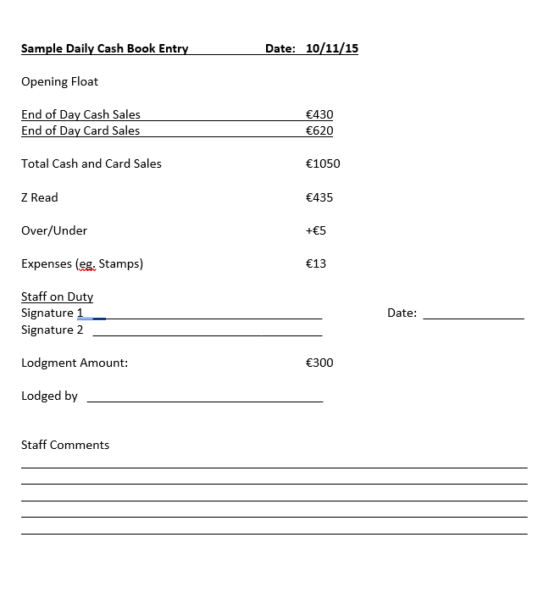

Appendix D: Weekly Report Form

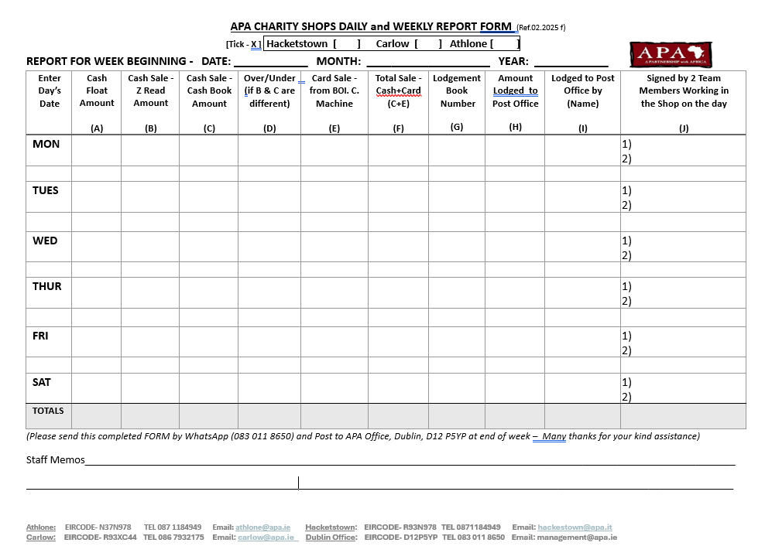

The term ‘children’ will be used to refer to those individuals who are under 18 years of age as recognised in the UNCRC.
United Nations Convention on the Rights of the Child
‘Representative’ means any person presenting themselves to a child because of their relationship with APA and/or CVM. This includes staff, volunteers, board members, partners or affiliated entities and their representatives consultants, donors, visitors, supporters including sponsors, the media and all those who have contact with children or sensitive information about children.
UN Covenant on Civil and Political Rights General Comment No. 18: Non-Discrimination, Article 1
UN Protocol to Prevent, Suppress and Punish Trafficking in Persons, especially women and children, supplementing the United Nations Convention against Transnational Organized Crime, Article 3 (a)
See Chapter 2 Advocacy for Children’s Rights
Third party fundraisers are those other than employees of the organisation, for example volunteer fundraisers, or people or companies contracted by your organisation to fundraise on the organisation’s behalf.
This would apply when someone presents to your organisation having already fundraised for the organisation without your knowledge
Where a charity receives gifts from named and/or anonymous donors of a size that could be construed as having the potential to influence the independence of the organisation’s decision-making then these should be disclosed in the Annual Report and Financial Statements (See p.16 of the Statement of Guiding Principles for Fundraising for details).
Regulations to be made by the Minister in relation to form and content of financial statements and Annual Report.
See www.dataprotection.ie

